Modul 13

Mata Kuliah : Management Pengetahuan

**Chat bots**

Apa Itu Chatbot?

Jika membahas tentang perkembangan teknologi memang tak ada habisnya. Semakin hari kian menjadi-jadi. Kemajuan pesat Artificial Intelligence (AI), Machine Learning, Deep Learning, dan big data analytics melahirkan aplikasi chatbot. Apa itu chatbot?

Mengutip dari Medium.com (12/3/2019), menurut Kamus Oxford, chatbot adalah program komputer yang dirancang untuk mensimulasikan percakapan dengan pengguna manusia, terutama melalui internet.

Jelasnya, chatbot merupakan asisten yang berkomunikasi dengan orang melalui pesan teks, pendamping virtual yang terintegrasi ke dalam situs web, aplikasi atau pesan instan dan membantu pengusaha untuk lebih dekat dengan pelanggan. Bot semacam itu adalah sistem komunikasi otomatis dengan pengguna.

Rupanya, chatbot telah lama ada. Chatbot mulai dikembangkan sekitar dekade 1960-an. Di awal kemunculannya, chatbot benar-benar terkesan seperti robot, kaku. Namun, berkat kehadiran AI, chatbot memiliki kemampuan dengan rasa percakapan yang lebih natural.

Shep Hyken, seorang pakar konsultan customer service dalam ulasan di Forbes mengatakan bahwa kecerdasan buatan sukses mengubah dunia bisnis secara drastis. Keberadaan chatbot yang dibekali teknologi AI sukses menjadi “saluran layanan pelanggan yang layak.”

Menginjak tahun 1966, Massachusetts Institute of Technology merilis sebuah chatbot pertama yang diberi nama ELIZA. ELIZA dirancang sebagai chatbot yang memiliki tabiat sebagai seorang psikoterapis yang mampu bercakap dengan lawan bicara manusia. Setelah era ELIZA muncul dan sukses, kini bertebaran chatbot-chatbot lain, seperti MegaHAL, CONVERSE, ELIZABETH, dan ALICE.

Peran chatbot dalam dunia bisnis begitu menguntungkan. Pasalnya, chatbot bisa menyingkirkan tugas rutin dan pemrosesan simultan dari beberapa permintaan pengguna. Selain itu, respon dari chatbot begitu cepat luar biasa sehingga ia mampu mendapatkan loyalitas pelanggan.

Perusahaan di Indonesia mengharapkan keuntungan yang serupa, sehingga banyak dari mereka yang sudah mengadopsi chatbot. Apa saja ya?

Telkomsel

Chatbot milik Telkomsel diberi nama Veronika. Kata.ai merupakan developer pengembangnya pada Agustus 2017. Lewat Veronika, Telkomsel mampu melayani pelanggan melalui chat di Facebook Mesengger, LINE, dan Telegram.

XL Axiata

Selanjutnya, XL Axiata juga telah mengadopsi chatbot untuk menguntungkan perusahaannya. Chatbot miliknya diberi nama Maya. Dengan Maya, XL Axiata mampu melayani konsumen lebih cepat dan mudah. Untuk mengembangkan Maya, XL Axiata menggandeng startup chatbot asal Yogyakarta bernama Botika.

BCA

Tak mau ketinggalan, Bank Central Asia (BCA) juga meluncurkan chatbot miliknya yang bernama Virtua Assitant Chat Banking BCA (Vira) pada Juni 2017. Vira merupakan hasil inovasi Fariz Tadjoedin, juara pertama kompetisi Financial Hackathon (Finhacks) yang diselenggarakan oleh BCA pada 2016.

BRI

Bank Rakyat Indonesia (BRI) juga memiliki chatbot yang bernama Smart BRI New Assistant (Sabrina). Sama dengan Telkomsel, BRI juga turut menggandeng Kata.ai.

Bank Mandiri

Selanjutnya masih dari sektor perbankan, Bank Mandiri memiliki Mita sebagai chatbot yang mereka andalkan, kepanjangannya adalah Mandiri Intelligence Assistant. Untuk mengembangkan layanan ini Bank Mandiri menggandeng startup binaannya, yakni InMotion.

Unilever Indonesia

Di sektor retail, PT Unilever Indonesia Tbk meluncurkan chatbot besutan Kata.ai sejak November 2016, Jemma. Dikembangkan sebagai media promosi, saat ini Jemma sudah berteman dengan 1,7 pengguna LINE dengan sesi obrolan rata-rata empat menit per orang per hari

Alfamart

Terakhir, ada PT Sumber Alfaria Trijaya (Alfamart) yang turut mengadopsi chatbot. Shalma atau Sahabat Alfamart juga dikembangkan oleh Kata.ai. Dengan adanya Shalma, konsumen bisa bertanya mengenai promo terbaru di Alfamart.

What are chatbots?

* A chatbot is a conversational agent that interacts with users using natural language.
* Started as an attempt to fool humans.
* Numerous applications of chatbots such as Customer Service, call centers etc

Need for chatbots?

* Widespread use of personal machines
* Better Human Computer Interaction
* “To express their interest, wishes, or queries directly and naturally, by speaking, typing, and pointing”.
* You: Hello
* Op: Hi. This is Railway Enquiry
* You: What is the status of train 2803?
* Op: It’s right on time. The train will leave CST at 5:45 pm. Is there anything else I could assist you with?
* You : No, thank you
* Op: You are welcome. Indian railways wishes a nice and happy journey.

History

ELIZA

* Developed in the 1960s
* Looks for pronouns and verbs
* ‘You’ becomes ‘I’ and vice versa
* User: You are a dork.
* ELIZA: What makes you think I am a dork?

PARRY (1972)‏

* Simulated a paranoid schizophrenic

RACTER

* 1984
* Generate English language prose at random
* Generated a book
  + The Policeman's Beard Is Half-Constructed

Excerpt from the book

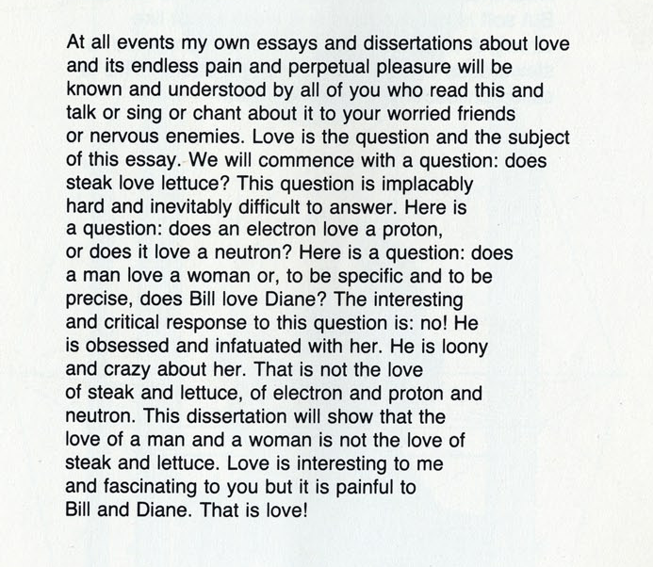

ALICE

* 1994
* Three time loebner prize winner
* Richard Wallace
* http://www.alicebot.org/

Talk Outline

* How do chat bots work?
* Use of AIML for storing language models.
* Applications
  + Intelligent Tutoring Systems
  + Other applications here
* Conclusion

How Do Chatbots Work

* Don’t have a good understanding of conversation
* Are based on pattern matching
* Chatterbots have a set of input and output rules
* Recognize cue words from user and responds with a pre-calculated response
* For e.g.:- Human: “I am feeling very worried today.”
  + Chatterbot: “Why are you feeling worried lately?”
* Other chatterbots learn through user interactions

ELIZA

* One of the first chatterbots designed in 1966
* Parodies a therapist rephrasing statements of the user and posing them back as questions
* Works by simple parsing and substitution of key words into canned phrases
* People get emotionally caught up by ELIZA’s confident replies forgetting that it’s a machine

Example of Conversation

* Eliza’s conversation with a patient is:-

Human: Well, my boyfriend made me come here.

ELIZA: Your boyfriend made you come here?

Human: He says I'm depressed much of the time.

ELIZA: I am sorry to hear you are depressed.

Human: It's true. I'm unhappy.

ELIZA: Do you think coming here will help you not to be unhappy?

* Able to elicit emotional responses from users though being programmed not to do so
* Demonstrates ELIZA effect

Jabberwacky

* No fixed rules and principles programmed into it
* Learns language and context through human interaction. Stores all conversations and comments which are used to find appropriate responses
* Problems faced due to this approach:-
  + Continuous changing of subject and conversation
  + May respond in a bad-tempered and rude manner
* Was designed to pass the Turing test and is the winner of the Loeber Prize contest

ALICE Chatbot System

* ALICE(Artificial Linguistic Internet Computer Entity) is inspired by ELIZA
* Applies heuristic pattern matching rules to input to converse with user
* ALICE is composed of two parts
  + Chatbot engine
  + Language Model
* Language models are stored in AIML(Artificial Intelligence Mark-up Language) files

Structure of AIML

* AIML consists of data objects which are made up of units called topics and categories
* A topic has a name attribute and categories associated with it
* Categories consist of pattern and template and are the basic unit of knowledge
* Pattern consists of only words, spaces and wildcard symbols _ and *.

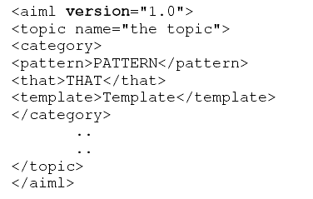

Types of ALICE/AIML Categories

* Atomic categories: do not have wildcard symbols.

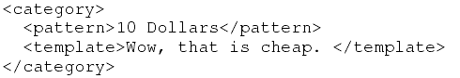

* Default categories: have wildcard entries * or _.

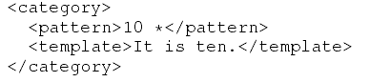

* Recursive categories:

Symbolic Reduction:

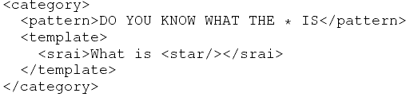

Divide and Conquer:

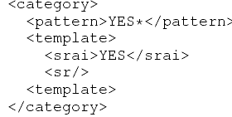

Synonyms

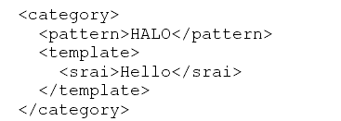

ALICE Pattern Matching Algorithm

* Normalization is applied for each input, removing all punctuations, split in two or more sentences and converted to uppercase.

E.g.: Do you, or will you eat me?.

Converted to: DO YOU OR WILL YOU EAT ME

* AIML interpreter then tries to match word by word the longest pattern match. We expect this to be the best one.

Algorithm

* Assume the user input starts with word X.
* Root of this tree structure is a folder of the file system that contains all patterns and templates.
* The pattern matching uses depth first techniques.

The folder has a subfolder stars with _,then, ”_/”,scan through and match all words suffixed X, if no match then:

Go back to the folder, find another subfolder start with word X, if so then turn to “X/”,scan for matching the tail of X. Patterns are matched. If no match then:

Go back to the folder, find a subfolder starting with *,turn to, “*/”, try all suffixes of input following “X” to see one match. If no match was found, change directory back to the parent of this folder and put “X” back to the head of the input.

Dialogue Corpus Training Dataset

Alice tries to mimic the real human conversations. The training to mimic ‘real’ human dialogues and conversational rules for the ALICE chatbot is given in the following ways.

* Read the dialogue text from the corpus.
* The dialogue transcript is converted to AIML format.
* The output AIML is used to retrain ALICE.

Other approaches

* First word approach:

The first word of utterance is assumed to be a good clue to an appropriate response. Try matching just the first word of the corpus utterance.

* Most significant word approach:

Look for word in the utterance with the highest “information content”. This is usually the word that has the lowest frequency in the rest of the corpus.

Intelligent Tutoring Systems

* Intended to replace classroom instruction
  + textbook
  + practice or “homework helpers”
* Modern ITS stress on practice
* Typically support practice in two ways
  + product tutors – evaluate final outcomes
  + process tutors – hints and feedbacks

Learner Modelling

* Modelling of the affective state of learner
  + student's opinion, self-confidence
* Model to infer learner's knowledge
* Target Motivation
  + just like expert human tutors do
  + instructions can be adjusted

Open learner Modelling

* Extension of traditional learner modelling
  + makes the model visible and interactive part
  + displays ITS' internal belief of the learner's knowledge state
* distinct records of learner's and system's belief
  + like an information bar
  + learner might challenge system's belief

ITS that use Natural Language

* Improved natural language might close the gap between human tutor and ITS
* Pedagogical agents or avatars
  + uses even non-verbal traits like emotions
  + act as peers, co-learners, competitors, helpers
  + ask and respond to questions, give hints and explanations, provide feedbacks, monitor progress

Choice of Chatbots

* Feasibility of integrating natural language with open learner model requires
  + Keeping the user “on topic”
  + Database connectivity
  + Event driven by database changes
  + Web integration
  + An appropriate corpus of semantic reasoning knowledge

Chatbots for Entertainment

* Aim has been to mimic human conversation
* ELIZA – to mimic a therapist, idea based on keyword matching.
* Phrases like “Very interesting, please go on”
* simulate different fictional or real personalities using different algorithms of pattern matching
* ALICE – built for entertainment purposes
* No information saved or understood.

Chatbots in Foreign Language Learning

* An intelligent Web-Based teaching system for foreign language learning which consists of:
  + natural language mark-up language
  + natural language object model in Java
  + natural language database
  + a communication response mechanism which considers the discourse context and the personality of the users and of the system itself.
* Students felt more comfortable and relaxed
* Repeat the same material without being bored

Chatbots in Information Retrieval

* Useful in Education – Language, Mathematics
* FAQchat system - queries from teaching resources to how to book a room
* FAQchat over Google
  + direct answers at times while Google gives links
  + number of links returned by the FAQchat is less than those returned by Google
* Based essentially on keyword matching

Chatbots in IR – Yellow Pages

* The YPA allows users to retrieve information from British Telecom’s Yellow pages.
* YPA system returns addresses and if no address found, a conversation is started and the system asks users more details.
* Dialog Manager, Natural Language front-end, Query Construction Component, and the Backend database
* YPA answers questions such as “I need a plumber with an emergency service?”

Chatbots in Other Domains

* Happy Assistant helps access e-commerce sites to find relevant information about products and services
* Sanelma (2003) is a fictional person to talk with in a museum
* Rita (real time Internet technical assistant), an eGain graphical avatar, is used in the ABN AMRO Bank to help customer doing some financial tasks such as a wire money transfer (Voth, 2005).

Conclusion

* Chatbots are effective tools when it comes to education, IR, e-commerce, etc.
* Downside includes malicious users as in yahoo messenger.
* The aim of chatbot designers should be: to build tools that help people, facilitate their work, and their interaction with computers using natural language; but not to replace the human role totally, or imitate human conversation perfectly.

References

* Bayan Abu Shawar and Eric Atwell, 2007 “Chatbots: Are they Really Useful?” : LDV Forum - GLDV Journal for Computational Linguistics and Language Technology. http://www.ldv-forum.org/2007_Heft1/Bayan_Abu-Shawar_and_Eric_Atwell.pdf
* Kerly, A., Hall, P., and Bull, S. 2007. Bringing chatbots into education: Towards natural language negotiation of open learner models. Know.-Based Syst. 20, 2 (Mar. 2007), 177-185.
* Lane, H.C. (2006).  Intelligent Tutoring Systems:  Prospects for Guided Practice and Efficient Learning. *Whitepaper for the Army's Science of Learning Workshop, Hampton, VA.  Aug 1-3, 2006.*
* http://en.wikipedia.org/wiki/Chatterbot
* ALICE. 2002. *A.L.I.C.E AI Foundation, http://www.alicebot.org/*