

MODUL PERKULIAHAN ELEARNING

MATA KULIAH - MCM 205 – ECOMMERCE (3 SKS)

PERTEMUAN 3 – *ELEARNING*

**FRAMEWORK OF ECOMMERCE**

Dosen

H. Andri Budiwidodo, S.Si., M.I.Kom.

(ID 7715)

Sumber penulisan modul:

Kenneth C. Laudon and Carol Guercio Traver. 2014. e-Commerce Business Technology Society. 10th Edition. New Jersey: Pearson. Halaman 19-28.

**TYPE OF E-COMMERCE**

There are several different types of e-commerce and many different ways to characterize them. **Table 1** lists the major types of e-commerce. For the most part, we distinguish different types of e-commerce by the nature of the market relationship—who is selling to whom. Social, mobile, and local e-commerce can be looked at as subsets of these types of e-commerce.

|  |  |  |
| --- | --- | --- |
| **TABEL 1** | **MAJOR TYPES OF E-COMMERCE** | |
| T Y P E O F E - C O M M E R C E | | EXAMPLE |
| B2C—business-to-consumer  B2B—business-to-business  C2C—consumer-to-consumer  Social e-commerce  M-commerce—mobile e-commerce  Local e-commerce | | Amazon is a general merchandiser that sells consumer products to retail consumers.  Go2Paper.com is an independent third-party marketplace that serves the paper industry.  On a large number of auction sites such as eBay, and listing sites such as Craigslist, consumers can auction or sell goods directly to other consumers.  Facebook is both the leading social network and social e-commerce site.  Mobile devices such as tablet computers and smartphones can be used to conduct commercial transactions.  Groupon offers subscribers daily deals from local businesses in the form of “Groupons,” discount coupons that take effect once enough subscribers have agreed to purchase. |

**Business-to-Consumer (B2C) E-commerce**

The most commonly discussed type of e-commerce is business-to-consumer (B2C) e-commerce, in which online businesses attempt to reach individual consumers. B2C commerce includes purchases of retail goods, travel services, and online content. Even though B2C is comparatively small (about $419 billion in 2013 in the United States), it has grown exponentially since 1995, and is the type of e-commerce that most consumers are likely to encounter (see **Figure 1**). Within the B2C category, there are many different types of business models. In next chapter has a detailed discussion of seven different B2C business models: portals, online retailers, content providers, transaction brokers, market creators, service providers, and community providers.

|  |
| --- |
| **business-to-consumer (B2C)**, e-commerce online businesses selling to individual consumers |

**Figure 1. eCommerce (B to C) Growth in USA**

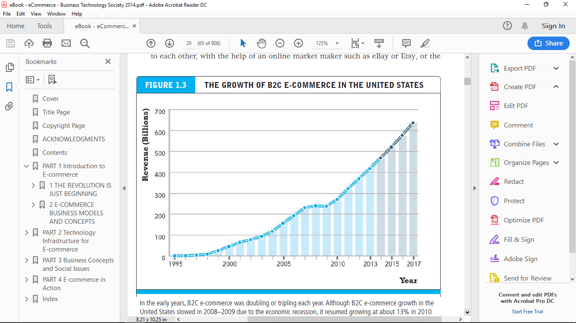

**Business-to-Business (B2B) E-commerce**

Business-to-business (B2B) e-commerce, in which businesses focus on selling to other businesses, is the largest form of e-commerce, with about $4.7 trillion in transactions in the United States in 2013 (see **Figure 2**). There is an estimated $12.9 trillion in business-to-business exchanges of all kinds, online and offline, suggesting that B2B e-commerce has significant growth potential. The ultimate size of B2B e commerce is potentially huge. There are two primary business models used within the B2B arena: Net marketplaces, which include e-distributors, e-procurement companies, exchanges and industry consortia, and private industrial networks

|  |
| --- |
| **business-to-business (B2B)**, e-commerce online businesses selling to other businesses |

**Figure 2. eCommerce (B to B) Growth in USA**

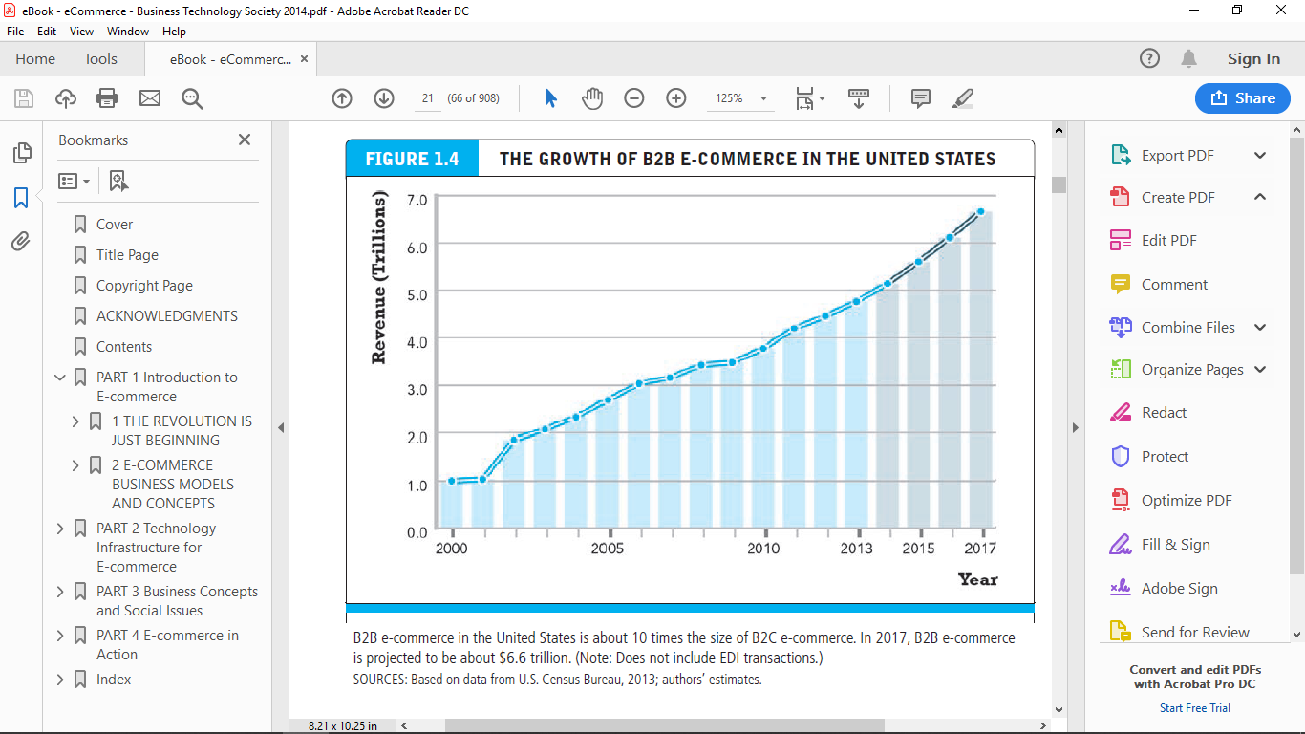

**Consumer-to-Consumer (C2C) E-commerce**

Consumer-to-consumer (C2C) e-commerce provides a way for consumers to sell to each other, with the help of an online market maker such as eBay or Etsy, or the classifieds site Craigslist. Given that in 2013, eBay is likely to generate around $75 billion in gross merchandise volume around the world, it is probably safe to estimate that the size of the global C2C market in 2013 is more than $90 billion (eBay, 2013).

In C2C e-commerce, the consumer prepares the product for market, places the product for auction or sale, and relies on the market maker to provide catalog, search engine, and transaction-clearing capabilities so that products can be easily displayed, discovered, and paid for.

|  |
| --- |
| **consumer-toconsumer (C2C)**, e-commerce consumers selling to other consumers |

**Social E-commerce**

Social e-commerce is e-commerce that is enabled by social networks and online social relationships. It is sometimes also referred to as Facebook commerce, but in actuality is a much larger phenomenon that extends beyond just Facebook. The growth of social e-commerce is being driven by a number of factors, including the increasing popularity of social sign-on (signing onto Web sites using your Facebook or other social network ID), network notification (the sharing of approval or disapproval of products, services, and content via Facebook’s Like button or Twitter tweets), online collaborative shopping tools, and social search (recommendations from online trusted friends).

Social e-commerce is still in its infancy, but is estimated to generate about $5 billion in the United States in 2013, and about $8 billion in the rest of the world (eMarketer, Inc., 2012a).

|  |
| --- |
| **social e-commerce**, e-commerce enabled by social networks and online social relationships |

**Mobile E-commerce (M-commerce)**

Mobile e-commerce, or m-commerce, refers to the use of mobile devices to enable online transactions. Described more fully in Chapter 3, m-commerce involves the use of cellular and wireless networks to connect laptops, smartphones such as the iPhone, Android, and BlackBerry, and tablet computers such as the iPad to the Internet. Once connected, mobile consumers can conduct transactions, including stock trades, in-store price comparisons, banking, travel reservations, and more. Mobile retail purchases are expected to reach almost $40 billion in 2013 (almost double that of 2012) and to grow rapidly in the United States over the next five years (eMarketer, Inc., 2013a).

|  |
| --- |
| **mobile e-commerce (m-commerce)**, use of mobile devices to enable online transactions |

**Local E-commerce**

Local e-commerce, as its name suggests, is a form of e-commerce that is focused on engaging the consumer based on his or her current geographic location. Local merchants use a variety of online marketing techniques to drive consumers to their stores.

Local e-commerce is the third prong of the social, mobile, local e-commerce wave, and is expected to grow in the United States from $3.6 billion in 2011 to an estimated $4.4 billion in 2013 (eMarketer, Inc., 2012b). **Figure 3** illustrates the relative size of all of the various types of e-commerce.

|  |
| --- |
| **local e-commerce**, e-commerce that is focused on engaging the consumer based on his or her current geographic location |

**Figure 3. THE RELATIVE SIZE OF DIFFERENT TYPES OF**

**E-COMMERCE**

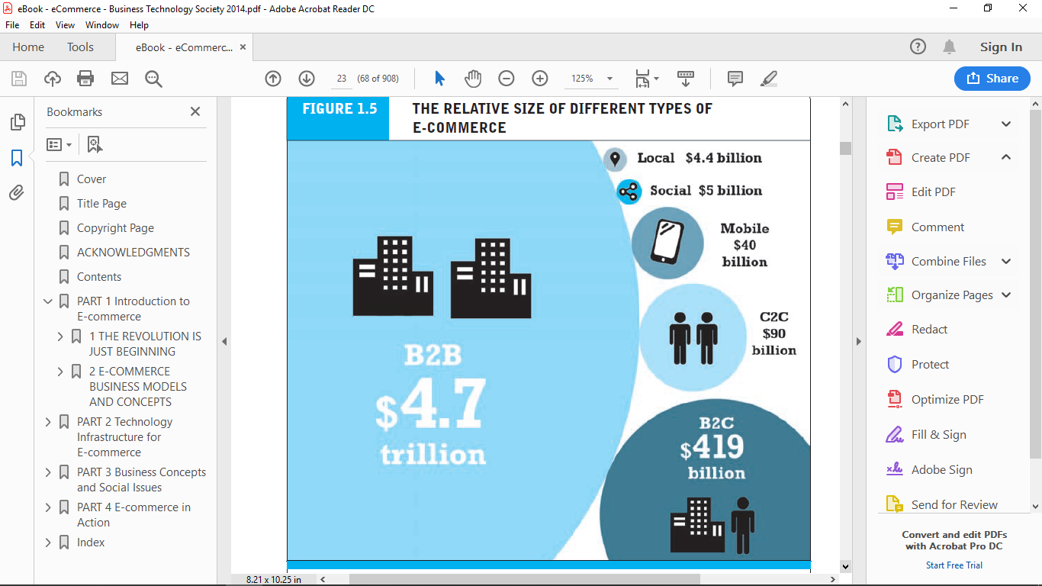

**Growth of the Internet, Web, and Mobile Platform**

The technology juggernauts behind e-commerce are the Internet, the Web, and increasingly, the mobile platform. We describe the Internet, Web, and mobile platform in some detail in next chapter. The Internet is a worldwide network of computer networks built on common standards. Created in the late 1960s to connect a small number of mainframe computers and their users, the Internet has since grown into the world’s largest network. It is impossible to say with certainty exactly how many computers and other wireless access devices such as smartphones are connected to the Internet worldwide at any one time, but the number is clearly more than 1 billion. The Internet links businesses, educational institutions, government agencies, and individuals together, and provides users with services such as e-mail, document transfer, shopping, research, instant messaging, music, videos, and news.

One way to measure the growth of the Internet is by looking at the number of Internet hosts with domain names. (An Internet host is defined by the Internet Systems Consortium as any IP address that returns a domain name in the in-addr.arpa domain, which is a special part of the DNS namespace that resolves IP addresses into domain names.) In July 2013, there were almost 1 billion Internet hosts in over 245 countries, up from just 70 million in 2000 (Internet Systems Consortium, 2013).

**The Internet** has shown extraordinary growth patterns when compared to other electronic technologies of the past. It took radio 38 years to achieve a 30% share of U.S. households. It took television 17 years to achieve a 30% share. It took only 10 years for the Internet/Web to achieve a 53% share of U.S. households once a graphical user interface was invented for the Web in 1993.

|  |
| --- |
| **Internet**, worldwide network of computer networks built on common standards |

**The World Wide Web (the Web)** is one of the most popular services that runs on the Internet infrastructure. The Web was the original “killer app” that made the Internet commercially interesting and extraordinarily popular. The Web was developed in the early 1990s and hence is of much more recent vintage than the Internet.

We describe the Web in some detail in next chapter. The Web provides access to billions of Web pages indexed by Google and other search engines. These pages are created in a language called HTML (HyperText Markup Language). HTML pages can contain text, graphics, animations, and other objects. You can find an exceptionally wide range of information on Web pages, ranging from the entire collection of public records from the Securities and Exchange Commission, to the card catalog of your local library, to millions of music tracks and videos. The Internet prior to the Web was primarily used for text communications, file transfers, and remote computing. The Web introduced far more powerful and commercially interesting, colorful multimedia capabilities of direct relevance to commerce. In essence, the Web added color, voice, and video to the Internet, creating a communications infrastructure and information storage system that rivals television, radio, magazines, and even libraries.

|  |
| --- |
| **World Wide Web (the Web)** provides easy access to Web pages |

There is no precise measurement of the number of Web pages in existence, in part because today’s search engines index only a portion of the known universe of Web pages, and also because the size of the Web universe is unknown. Google has identified over 30 trillion unique URLs, up from 1 trillion in 2008, although many of these pages do not necessarily contain unique content. Today, it is likely that Google indexes at least 120 billion Web pages, if not more. In addition to this “surface” or “visible” Web, there is also the so-called “deep Web” that is reportedly 1,000 to 5,000 times greater than the surface Web. The deep Web contains databases and other content that is not routinely indexed by search engines such as Google. Although the total size of the Web is not known, what is indisputable is that Web content has grown exponentially since 1993.

The mobile platform is the newest “latest and greatest” development in Internet infrastructure. The mobile platform provides the ability to access the Internet from a variety of mobile devices such as smartphones, tablets, and other ultra-lightweight laptop computers via wireless networks or cell phone service.

|  |
| --- |
| **mobile platform** provides the ability to access the Internet from a variety of highly mobile devices such as smartphones, tablets, and other ultra-lightweight laptop computers |

In 2013, there are over 363 million mobile devices in the United States that can be connected to the Internet (more than 1 device for each person in the United States), and that number is expected to grow to almost 400 million by 2017 (eMarketer, Inc., 2013b). **Figure 4** illustrates the rapid growth of mobile Internet access.

**Figure 4. Mobile Internet Access in the United States**

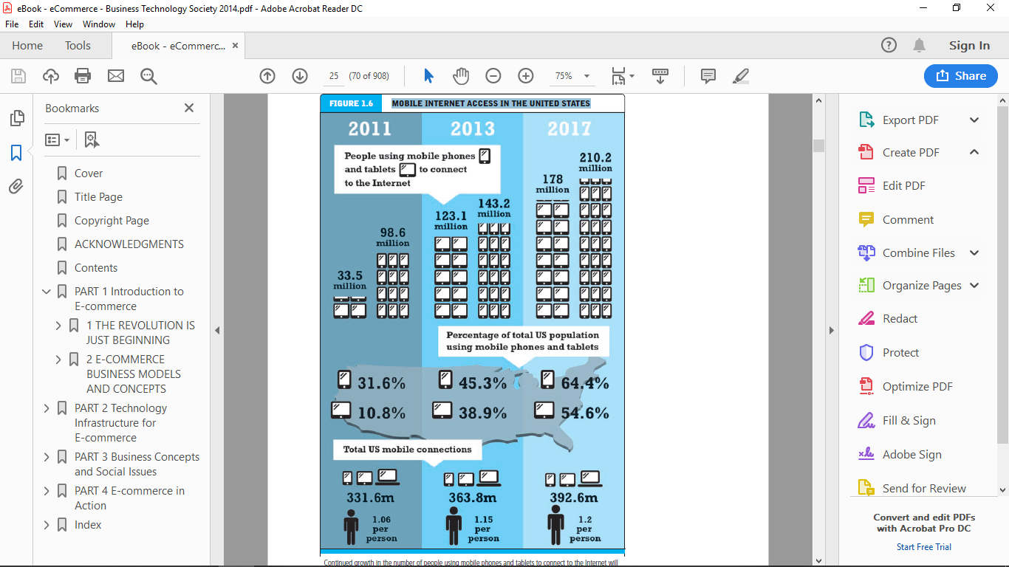

**Insight on Technology: *Will Apps Make the Web Irrelevant*? for a look at the challenge that apps and the mobile platform pose to the Web’s dominance of the Internet ecosphere**.

|  |
| --- |
| **Will Apps Make the Web Irrelevant?** |
| Nowadays, it’s hard to recall a time before the Web. How did we get along without the ability to pull up a Web browser and search for any item, learn about any topic, or play just about any type of game? Though the Web has come a remarkably long way from its humble beginnings, many experts claim that the Web’s best days are behind it, and that there’s a new sheriff in town: apps. Opinions vary widely over the future role of the Web in a world where apps have become an ever larger portion of the Internet marketspace. In 10 years, will Web browsers be forgotten relics, as we rely entirely on apps to do both our work and our play on the Internet? Will the Web and apps coexist peacefully as vital cogs in the Internet ecosystem? Or will the app craze eventually die down as tech users gravitate back towards the Web as the primary way to perform Internet-related tasks?  Apps have grown into a disruptive force ever since Apple launched its App Store in 2008. The list of industries apps have disrupted is wide-ranging: communications, media and entertainment, logistics, education, and healthcare. The average U.S. consumer spends over 2 and a half hours per day on smartphones and tablets, 80% of which is spent within apps. Despite not even existing prior to 2008, apps account for $25 billion in revenues, and the app economy is continuing to show robust growth, suggesting it is nowhere near saturated. Not only that, but the growth is not coming from more users trying the same small number of apps. Consumers are trying new apps all the time, leaving plenty of room for new app developers to innovate and create best-selling apps.  In June 2011, the amount of time users spent on apps overtook the amount of time users spent on desktops and the mobile Web for the first time. Consumers have gravitated to apps for several reasons. First, smartphones and tablet computers enable users to use apps anywhere, instead of being tethered to a desktop or having to lug a heavy laptop around. Of course, smartphones and tablets enable users to use the Web too, but apps are often more convenient and boast more streamlined, elegant interfaces than mobile Web browsers.  Not only are apps more appealing in certain ways to consumers, they are much more appealing to content creators and media companies. Apps are much easier to control and monetize than Web sites, not to mention they can’t be crawled by Google or other services. On the Web, the average price of ads per thousand impressions is falling, and after twenty years, many content providers are still mostly struggling to turn the Internet into a profitable content delivery platform. Much of software and media companies’ focus has shifted to developing mobile apps for this reason.  These trends are why some pundits boldly proclaim that “the Web is dead,” and that the shift from the Web to apps has only just started. These analysts believe that the Internet will be used to transport data, but individual app interfaces will replace the Web browser as the most common way to access and display content. Even the creator of the Web, Tim Berners-Lee, feels that the Web as we know it is being threatened. That’s not a good sign.  But there is no predictive consensus about the role of the Web in our lives in the next decade and beyond. Many analysts believe the demise of the Web has been greatly exaggerated, and that the Web boasts many advantages over today’s apps that users will be unwilling to relinquish. Although apps may be more convenient than the Web in many respects, the depth of the Web browsing experience trumps that of apps. The Web is a vibrant, diverse array of sites, and browsers have an openness and flexibility that apps lack. The connections between Web sites enhance their usefulness and value to users, and apps that instead seek to lock users in cannot offer the same experience.  Other analysts who are more optimistic about the Web’s chances to remain relevant in an increasingly app-driven online marketplace feel this way because of the emergence of HTML5. HTML5 is a new markup language that will enable more dynamic Web content and allow for browser-accessible Web apps that are as appealing as device-specific apps. In fact, there is another group of analysts who believe that apps and the Web are going to come together, with HTML5 bringing the best of the app experience to the Web, and with apps developing new Web-like capabilities. Already, work is underway to create more “smart” apps that handle a wider array of tasks than today’s apps can handle, such as Google Glasses or apps with Siri integration.  A shift towards apps and away from the Web would have a ripple effect on e-commerce firms. As the pioneer of apps and the market leader in apps, smartphones, and tablet computers, Apple stands to gain from a shift towards apps, and although they will also face increasing opposition from other companies, including Google, the established success of the App Store will make it next to impossible to dethrone them. Google’s search business is likely to suffer from all of the “walled garden” apps that it cannot access, but it also has a major stake in the world of smartphones, tablets, and apps itself with its fleet of Android-equipped devices. Facebook has already seen its members make the transition from using its site on the Web to using its mobile app, but it has yet to determine how it will monetize the app platform effectively. Web based companies that fail to find an answer to this problem may eventually fall by the wayside. The one sure bet is that nobody knows for sure exactly what the future holds for apps, the Web, and the Internet. |
| *SOURCES: “Convergence of User Experiences,” Savas.me, April 4, 2013; Simon Khalaf, “Flurry Five-Year Report: It’s an App World. The Web Just Lives in It,” Flurry.com, April 3, 2013; Eric Jackson, “Here’s Why Google and Facebook Might Completely Disappear in the Next 5 Years,” Forbes.com, April 30, 2012; Gabe Knuth, “Is The Web Dead In the Face of Native Apps? Not Likely, But Some Think So,” Brianmadden.com, March 28, 2012; Janna Quitney Anderson and Lee Rainie, “Imagining the Internet,” Pew Internet and American Life Project, March 23, 2012; Chris Anderson and Michael Wolff, “The Web is Dead. Long Live the Internet,” Wired.com, August 17, 2010; Chris Anderson, “The Web is Dead? A Debate,” Wired.com, August 17, 2010* |

**Origins and Growth of E-commerce**

It is difficult to pinpoint just when e-commerce began. There were several precursors to e-commerce. In the late 1970s, a pharmaceutical firm named Baxter Healthcare initiated a primitive form of B2B e commerce by using a telephone-based modem that permitted hospitals to reorder supplies from Baxter. This system was later expanded during the 1980s into a PC-based remote order entry system and was widely copied throughout the United States long before the Internet became a commercial environment. The 1980s saw the development of Electronic Data Interchange (EDI) standards that permitted firms to exchange commercial documents and conduct digital commercial transactions across private networks.

In the B2C arena, the first truly large-scale digitally enabled transaction system was deployed in France in 1981. The Minitel was a French videotext system that combined a telephone with an 8-inch screen. By the mid-1980s, more than 3 million Minitels were deployed, and more than 13,000 different services were available, including ticket agencies, travel services, retail products, and online banking. The Minitel service continued in existence until December 31, 2006, when it was finally discontinued by its owner, France Telecom.

However, none of these precursor systems had the functionality of the Internet. Generally, when we think of e-commerce today, it is inextricably linked to the Internet. For our purposes, we will say e commerce begins in 1995, following the appearance of the first banner advertisements placed by AT&T, Volvo, Sprint, and others on Hotwired.com in late October 1994, and the first sales of banner ad space by Netscape and Infoseek in early 1995. Since then, e-commerce has been the fastest growing form of commerce in the United States.

The data suggests that, over the next five years, B2C e-commerce in the United States will grow by about 14% annually, much faster than traditional retail sales (which are growing at only about 4% a year). There is tremendous upside potential. Today, for instance, B2C retail e-commerce is still a very small part (around 6–7%) of the overall $3.8 trillion retail market in the United States, and under current projections, will still be less than Walmart’s fiscal 2013 revenue ($466 billion) in 2017. There is obviously much room to grow (see **Figure 5**).

**Figure 5. Room to Grow**

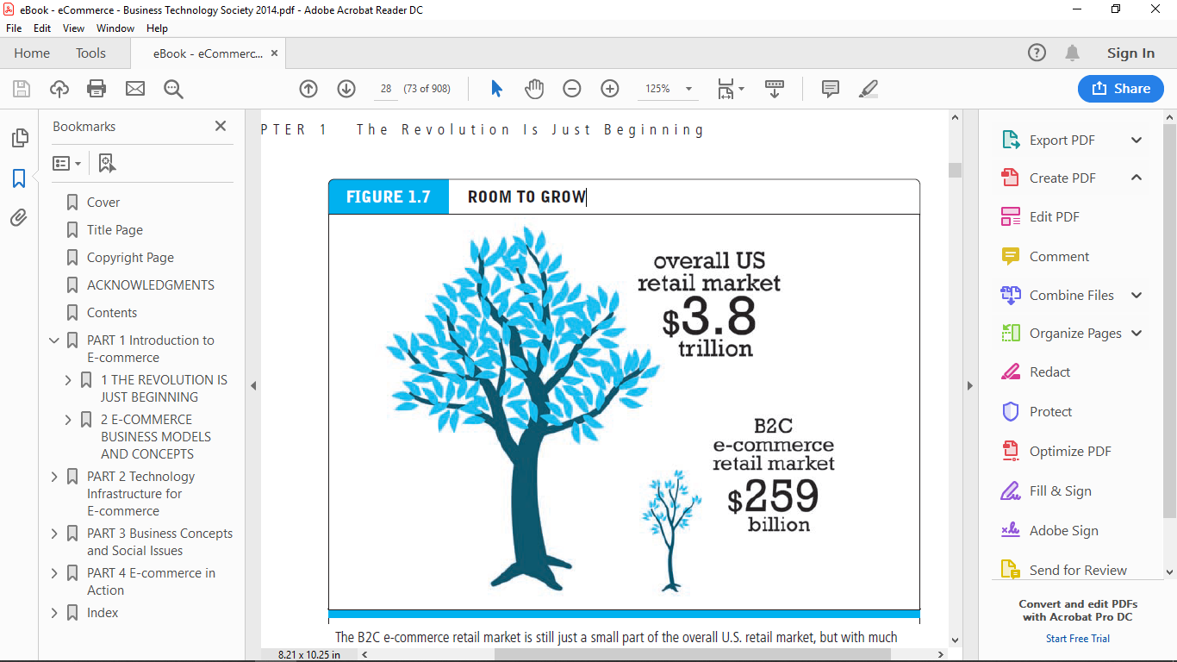

However, it’s not likely that B2C e-commerce revenues music, to video, medical information, games, and entertainment, have an even longer period to grow before they hit any ceiling effects will continue to expand forever at double-digit rates. As online sales become a larger percentage of all sales, online sales growth will likely eventually decline to that growth level. This point still appears to be a long way off. Online content sales, everything from music, to video, medical information, games, and entertainment, have an even longer period to grow before they hit any ceiling effects.