

MODUL BAHASA INGGRIS UNTUK GURU SD

(PSD 225)

Materi 13

The Principles of Lesson Plan for Micro Teaching

Disusun Oleh

Dr. Febriyantina Istiara, M.Pd

UNIVERSITAS ESA UNGGUL

2018

**The Principles of Lesson Plan for Micro Teaching**

1. **Introduction**

This module becomes a part of Teaching English for Young Learners in English Education Department. Lesson Plan for Micro Teaching is the sixth topics being discussed of this subject. It discusses how the teacher’s make a guide line in micro class activity. This module starts with the definition and the opinion of expert regarding this topic. After that, the module gives explanation of how to make a guideline and composed it into teaching classroom activity. At the end of this lesson, students are expected to be able to identify the principles of lesson plan for micro teaching.

This module can be used as reference for the students who would like to learn about The principles of lesson plan for micro teaching. The students may practice to teach according to what’s written in this module.

1. **Basic Competence**

Students are able to comprehend the basic principles of lesson plan for micro teaching

1. **Kemampuan Akhir yang Diharapkan**

* Student are able to create guidelines for planning each part of a lesson plan
* Students are able to identify the principles of lesson plan

**Learning Activities 1.**

**The Principles of Lesson Plan for Micro Teaching**

A lesson plan is designed for a specific set of learners during a single class period. The class period may vary in length from one to four hours and provides learners with instruction on skills needed to accomplish an objective from the unit plan. The lesson plan breaks the unit plan down into detail and is the direction for the class period. Adult learners appreciate instruction that is well planned and want to know the objective for the class period. Learners want to know what they will be able to do when the class ends and how it applies to their lives beyond the classroom.

Writing a lesson plan requires thinking about the skills to be taught, the objectives, timing, and procedures for the class. This section provides an explanation of how to write a lesson and a sample health lesson that aligns with the sample health unit. Writing and implementing a lesson plan takes practice and experience. It is important to be a reflective instructor as you hone your teaching skills. In the Blank Forms section, you will find the unit plan form, lesson plan form, and a page for notes where you can jot down observations, comments, and reflections on your teaching experience.

**Micro Teaching**

Micro-teaching is a scaled-down teaching encounter which has been developed at Stanford University to serve 3 purposes:

1. as preliminary experience and practice in teaching
2. as a research vehicle to explore training effects under controlled conditions
3. as an in-service training instrument for experienced teachers In micro-teaching the trainees are exposed to variables in classroom teaching without being overwhelmed by the complexity of the situation.

Microteaching is a scaled down teaching encounter. In microteaching, however, the complexities of the normal teaching encounter have been reduced and the level of feedback to the teacher has been greatly increased. Further- more, the objectives of a given microteaching lesson are neither inadvertent, as is often the case with traditional practice teaching, nor are the appraisals of the experience purely subjective and arbitrary

From a purely descriptive point of view, micro- teaching is quite simple. Its basic elements are a teacher, the micro class (usually four or five pupils), a short lesson of five to twenty minutes, and predetermined objectives which have been stated for the particular microteaching occasion.

These seemingly limited parameters can be ap- plied to purposes ranging from training, to diagnostic evaluation, to experiment with innovation. The advantages of flexibility offered by micro- teaching are matched and indeed at some points derived from concomitant advantages in economy. If the objectives that are dealt with in the microteaching setting were attempted within the traditional teacher-training environment, the re- quired educational resources would make such an experience prohibitively expensive.

In creating a microteaching setting, five essentials are combined:

1. Actual teaching takes place, even though the teacher and students are brought together specifically for practice.
2. The complexity of the normal teaching situation, including the number of students, the scope of the presentation, and the length of class time, are deliberately reduced.
3. The focus of teacher training is reduced in order to accomplish a specific task, such as the practice of instructional skills or techniques of teaching, the mastery of specific curriculum materials, or the. demonstration of a particular teaching methodology.
4. A high degree of control over such diverse elements as time, the use of students, and the methods of feedback and supervision is structured into the training situation.
5. The typical feedback dimension in teaching is greatly expanded through an immediate follow-up critique utilizing sources such as the trainee's own analysis, students' reactions, and video tape, with the assistance of a colleague or a supervisor. Generally, the evaluation focuses on one particular aspect of the teacher trainee's performance, and an attempt is made immediately to translate the suggested improvements into actual practice during a second microteaching session shortly after the critique conference.

Microteaching has evolved as one part of an experimental teacher-education program sup- ported by the Kettering and Ford foundations over the past several years. This program included research which identified specific teaching behaviors that can be isolated as observable skills as well as the development and testing of appraisal instruments that measured attainment of these skills.

Microteaching itself was a by product of this research, and continuing attempts are being made to identify new teaching skills and discover further experimental applications for microteaching. During the past seven years, both the impact of microteaching and the evaluation instruments developed for assessing teacher trainee progress have been validated.

For example, during one period of experimentation, teacher interns training ten hours per week in the microteaching clinic demonstrated a higher level of teaching competence at the end of eight weeks than did a similar group receiving separate instructions and experiences as teaching aides for an average of 20 to 25 hours per week

Mental treatment within the microteaching setting, there were positive changes in intern performance. Teacher candidates in the microteaching clinic recorded a high acceptance of the microteaching technique and credited it with greatly increasing their perceptions of weak- nesses and strengths in their own teaching performances.

Significantly, performance in the microteaching situation accurately predicted sub- sequent success in classroom teaching. When the defects of traditional teacher training programs are considered, the economy of microteaching as a method of teacher training becomes more than apparent. In traditional pro- grams, the teacher trainee must travel far and at too frequent intervals to get practice teaching experience, usually under spotty supervision with no student feedback. Microteaching offers the advantages of both the controlled laboratory environment and the reality of bona fide teaching.

It is not a substitute for practice in teaching (for example, problems of discipline and classroom control cannot at present be dealt with in microteaching settings) but, certainly, it supplies some impressive alternatives such as close supervision, manageable objectives established according to individual training needs and progress, continuous diagnostic feedback, unprecedented opportunity for self-evaluation, immediate guidance in areas of demonstrated deficiency, and an opportunity to repeat a lesson conveniently as often as desirable

Microteaching setting can provide both beginning and experienced teachers with a safe practice environment for the development of competencies in the techniques and skills of the profession. Practice is an essential prerequisite for many learning activities; a significant portion of the typical teaching day is made up of activities that are learned and can be improved upon through practice.

However, virtually all of the actual practice which occurs under the traditional preservice and in-service structure consists of on-the-job practice. On-the-job practice in a normal classroom setting has severe limitations:

1. Students are there to be taught, not practiced on
2. Practice of a specific skill or technique must fit well with- in a longer lesson specified for that particular day,
3. There is only limited opportunity to receive feedback on the skill which is practiced. Teachers can utilize the practice setting of microteachings not only for skill training but also to try out new curriculum materials and instructional techniques.

Instructional techniques. As an instrument which focuses on specific teaching skills, the second major advantage of microteaching is its potential use as a means of providing improvement in the teacher's classroom performance. In the past, one of the major barriers to improvement has been the vagueness and mystique surrounding the teaching act. The fact that there is an artistic quality in an excellent teacher's performance does not preclude the need for a more precise way of describing and improving specific aspects of the teaching act.

Teaching has been analyzed into various types of activities (for example: explaining, questioning, demonstrating), and the behaviors involved in certain teaching skills can be isolated and made the focus of training. After an individual teacher has identified a teaching activity or cluster of activities for improvement, microteaching provides a practice environment.

By eliminating irrelevant concerns and providing immediate feedback from several sources, the microteaching setting allows the teacher to concentrate and thus make great progress in acquiring improved teaching proficiency in a very short period of time. A third major contribution of microteaching is the development of a wide variety of readily available instructional skills models.

Although there are many model teachers within the school setting, their influence on other teachers is diminished by their relative isolation within their classrooms and by the difficulty that a neophyte teacher has in separating an excellent teacher's performance into smaller, more digestible parts. A combination of video tapes focusing on a model teacher's performance in the classroom and a series of specifically designed microteaching video tapes demonstrating his individual technical skills would serve as excellent models for the beginning teacher.

Opportunities for new approaches to supervision is a fourth area in which microteaching contributes unique relevance. In schools today, no one really knows what teacher supervision has accomplished. Teachers are evaluated by principals during randomly selected class periods followed months later by other observations that usually involve entirely different circumstances different instructional settings, different lessons, and perhaps even different classes, different grade levels, or different subject areas.

Teachers have no real basis for perceiving, let alone changing, ineffective teaching patterns. A microteaching clinic can provide a less threatening setting for supervision than traditional approaches to evaluation.

Although most teachers are rather sensitive about having super- visors observe them in their classrooms, a micro- teaching clinic is considered neutral territory the emphasis is on instructional help for the teacher. Whatever the specific goals of the micro- teaching lesson, both the teacher and the super- visor have a clear picture of those goals ahead of time. As a result, the critique period following the microlesson enables both the teacher and the supervisor to talk realistically about growth within the narrow range of mutual concern.

Microteaching supervision tends to be highly specific, and the teacher can immediately apply a supervisor's suggestion in a reteach session. Microteaching could be applied to obtain consistent and constructive supervision and to train supervisors in helping teachers to improve their classroom performance

A fifth use of a microteaching clinic within a school system is to test new instructional materials and techniques before their introduction to the classroom. Even the most experienced teacher can make serious misjudgments about the student experience or maturity required to learn a given set of materials or to function effectively under a new organizational structure.

The microteaching clinic would provide an opportunity for quick judgments of student receptivity toward new curricular materials or instructional techniques. Teachers would also have the opportunity to gain mastery over materials before actual tryout in the classroom. To facilitate transition from self-contained classrooms to team teaching settings, microteaching provides opportunities for fledgling teaching teams to develop new materials and to test new modes of presentation while the other team members evaluate them.

In the process, microteaching can serve as a catalytic element for bringing teachers together to discuss professional issues in light of a shared experience. It can be used as an effective neutral ground upon which to bring diverse elements within a faculty together to focus on the teaching-learning process

From its inception as a simple device for the training of secondary school teachers in a few selected teaching skills, microteaching has grown to the point where multiple specific applications are being made at all levels of education, from the elementary school to the university.

Pre- service as well as Inservice microteaching clinics and workshops have been established in many universities and public-school systems throughout the country. Microteaching techniques and research have also been implemented with in- creasing frequency in new and different ways outside of teacher training, as in medical education.

There are numerous examples of usage within the field of education. At the University of Massachusetts, the regular preservice microteaching clinic is supplemented by an intensive summer workshop to train school personnel who can then return to their systems and establish micro- teaching clinics and practices on a local basis.

At the University of Illinois, Arye Perlberg utilized microteaching in the preparation of vocational education personnel and in the refinement of teaching skills among university professors.' At the University of Maryland, David B. Young has used microteaching in teacher education centers to:

1. Train center faculty members to work with student teachers within the centers
2. To develop the teaching skills of student teachers.

Young and his associates have also used microteaching and selected self-analysis techniques at Johns Hopkins University to individualize preservice training and internships for prospective teachers.2 The use of microteaching to train Peace Corps volunteers is an excellent example of its flexibility with unique teacher-training objectives.

The microteaching clinic was adapted specifically to the preparation of the Peace Corps volunteer for the Philippines and has since become a model for other Peace Corps training programs.

Objectives for the Philippine Peace Corps clinic were:

1. To equip the volunteers with teaching skills directly related to English as a second language,
2. To acquaint them with special materials for teaching English as a second language,
3. To provide a reality test during which the volunteers could decide if they really wanted to become elementary school teachers in the Philippines for the next two years.

Since the micro classes were made up of Philippine students who had been in the United States less than six months, the microteaching sessions were much more directly related to the reality to be faced by the Peace Corps volunteers than would have been possible in a regular classroom situation.

An example of how microteaching concepts and techniques have been utilized in counseling and guidance has been provided by Allen Ivey. He and his associates3 developed the concept of micro counseling, which is a video method of training counselors in the basic skills of counseling. Micro counseling training procedures focus on these skills: attending behavior, reflection of feeling, and summarization of feeling.

Microteaching techniques and principles have been used with some effectiveness in the area of medical education. Hilliard Jason, director of the Office of Medical Education Research and Development in the College of Human Medi- cine at Michigan State University, has utilized microteaching techniques in assisting medical students to acquire the skills of relating to patients. He is developing a series of process skills utilizing patient simulation, videotaped patient- doctor relationships, immediate video playback, and supervisor-doctor critique and analysis.

Additional areas exist, both within and out- side of education, where microteaching techniques and principles appear to be useful. For example, microteaching could be useful within education for preemployment prediction as a framework for selection or rating of experienced teachers seeking employment within a school district.

This concept could also be extended to include the evaluation of current employees for possible promotion; however, it would be necessary to indicate clearly to teachers those occasions when their microteaching sessions would be utilized as the basis for evaluating their competency.

Microteaching principles and techniques might be effectively applied in the training of administrators to improve presentation skills, particularly in the area of administrator-parent communications. Such prior practice, combined with an effective supervisory critique of the administrator's micro-presentation, might result in a significant improvement in the administrator's ability to communicate with his community and might also result in an increase in the number of bond issues which are subsequently approved.

Another example of the possible application of microteaching is the training of personnel such as secretaries or receptionists. They might be trained in specific interpersonal relations skills to become more effective in dealing with the public. Teacher aides who would be working primarily with students (e.g., in open laboratories, resource centers, or cafeteria duty) could also receive such training. Potential areas outside of education would include those service areas where information is obtained by a specialist from individual clients or from groups of clients such as social workers, psychiatrists, and police officers.

Inservice teachers in diverse preparation institutions (hospitals, police academies, the military, and schools pre- paring social workers) could increase their competence through the use of microteaching procedures. Microteaching can also help to train people in the techniques of oratory and debate. Law school students could practice the skills of set induction, closure, and probing questions before a small audience. High school students, politicians, and ministers could improve speaking skills in a microteaching setting in which they could practice specific speaking skills on a small audience.

The normal classroom setting contains so many variables that precise research is virtually precluded. A major attraction of the microteaching format is that it simplifies the teaching act and provides an opportunity for real experimental control and manipulation of variables. As a teacher training technique, microteaching is in its infancy, and many issues related to its most effective use have not as yet been resolved.

There is no convincing research evidence regarding the optimal number of students for microteaching sessions. It would be useful to ex- amine the impact of student characteristics upon the success or failure of the teacher training session and the impact of a variety of different timing and sequencing arrangements within the microteaching setting. Finally, how to increase the effectiveness of the self-confrontation critique and the feedback that it supplies in training teachers to acquire specific teaching skills must be determined.

The important point here is that microteaching as a teacher training technique should proceed in light of a careful investigation of the contributions of each of its components. The microteaching situation suggests that a second major category for research experimentation might focus upon the process of learning itself. Some of the learning situations which might be investigated relate to the use of models in the training of specific teaching skills.

As noted in Allen and Ryan,4 the key issues which might be examined are as follows.

1. Is a model of a skill a more efficient aid to learning if it contains the positive and negative instances of the skill or if it contains only the positive instances?
2. To what extent does extreme exaggeration of teaching techniques in a model add to or detract from its usefulness in a training situation?
3. Is transfer of the skill to the real classroom by the teacher trainee improved by the use of models in several different contextual situations (e.g., one in a microteaching situation, one in a regular classroom, and one in a large group lecture hall)?
4. Are modeling procedures more effective in producing learning if they contain segments which show the model being reinforced for performing the desired skill?

The supervisory sessions within microteaching also provide an opportunity for investigating some basic learning phenomena related to self-confrontation situations. Examples of the kinds of issues involved are:

1. The effective- ness of various schedules of reinforcement in training particular skills
2. The effectiveness of different verbal and nonverbal reinforcers in training particular skills
3. The relative training effectiveness of pointing out positive and/or negative instances of a training use of a particular skill in a self-confrontation situation
4. The effects of training on different attitudinal sets and expectancy on the part of a supervisor
5. The investigation of supervisory techniques and cueing devices which can eventually eliminate the role of the supervisor and can make the trainee himself an adequate critic of his own teaching behavior.

A third major category of microteaching re- search would focus on the interactions between students and teachers. Teacher trainers must begin to face the problems of determining the relationships between teacher performance and student performance so that they can build empirically based justification for the objectives of their training programs.

Video tapes on which the students and the teacher are recorded simultaneously will make it possible to do this. In addition to observing the immediate effect upon student behavior of a particular teaching skill, appropriate achievement measures could be given to the micro class students to determine the long-range impact of the teaching skill upon student learning.

As researchers begin to gather evidence in this area, we can begin to utilize teacher training programs where the skills, attitudes, and understandings required by prospective teachers are supported by the empirical evidence of their efficacy in producing learning. Microteaching can and should be used as a research tool to investigate which training strategies are most effective for teacher trainees with different backgrounds and aptitudes.

At the same time, it can be used as a training strategy to give individual teachers the kind of teaching most suited to their particular abilities. Such research into alternate training routes should provide educators with a means of approaching the problem of individualizing instruction within teacher education. There is a strong probability that teachers who are prepared in such an individualized program will subsequently be much more able to develop and implement individualized instructional approaches with their students

While the four specific microteaching research categories which have been discussed are only those areas which today appear to be most fruitful, the most promising thing about microteaching as a research device is the extent to which it is open to new implementation and as yet unconceived experimental issue.

Microteaching stands today as one of the few experimental techniques which by its very structure encourages a combination of theory and practice, research and training, innovation and implementation.

The phenomenal growth and diversity of microteaching should not obscure the fact that the technique is still in its infancy. The ultimate potential of this most promising tool for both research and training depends entirely upon our imagination and our ingenuity in developing and testing new ways of applying microteaching principles and techniques to the problems of education.

They are required to teach brief lessons ( 5 to 25 minutes) in their teaching subject, to a small group of pupils (up to 5). These brief lessons allow opportunity for intense supervision, video -tape recording for immediate feedback, and the collection and utilization of student feedback.

The research to be reported in this article was done in the fourth micro - teaching summer clinic which was held as a pre – internship raining program for the Stanford Secondary Teacher Education Program for 1966. As in past micro - teaching clinics the focus was on instructing the interns in the use of certain technical skills of teaching, and allowing the interns the opportunity of practicing these skills in the micro teaching clinic under the close supervision of a trained supervisor.

**Planning and Objective of Micro Teaching**

Prior to the 1966 micro - teaching clinic a series of seminars was held to discuss, refine, and reformulate the structure and objectives of the program. The Stanford Teacher Education Program staff headed by Drs. Allen, Bush, and McDonald developed the following teaching skills for the summer clinic:

1. Reinforcement
2. Varying the Stimulus
3. Presentation Skill - Set Induction
4. Presentation Skill - Lecturing and use of A-V
5. Illustrating and Use of Examples
6. Presentation Skill - Closure
7. Student-Initiated Questions

**Description of Structure and Format**

There was also another structural change in the micro-teaching clinic this year. In previous years the interns would teach a lesson for five minutes, critique the lesson with their supervisor making use of the video -tape units, and immediately reteach the lesson over again to a new group of students.

In last year's clinic we discovered almost no behavior change from the teach to the reteach as measured by the students' ratings an hypothesis was tested this year that the reason for the lack of improvement between the teach and reteach was because there was not sufficient time between the teach and reteach to allow the intern to make sufficient behavior changes. This year the format was as follows:

1. Teach for 5 minutes
2. Critique for 10 minutes
3. Break for 15 minutes so that the intern could plan the changes to be made in the reteach lesson (during this break another intern went through a 5-minute teach and 10 minutes critique)
4. Reteach to a different group of students for 5 minutes
5. Critique for 10 minutes.

The total teaching time was 10 minutes and the total time allotted for the critique was 20 minutes. The results of our hypothesis will be discussed later in each skill's analysis and in the Summary. On the first day of the micro- teaching clinic each of the 145 interns taught a five minutes diagnostic lesson.

**What is a lesson?**

An organized set of activities designed to present one piece of your course while working toward achieving one or more learning objective.

* Lesson and Lecture have two different meanings – don’t confuse them!
* You may have more than one lesson in a 90 minutes lecture or lab.
* A lecture is a teaching technique that you can use to facilitate your lesson.

**The parts and flow of a lesson**

Every lesson is a complete segment that you create for the purposes of new learning. Keep your students in mind as you plan a lesson and ask these questions:

* Who are my students?
* What do they already know?
* Why should they learn about this?
* What must they learn?
* What must they do to learn?

The parts, or stages, of the lesson determine what the instructor and students do. Regardless of activity or lecture, each lesson should build on the last and flow seamlessly into the next.

**Using the appropriate technique**

The techniques you plan to use in your lessons depend on:

* The types of students in your class and their previous knowledge
* The type of learning you are aiming for. Some of the possibilities are listed below.
* The physical teaching environment and the available equipment and resource

**To convey information use:**

* lecture
* field trips
* discussion group
* interviewing an expert
* selected reading
* case studies
* demonstration by an expert

**Steps for Planning the Lesson**

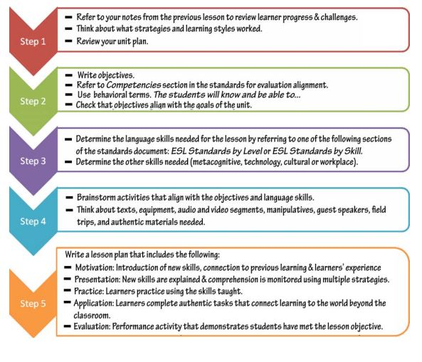

**To provide balanced presentation of a controversial subject, use**:

* discussion group
* panel discussion
* selected reading
* simulation
* debate

**To involve people, use:**

* discussion
* written work
* field trips
* case studies
* role playing
* group work
* guided experience

**To teach a skill, use:**

* demonstration by an expert
* workshop
* labs
* guided experience
* practice with feedback (coaching)

**To pool thoughts and ideas, use:**

* discussion
* brainstorming
* group work

**To reinforce memory, use:**

* drill
* memory aids
* practice with feedback (coaching)
* written work

**Resources you can use If you need help with any of the steps in your checklist, you can use one of the following instructional development job aids:**

* Increasing Student Motivation
* Managing Student Behavior in the Classroom and Lab
* Making Large Lectures Interactive
* Preparing and Using Student Handouts
* Preparing and Using Overhead Transparencies

They can be obtained from the Learning Resources Unit. Also, colleagues in your own department may have suggestions to help you to develop lesson plans that are well suited to your subject matter and students.

**Guideline for Making Lesson Plan**

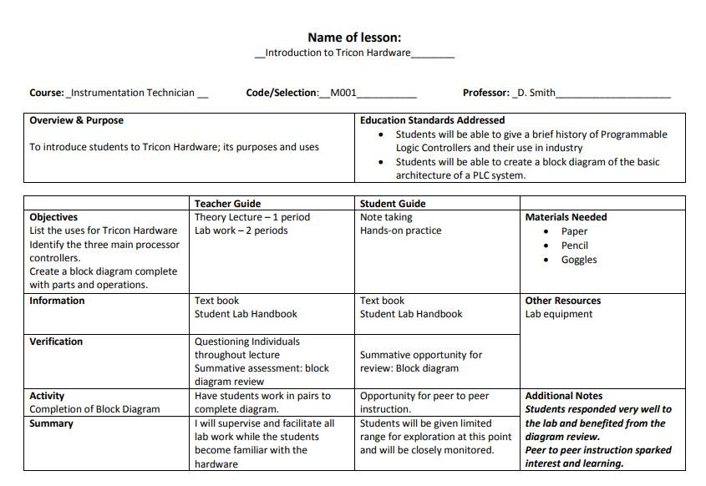

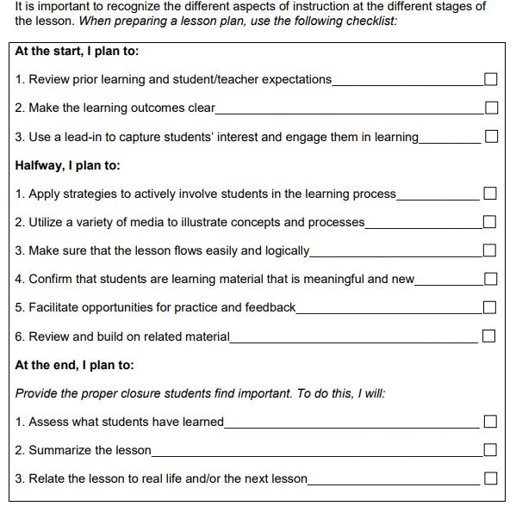

**Exercise**

1. The following statements are the steps to make a lesson plan, except:
2. Review prior learning
3. Making the learning outcomes
4. Captures the student interest
5. Make a clear verification

1. To reinforce memory you can use, except:
2. Drill
3. Memory aids
4. Coaching
5. Group Work
6. To pool an idea you can use, except
7. Discussion
8. Brainstorming
9. Group work
10. Demonstration
11. The list below is used to teach a skill besides…
12. Demonstration
13. Brain Storming
14. Coaching
15. Workshop
16. To convey information, you can use
17. Workshop
18. Coaching
19. Group Work
20. Case Study
    1. Umpan Balik dan Tindak Lanjut

Please match your answers above with answer key of formative test 1 which is located in the end of the module. Measure your topic mastery of learning activity 1 with formula given below:

Level of mastery= (total of right answers: 5) x 100%

Vey good = 90-100%

Good = 80 - 89%

Fair = 70 – 79%

Poor = 0 – 69 %

If level of mastery of the topic is more than 80%, you can continue to learning activity 2 . If level of mastery is less than 80% you need to re-do learning activity 1 especially from you have not understood part.

1. **Kegiatan Belajar 2**
   1. Uraian dan contoh

text

* 1. Latihan

text

* 1. Rangkuman

text

* 1. Tes Formatif

text

* 1. Umpan Balik dan Tindak Lanjut

text

1. **Kegiatan Belajar 3**
   1. Uraian dan contoh

text

* 1. Latihan

text

* 1. Rangkuman

text

* 1. Tes Formatif

text

* 1. Umpan Balik dan Tindak Lanjut

text

1. **Kunci Jawaban**
   1. Tes formatif 1

1. D

2. D

3. D

4. B

5. D

* 1. Tes formatif 2

text

* 1. Tes formatif 3

text

**Daftar Pustaka**

* Allen, Dwight W., and Ryan, Kevin. Micro- teaching. Reading, Massachusetts: Addison-Wesley Publishing Co. (in press)
* Allen, D.W. and Eve, A.W. (1968) : 'Microteaching' Theory into practice 7(5) P.185.
* Allen, £>.W. and Ryan, K.A. (1969) : Microteaching, Addison : Wesky, Reading Massachusetts, California.
* Ailed, D.W. (1975): 'Introduction' in Ivey and J. Authir 'Microteaching' II ed. C.C.Thomas Illinois, U.S.A.
* Anderson, L.W. and Blak, J.H. (1987): 'Mastery Learning' In Dunkin M.J., Encyclopaedia of Teaching and Teacher Education: Oxford, Pergamon Press.
* Asian Institute for Teacher Education (1972) : Identification of Technical Teaching Skills of Teaching and Development of Training Material Together with Suggestions for the Development of a Model for Analyzing Classroom : AITE
* Bandura, A., (1977) : 'Social Learning Theory1 Englewood Clifts, New Jersey : Prince Hall Inc.
* Best, T.W., (1983): 1 Research in Education1, New Delhi: Prentice Hall of India Private Limited.
* Bhalwankar, A.G. and Joshi, A.N. (1981): Process-Process Appraising Scale of Teacher Effectiveness: Pune: S.N.D.T. College of Education.
* Bindra, D. (1976): *A Theory of Intelligent Behaviour' New York :
* John Wiley and Sons Inc. Blair, J.S. "Educational Psychology" (1963) New York : The MacMillan Co.
* <https://www.ontariolearn.com/checklist/4ii%20Howtowritelessonplans.pdf>
* <https://www.dllr.state.md.us/gedmd/cs/eslcslesson.pdf>
* <http://northernc.on.ca/leid/docs/lessonplanning.pdf>