**BASIC WRITING**

**COMPOSITION ABOUT FAMILY**

**MEIYANTI NURCHAERANI S.S.,M.HUM**

**UNIVERSITAS ESA UNGGUL**

**JAKARTA**

**2018 – 2019**

**Learning Outcomes**

Students are able to write a composition related to family members and their relationship

**Creating an Outline for an Essay**

Most analytical, interpretive, or persuasive essays tend to follow the same basic pattern. This page should help you formulate effective outlines for most of the essays that you will write.

Introduction

1. Sentence to get the attention of your readers:

2. One-sentence thesis statement:

**Body**

1. First main idea:

a. Supporting evidence for the first idea:

b. Supporting evidence for the first idea:

c. Supporting evidence for the first idea:

2. Second main idea:

a. Supporting evidence for second main idea:

b. Supporting evidence for second main idea:

c. Supporting evidence for second main idea:

3. Third main idea:

a. Supporting evidence for third main idea:

b. Supporting evidence for third main idea:

c. Supporting evidence for third main idea:

**Conclusion**

1. Restatement of your thesis:

2. Insightful sentence to end your essay:

Sample of Outlining

I. INTRODUCTION

Introduction sentence

Thesis statement

Background information about the family

II. BODY PARAGRAPHS

Paragraph 1: a) Justify why the family is important; b) Share some of the personal experience within the family.

Paragraph 2: a) Supporting the thesis statement; b) Details about the meaning and the importance of a family.

Paragraph 3: The third supporting point about the importance of family.

III. CONCLUSION

Restating the thesis statement

Summarizing the main points

Making the final, conclusive sentence.

**Sample of Paragraph**

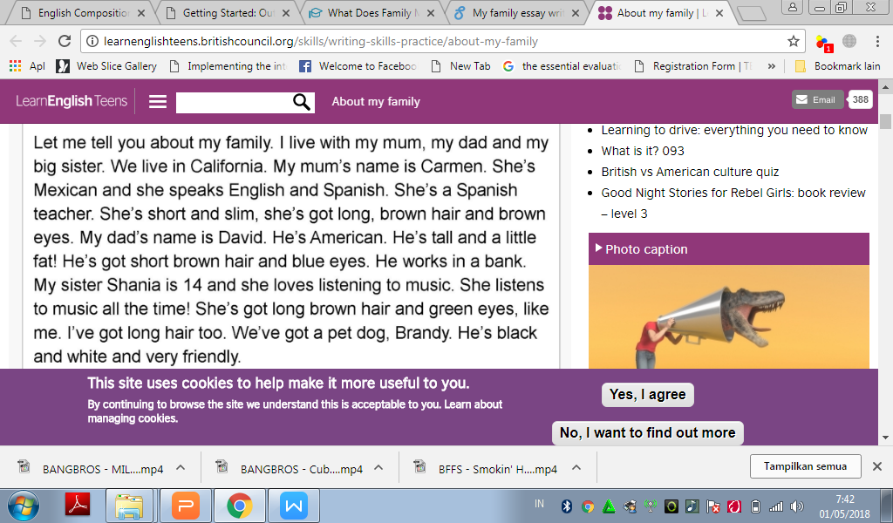

**Revise**

Let me tell you about my family. Firstly, I have very big family. I live with my mum, my dad, my two little sisters and my two little brothers. We live in france. My mum's name is Béatrice. She's camerounian and she speak french and much traditional languages of cameroon. She's saleswoman. She's short an a bit fat, she'is got short, black hair and brown eyes. My dad's name is paul. He's camerounian too. He'is tall and slim! he's got short black hair and green eyes. He's accounting. My first sister kevine is 14 and she has a mental handicap. She loves watch TV. She's watches TV all the time! she's got long black hair and green eyes, i love her particularly. My another sister is 18 months. She's got short black hair and brown eyes. My two little brothers are a twins. They've short brown, hair and brown eyes together. I've short black hair and green eyes, I loves all my family. We don't have any animals.

**References**

Anker, Susan.(2009). *Real Writing with Reading* . NY: Bedford.

Brook Guy and Vanessa Jakeman.(2013).*Complete IELTS*. Cambridge: Cambridge University Press.

http://www2.ivcc.edu/rambo/eng1002/outline.htm.

http://learnenglishteens.britishcouncil.org/skills/writing-skills-practice/about-my-family