**PASSIVE VOICE**

**BASIC GRAMMAR**

**MEIYANTI NURCHAERANI S.S.,M.HUM**

**UNIVERSITAS ESA UNGGUL JAKARTA**

**2018-2019**

ENGLISH GRAMMAR

The Passive Voice 1

**THE PASSIVE VOICE INTRODUCTION**

The passive of an active tense is formed by putting the verb to be into the same tense as the active verb and adding the past participle of the active verb. The subject of the active verb becomes the ‘agent’ of the passive verb. The agent is very often not mentioned. When it is mentioned it is preceded by by and placed at the end of the clause.

Active: My grandfather planted this tree.

Passive: This tree was planted by my grandfather.

PASSIVE VERB TENSES TO ACTIVE VOICE PASSIVE VOICE

Present Simple

He delivers the letters. The letters are delivered.

Past Simple

He delivered the letters. The letters were delivered.

Future Simple

He will deliver the letters. The letters will be delivered.

Present Continuous

He is delivering the letters. The letters are being delivered.

Past Continuous

He was delivering the letters. The letters were being delivered.

Going to He is going to deliver the letters. The letters are going to be delivered.

Present Perfect

He has delivered the letters. The letters have been delivered.

Past Perfect

He had delivered the letters. The letters had been delivered.

Infinitive

He has to deliver the letters. The letters have to be delivered.

Modals

He must deliver the letters. The letters must be delivered.

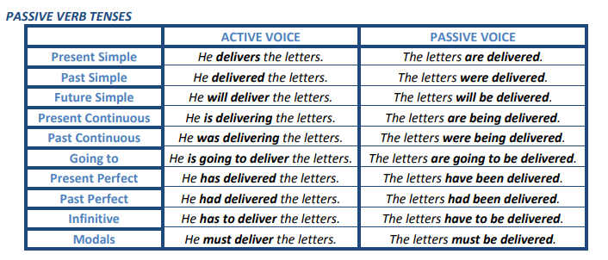

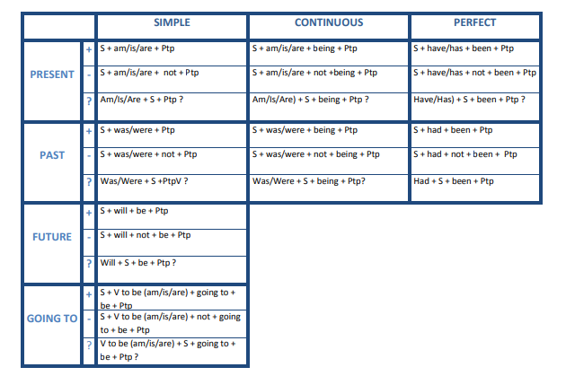

We use the verb to be (am/is/are/was/were) for Present Simple, Past Simple, Present Continuous, Past Continuous and Going To questions.

• we use the verb have (have/has/had) for Present Perfect and Past Perfect questions.

• we use will for Future Simple questions.

**USE**

The Passive is used:

1. when the agent (=the person who does the action) is unknown, unimportant or obvious from the context.

Jane was shot. (We don’t know who shot her.)

This church was built in 1815. (Unimportant agent)

He has been arrested. (Obviously by the police)

1. to make more polite or formal statements.

The car hasn’t been cleaned. (more polite) (You haven’t cleaned the car. – less polite)

1. when the action is more important than the agent, as in processes, instructions, events, reports, headlines, new items, and advertisements.

30 people were killed in the earthquake.

1. to put emphasis on the agent.

The new library will be opened by the Queen.

**AGENT**

To say who did the action that we are talking about, ie. to refer to the agent, we use the preposition by and the name (by Peter) , noun (by the teacher) or pronoun (by him) at the end of the sentence.

We usually only refer to the agent when it gives us some important information which otherwise would be missing from the sentence.

Our house was designed by a famous architect.

We don’t mention the agent:

1. if we don’t know who has done what we are talking about.

Our car was stolen last night. (We don’t know who stole it)

2. if we are not interested in who has done what we are talking about or it is not important to mention it.

He has been taken to hospital. (What we are interested in is the fact that he has been taken to hospital and not who has taken him.)

3. if it is easy to understand who did something without it being mentioned.

The murderer was arrested last night. (It is not necessary to mention that he has been arrested by the police because it is self-evident.)

4. if the subject of the active voice sentence is something like somebody, people, they, you, etc.

Someone broke the window. → The window was broken.

**ACTIVE TO PASSIVE**

To change a sentence from the active voice to the passive voice:

• the object of the active voice sentence becomes the subject of the passive voice sentence.

Agatha Christie wrote this book. This book was written by Agatha Christie.

• we change the main verb of the active voice sentence into the passive voice. The tense remains unchanged.

• the subject of the active voice sentence becomes the agent of the passive sentence. It is placed after the past participle and it is preceded by the preposition by.

ENGLISH GRAMMAR

The Passive Voice 3

Agatha Christie wrote this book. This book was written by Agatha Christie.

Leslie took this photograph yesterday.

SUBJECT ACTIVE VERB OBJECT TIME COMPLEMENT

This photograph was taken by Leslie yesterday.

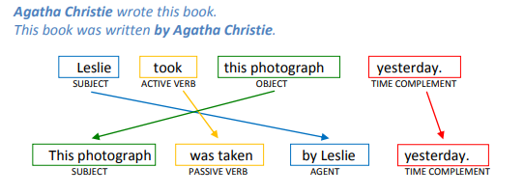

**SUBJECT PASSIVE VERB AGENT TIME COMPLEMENT**

**BY OR WITH?**

In the passive voice, we use:

• by with the agent to refer to by whom the action is being done.

The door was opened by Mr Black. (Mr Blak = agent)

• with to refer to the instrument, object or material that was used for something to be done.

The door was opened with a key. (a key = the object that was used)

The omelette was made with eggs, cheese and peppers.

(eggs, cheese and peppers = the material that was used)

DOUBLE OBJECT VERBS

When we have verbs that take two objects like,

for example, give somebody something, we can convert the active sentence into a passive one in two ways:

a. by making the indirect (animate) object the subject of the passive voice sentence, which is also the way that we usually prefer.

b. By making the direct (inanimate) object the subject of the passive voice.

Rick gave me (indirect object) this book (direct object).

I was given this book by Rick.

This book was given to me by Rick.

Some of the verbs that take two objects are:

give, tell, send, show, bring, write, offer, pay, etc.

When the indirect object is alone after the verb in the passive voice sentence, it needs the preposition to. If the indirect object of the active voice sentence is a personal pronoun it has to be changed into a subject pronoun to be the subject of the passive voice sentence.

SUBJECT OBJECT I ←→ me SUBJECT OBJECT

You ←→ you We ←→ us He ←→ him You ←→ you She ←→ her They ←→ them It ←→ it

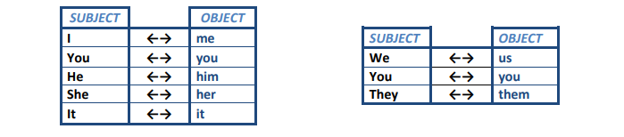

**BIBLIOGRAPHY**

A.J. Thomson and A.V. Martinet, A Practical English Grammar, Oxford University Press, 1986 - V.

Evans, Round-Up (English Grammar Practice), Longman, 1995 –

M. Carling and S. Jervis, Grammar Time 4, Longman, 2003 –

S. Jervis, Grammar Time 5, Longman, 2003 –

M. Carling, Grammar Time 6, Longman, 2003 4

<https://inglescarmelitaslb.files.wordpress.com/2011/03/the-passive-voice1.pdf>

EXERCISES 1.

Complete the sentences with the correct passive form of the verbs in brackets. Use the Present Simple.

a. English ____________________ (speak) in many countries.

b. The post ______________________ (deliver) at about 7 o’clock every morning.

c. ______________________________ (the building/use) any more?

d. How often ______________________________ (the Olympic Games(hold)?

e. How _______________________ (your name/spell)?

f. My salary _____________________ (pay) every month.

g. These cars _________________________ (not make) in Japan. h. The name of the people who committed the crime _____________________ (not know).

i. His travel expenses ________________________ (not pay) by his company.

2. Complete the sentences with the correct passive form of the verbs in brackets. Use the Past Simple.

a. My car ______________________ (repair) last week.

b. This song ________________________ (not write) by John Lennon.

c. ________________________________ (the phone/answer) by a young girl?

d. The film ________________________ (make) ten years ago.

e. When ______________________________ (tennis/invent)?

f. The car ________________________ (not damaged) in the accident.

g. The original building _________________________ (pull) down in 1965.

h. Where ______________________________ (this pot/make)?

i. When _______________________________ (this bridge/build)?

3. Choose the correct form of the verbs in brackets.

FIAT

Fiat 0 was started (started/was started) by a group of Italian businessmen in 1899. In 1903, Fiat, 1 _________________ (produced/was produced) 132 cars. Some of these cars 2 _____________________ (exported/were exported) by the company to the United States and Britain. In 1920, Fiat 3 _________________ (started/was started) making cars at a new factory at Lingotto, near Turin. There was a track on the roof where the cars 4 ____________________ (tested/were tested) by technicians. In 1936, Fiat launched the Fiat 500. This car 5 ____________________ (called/was called) the Topolino – the Italian name for Mickey Mouse. The company grew, and in 1963 Fiat 6 _____________________ (exported/was exported) more than 300,000 vehicles. Today, Fiat is based in Turin, and its cars 7 _________________ (sold/are sold) all over the world.

4. Change the following sentences into passive sentences using the words in brackets.

a. We sell tickets for all shows at the Box Office. (Tickets for all shows/sell/at the Box Office) _________________________________________________________________________________

b. Thomas Edison invented the electric light bulb. (The electric light bulb/invent/by Thomas Edison) _________________________________________________________________________________

c. Someone painted the office last week. (The office/paint/last week) _________________________________________________________________________________

d. Several people saw the accident. (The accident/see/by several people) _________________________________________________________________________________

e. Where do they make these video recorders? (Where/these video recorders/make) _________________________________________________________________________________

ENGLISH GRAMMAR

The Passive Voice 5

5. Rewrite these sentences in the passive voice.

a. Someone built this house 200 years ago.

________________________________________________________________

______________

b. A thief stole my purse.

_________________________________________________________________________________

c. The police will arrest the robbers.

_________________________________________________________________________________

d. They produce cars in this factory.

_________________________________________________________________________________

e. They serve breakfast at eight o’clock every day.

_________________________________________________________________________________

f. People throw away tones of rubbish every day.

_________________________________________________________________________________

g. They make coffee in Brazil.

_________________________________________________________________________________

h. Someone stole Jim’s bike lat night.

_________________________________________________________________________________

6. Rewrite these sentences in the passive voice.

a. They will build a new bridge next year.

_________________________________________________________________________________

b. Brian Brody directed The Ultimate Space Adventure.

_________________________________________________________________________________

c. Pierre Matie will design her costume.

_________________________________________________________________________________

d. Someone found my wallet.

_________________________________________________________________________________

e. One of the students broke the window.

_________________________________________________________________________________

f. They will deliver my computer on Monday.

_________________________________________________________________________________

g. Mary invited Paul to her birthday party.

_________________________________________________________________

_______________

h. British astronomers discovered a new planet.

_________________________________________________________________________________

7. Form the question.

a. Paper is made from wood. Is paper made from wood ?

b. The telephone was invented by Mr Bell.

___________________________________________?

c. This picture was painted by Peter.

___________________________________________?

d. The thieves will be arrested by the police.

___________________________________________?

e. Champagne is made in France.

___________________________________________?

f. The letters will be sent next week.

___________________________________________?

g. The animals are fed three times a day.

___________________________________________?

h. This article was written by Stanley.

___________________________________________?

6.CDs are made of plastic.

___________________________________________?

j. The party was organised by Paul.

___________________________________________?

8. Read and complete. Use Past Simple.

a. The toothbrush / invent / in the 15th century. _________________________________________________________________________________

b. The first public basketball game / play / in 1892. _________________________________________________________________________________

c. The first eyeglasses / wear / in the 1200s. _________________________________________________________________________________

d. The first bicycle / ride in 1791. _________________________________________________________________________________

e. The first hot dog / eat / in the 1860s. _________________________________________________________________________________

f. The first CDs / sell / in the 1980s. _________________________________________________________________________________

g. The first electric guitar / play / in 1923. _________________________________________________________________________________

h. The first computer mouse / use / 1964. _________________________________________________________________________________

9. Complete with the passive.

Use Present Simple.

a. This programme _______________________ (watch) by millions of people.

b. Paper __________________________ (make) from wood.

c. Hundreds of people _______________________ (kill) in accidents every year.

d. London __________________________ (visit) by thousands of tourists every year.

e. The biology class _________________________ (teach) by Mr Green.

f. English _____________________ (speak) all over the world.

g. Lunch _____________________ (serve) at twelve o’clock.

h. Books _____________________ (write) by authors.

10. Put the verbs in brackets into Past Simple Passive.

Two men _________________________ (see) breaking into a house in my street last night. The police _____________________ (call) and they arrived very quickly. One man _____________________ (catch) immediately. The other escaped, but he ______________________ (find) very soon. Both men _____________________ (take) to the police station where they _________________________ (question) separately by a police officer. The two men ________________________ (charge) with burglary.

11. Rewrite the following passage in the Passive. Somebody has stolen a bus from outside the school. Some children saw the thief. The police are searching for the bus now. They will use the children’s descriptions to catch the thief. ____________________________________________________________________________________ ____________________________________________________________________________________ ____________________________________________________________________________________

ENGLISH GRAMMAR

The Passive Voice 7

12. Rewrite the following passage in the Passive.

Some people saw a UFO in the sky above London last night. They reported it to the police. The army sent a helicopter to look at it more closer. The UFO shot the helicopter down and killed both men in it. People have given photographs of the UFO to the police. Experts are looking at them now.

____________________________________________________________________________________ ____________________________________________________________________________________ ____________________________________________________________________________________ ____________________________________________________________________________________ ____________________________________________________________________________________

13. Rewrite the following passage in the Passive.

Someone broke into a local jewellery shop yesterday. The owner had just locked up the shop when a robber with a gun threatened him. The robber told him to unlock the shop and give him all the diamonds in the safe. Then the robber tied him up. The police have organized a search for the robber. They hope they will find him in a few days. Doctors are treating the owner of the shop for shock.

____________________________________________________________________________________ ____________________________________________________________________________________ ____________________________________________________________________________________ ____________________________________________________________________________________ ____________________________________________________________________________________ ____________________________________________________________________________________

14. Rewrite the following passage in the Passive. My uncle painted this picture. Someone has offered him a lot of money for it. He will deliver the painting tomorrow. When they give him the money, he will tell them the truth. He painted it one night while he was sleepwalking!

____________________________________________________________________________________ ____________________________________________________________________________________ ____________________________________________________________________________________ ____________________________________________________________________________________

15. Rewrite the following passage in the Passive.

Our school is organizing a contest. The teachers will choose the best project about the environment. The students must include pictures and drawings in their projects. The students will also have to do all the writing themselves. The school will give the winner a set of encyclopaedias.

____________________________________________________________________________________ ____________________________________________________________________________________ ____________________________________________________________________________________ ____________________________________________________________________________________

16. Turn from Active to Passive in two ways.

a. He gave me a present.

______________________________________________________________ _________________________________________________________________________________

b. The waiter will bring us the bill

_______________________________________________________ _________________________________________________________________________________

c. Her mother bought Mary some sweets.

_________________________________________________ _________________________________________________________________________________

d. Bob has sold Ted a second-hand car.

___________________________________________________ 8 _________________________________________________________________________________

e. Larry is going to send a letter to Tom.

__________________________________________________ _________________________________________________________________________________

17. Turn from Active to Passive.

a. Someone is helping her with the housework.

_________________________________________________________________________________

b. The mail-order company sent Mrs Green a parcel.

_________________________________________________________________________________

c. My friend sent me an invitation.

_________________________________________________________________________________

d. The secretary has given Mrs Jones some letters.

_________________________________________________________________________________

e. The traffic warden had already given him a ticket for illegal parking.

_________________________________________________________________________________

f. John gave Elizabeth that beautiful ring.

_________________________________________________________________________________

g. Her students have sent her flowers.

_________________________________________________________________________________

h. He must give the message to the right person. _________________________________________________________________________________

i. We teach our students English and French.

_________________________________________________________________________________

j. Someone bought flowers for the bride.

_________________________________________________________________________________

k. They showed the tourists the sights of Athens.

_________________________________________________________________________________

l. They pay her an excellent salary.

________________________________________________________________________________

m. They paid the artist £1,000 for his painting.

_________________________________________________________________________________

18. Rewrite these sentences in the passive voice.

1. They sell oysters in the shop next door.

_________________________________________________________________________________

2. They haven’t delivered the food yet.

_________________________________________________________________________________

3. Shakespeare wrote King Lear.

_________________________________________________________________________________

4. They have to answer the questions on this sheet.

_________________________________________________________________________________

5. Has anybody put the cases upstairs?

_________________________________________________________________________________

6. Someone should take this rubbish away.

_________________________________________________________________________________

7. They’ll ask you a lot of questions.

_________________________________________________________________________________

8. Someone’s going to send her some flowers.

_________________________________________________________________

_______________

ENGLISH GRAMMAR

The Passive Voice 9

9. They didn’t pay me much for that job.

_________________________________________________________________________________

10. Have they offered him a better job?

_______________________________________________________________________________

11. They told us a secret.

_________________________________________________________________________________

12. Would they lend me their car?

_________________________________________________________________________________

13. People should send their complaints to the head office.

_________________________________________________________________________________

14. They had to postpone the meeting because of illness.

_________________________________________________________________________________

15. They are going to hold next year’s congress in San Francisco.

_________________________________________________________________________________

16. The bill includes service.

_________________________________________________________________________________

17. People don’t use this road very often.

_________________________________________________________________________________

18. They cancelled all the flights because of fog.

_________________________________________________________________

_______________

19. Somebody accused me of stealing the money.

_________________________________________________________________________________

20. They are building a new ring-road round the city.

_________________________________________________________________________________

21. I didn’t realize that someone was recording our conversation.

_________________________________________________________________________________

22. They have changed the date of the meeting.

_________________________________________________________________________________

23. Brian told me that somebody had attacked and robbed him in the street.

_________________________________________________________________________________

24. You should open the wine about three hours before you use it.

_________________________________________________________________________________

25. Somebody had cleaned my shoes and brushed my suit.

_________________________________________________________________________________

26. We use this room only on special occasions.

_________________________________________________________________________________

27. In some districts farmers use pigs to find truffles.

_________________________________________________________________________________

28. John gave Elizabeth that beautiful ring.

_________________________________________________________________________________

29. They have offered Sarah a very good job.

_________________________________________________________________________________

30. The estate agent showed the house to the young people.

_________________________________________________________________________________

31. We will pay the gardener a lot of money.

_________________________________________________________________________________

32. Someone is going to repair the roof next week.

_________________________________________________________________________________

10

33. They can’t find Joanna.

_________________________________________________________________________________

34. They should decorate the room with flowers.

_________________________________________________________________________________

35. Archaeologists have discovered an ancient temple.

_________________________________________________________________________________

36. We will put all these things into boxes.

_________________________________________________________________________________

37. The firefighters rescued the teenagers from the burning building.

_________________________________________________________________________________

38. The youngest student in the class has written the best composition.

_________________________________________________________________________________

39. The children send me messages every day.

_________________________________________________________________________________

40. The villagers gave the travellers food and water.

_________________________________________________________________________________

41. A very talented young girl wrote the story.

_________________________________________________________________________________

42. They are going to finish the new road in a few days.

_________________________________________________________________________________

43. They cancelled the match because of the rain.

_________________________________________________________________________________

44. You must not cross this line

_________________________________________________________________________________

45. They had picked the oranges before the storm.

_________________________________________________________________________________

46. Professor Smith should write the book.

_________________________________________________________________________________

47. Mr Elliot will pay the workers.

_________________________________________________________________________________

48. Two men were following Tom.

_________________________________________________________________________________

49. Millions of people use the Internet every day.

_________________________________________________________________________________

50. They gave Bob a CD player for his birthday.

_________________________________________________________________________________

51. The prime minister will give a medal to the winners.

_________________________________________________________________________________

52. She is telling the children a story.

_________________________________________________________________________________

53. They’ve offered Sally a job.

_________________________________________________________________________________

54. Poisonous chemicals have polluted the river.

_________________________________________________________________________________

55. Doctor Simms is examining her.

_________________________________________________________________________________

56. You must stop him now.

_________________________________________________________________________________

57. Someone gave them free tickets for the concert.

_________________________________________________________________________________