**TEACHING ENGLISH FOR YOUNG LEARNERS**

**BAHASA INGGRIS UNTUK GURU SD**

OLEH

DR. FEBRIYANTINA ISTIARA, M.PD

DOSEN UNIVERSITAS ESA UNGGUL

**A. INTRODUCTION**

This chapter will introduce you to teaching English to young learners (TEYL). You will learn about the growth of English of global language, the advantages of early language learning, the various kinds of programs models used around the world some of the problems associated with TEYL and various teaching practices that have been found to be effective in teaching English to young learners.

You will have the opportunity to reflect on the readings and discuss key questions related to the chapter. To help you apply new knowledge, you will respond and you will hear the voices of teacher in the field who share their experiences teaching English to young learners.

It has already been more than a decade English is given to children in elementary school in Indonesia as a local content. Elementary school may take English as one of the school subjects when all the need for English for young learners’ implementation is provided. The implementation of teaching English in elementary school is far from idealism. There are many problems faced by the institution especially the teachers, the problems are caused by different understandings to the principles.

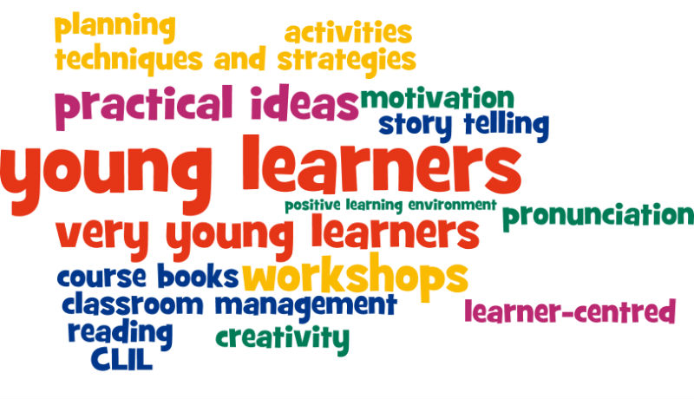Picture 1. Foreign Language Learning at Primary Level

* One aspect of globalization is the growing trend for using English as a world language which has led to the introduction of English language learning by many children in many countries all over the world.
* A believe that “young children learn language better more easily than older children” lead the government and private school over the world have decided to introduce English at primary level.
* Globalization of the world has caused people can more easily come into contact with other cultures and languages through travel, communication or new technology.
* Pressure to introduce early English learning has often come from the parents who strongly believe that having English as a tool will benefit their children greatly by giving them more opportunities to gain economic, cultural or educational advantages.



Picture 2. Teaching English For Children

**B. Teaching English for Young Learners**

Young learnersrefer to elementary school students from the first graders to the sixth graders. Sometimes they are grouped in to primary and higher beginners. Primary beginners are those Teaching English For Young learners (teyl) Misunderstandings About Teyl in Elementary School first, second, and third grade. While the students in the fourth, fifth, and sixth grades belong to the higher beginners. Teaching English to young learners is not only a process of transferring a new language to children. Moreover, it needs many considerations. The considerations are related to the readiness of a school in implementing the teaching and learning process. Some schools see English subject only as a subject, which should be given to the students. English subject is seen as the demand of the curriculum from the government or educational institution. Teaching a foreign language to young learners should be given based on the student needs. The process of teaching and learning will give effect to their next experience. A teacher should be concerned with the process because it is not only a kind of experiment to the students. The responsibility of the teacher is giving the basic knowledge to the students and it will be the foundation to the next development. The basic understanding about educational philosophy above will be the step of a school or a teacher in the teaching and learning process. Here are some misunderstandings about teaching English to young learners.

**1. Teaching English to young learners is straight forward**

In our society, teaching children is seen as an extension of mothering rather than as intellectual enterprise. Some people perceive that teaching children is simpler than teaching adult. It does not need a high awareness. It is proven by the teacher qualification. Some teachers think that they do not need more skills in their teaching.

They feel confident enough using their past experience as their step in teaching process. Teaching language to children needs all the skills of the good primary teacher in managing children and keeping them on task, plus knowledge of the language, of language teaching, and language learning. An English teacher, before teaching, should understand the children needs and goals, kinds of teaching approach, and teaching techniques. In detailed, a teacher should translate and interpret the curriculum components, objective, methodology material and evaluation. Teacher actually has responsibility to be :

1. An adviser who has closed relationship with young learners
2. A helper who can help the students difficulties
3. A model in practicing the language. It consists of pronunciation, spelling and also grammar.
4. As facilitator in giving facility to the student needs
5. As decision maker in deciding the suitable method and technique for the students in addition, that the limitation of children in viewing the world did not imply that teaching children is simple or straight forward. The teacher needs to be highly skilled to reach into children’s world and lead them to develop their understanding towards more formal, more extensive and differently organized concept. The teacher must put both psychological understanding and intellectual understanding.

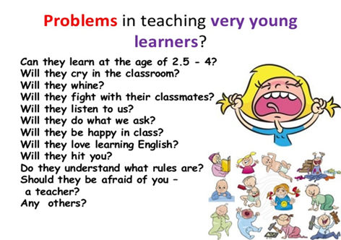

Picture 3. Problems in teaching to young learners

**2. Children only need to learn simple language**

It is about people perception. Some people think that children can study a simple language. In teaching language, a teacher may give a simple language to young learners. In a class for example, an English teacher just teach, color, name of fruits or animals. In their daily experience, children live in a community; they can communicate with other people.

They can explore many things related to what they see and feel. However, they need more than simple language in their communication. that a child has ability to interact with and lead people with understanding by interpreting their intensions, needs, emotions, and desires. When we are talking about children ability, it will be related to children potential. Children potential is more than we ever think. They, sometimes, are interested in abstract thing and difficult thing. When they meet something works, they will ask a question, how does it work? or How can it be?. In teaching language, it is not enough when a teacher only teach the students about vocabularies. They need more than it.

**3. Hyperactive children will be a problem for teacher**

Every learner has their own characteristics. It is an individual character grows up along with the progress of their life in general. not easy to mention a specific character that applies to all individual One of young learners’ characteristics is that they are very active. We often meet the students in a class like to move around. Young learners are bored when a teacher just considers the students passive.

They will move to another place, because they like to feel busy. A teacher, usually, will ask the students to keep silent. He/she does not allow the students to move around. He/she thinks that it will disturb the learning process. Therefore, in teacher perception that it is better when the students are sitting quietly and listening to the teacher explanation. Children like learning by doing. They like playing and to be active in the learning process. A teacher, hopefully, employs the students’ characteristic to create the interesting methods and techniques. Teachers can accommodate the students’ characteristic to create techniques that allowed the students to be active in the class.

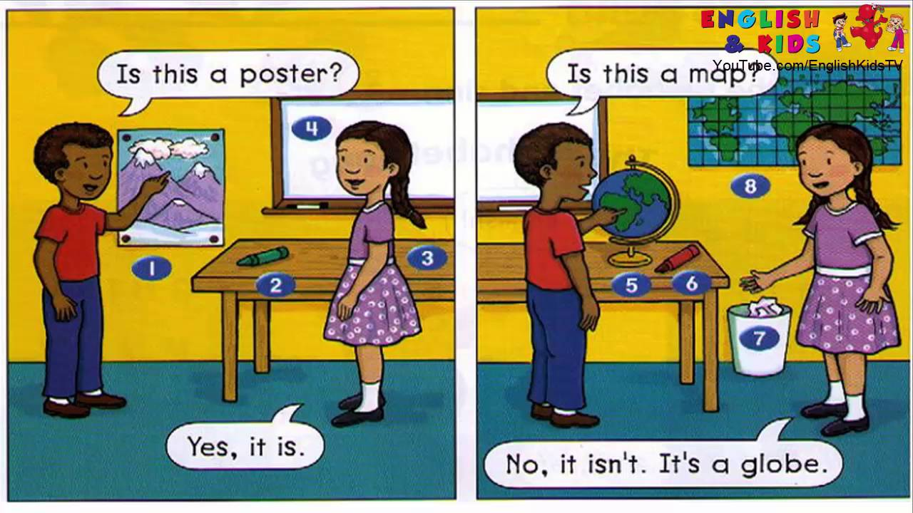

Picture 4.Media Teaching English For Young Learners

**4. Media for TEYL is difficult to get**

Media is one of the factors that influence EYL learning. Teaching English for young learners will be effective when a teacher uses a media in learning process. There are many media that can be used by a teacher, like puppet, pictures, and card. Some elementary school teachers perceive that they are difficult to get a good media.

They think that a good media is very expensive. In their daily class, they just transfer the material by their traditional ways. They are rarely used a suitable media that can help the students in understanding the material. So, we often find the students feel bored with the class.

A good media is media that is suitable with the topic, material, the children, easy to prepare and practical to use, can be used again and again for different topic and different activity and not easily broken One of media can be used by a teacher is electronic media. Electronic media is mainly provided by professional institution specialized for teaching media production.

However some teaching media can be developed by teacher and pupil themselves Teachers, especially in elementary school, should be creative. They are not to be dependent teachers. They have to use their creativity in fulfilling their teaching process, so that, they can look for and create some creative media by themselves. A creative teacher may create a new media or sometimes he or she can be the media itself.

**C. The principles of teaching for elementary**

**Why teach english at the primary level?**

1. increased use of and exposure to English in daily life practical need

2. exposes children to understanding of foreign cultures

3. communication to the understanding of new concepts

4. the earlier you start the more time you get to learn the language

5. Having appropriately trained teachers, proper timetabling with sufficient timing, appropriate methodology, continuity and liaison with secondary school.

6. The conferences and reports highlighted the issues for introducing early foreign language learning including :

* Advantage can be taken of certain aptitudes children have.
* There is no theoretical optimum age to start teaching. The starting age can vary according to country and linguistic situation; although at that time the age of nine was often chosen.
* Early learning of a non-mother tongue language must be integrated into other teaching in the primary school.
* Whatever else may be achieved, the main concern is to prepare the ground so that the most can be made of teaching which will be received in secondary school.
* The linguistic and pedagogical skills of the teachers are the two most important factors.
* One reason for starting to learn foreign language several years earlier (i.e. at age six or nine instead of eleven or twelve) was simply to increase the total number of years spent learning the language.
* Another reason most commonly put forward was the fact that young children seem to have a great facility for understanding and imitating what they hear than secondary school pupils.



Picture 5. TEYL in the class

**Why should we do to teach English?**

* Use many objects or pictures
* Demonstrate what you do
* Exposure the language by singing or telling stories
* Use variety of activity, pace, organization, and voice.
* Apply the routine (repeat the situations or activities)
* Make regular note to assess student’s progress

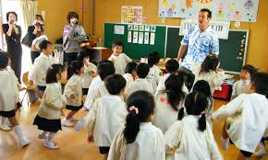

Picture 6. Current situation in the class

**Current Situation**

* English for Primary school does not become compulsory in primary education curriculum.
* Due to falling grade of Bahasa language exam in Senior high school
* Another reason is learning English takes too much time rather than learning Bahasa
* Most of private schools and some public elementary schools take English as Adding subject.
* English is still important and still being introduced as young as possible.

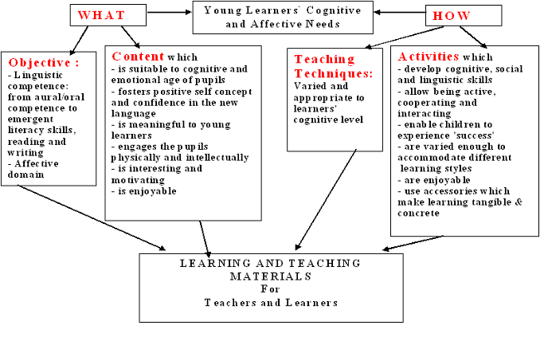

Picture 7. Learning and teaching Materials

**D. Course Description**

This course has three main objectives: (1) to understand the primary theories and the specific features of children’s cognitive and language development, (2) to explore language teaching methodologies, approaches, and techniques, and (3) to improve teaching skills through participants’ demonstrations of English teaching in class or by observing video recordings of actual teaching in the students’ own classes, and to communicate your ideas about teaching English to young learners in writing.

The course will first provide students with a theoretical foundation for teaching English to young learners. It aims at enhancing their understating of children’s cognitive development and how such theories as Piaget’s and sociocultural theories of development can be applied to teaching English to children. The course also explores children’s perceptual, language, and memory development to help students maximize their skills in teaching-learning situations.

The course will then explore various practical methods for teaching children listening and speaking, reading and writing, and skills required for storytelling. Finally, based on the theoretical underpinnings, students will plan a lesson and conduct it in their school or do microteaching demonstrations in class. We will take a close look at instructional practices students designed for their own classrooms to improve skills for teaching English to young learners.

**What five to seven years olds can do at their own level**

* They can talk about what they are doing
* They can tell you about what they have done or heard
* They can plan activities
* They can argue for something and tell you why they think
* They can use logical reasoning
* They can use their vivid imaginations
* They can use a wide range of intonations patterns in their mother tongue.
* They can understand direct human interaction.

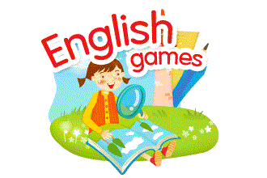

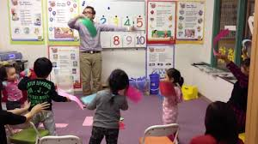

Picture 8. Making English Fun

**E. Teaching English to very young learners using games**.

Games are a valuable activity for language learning, especially for very young learners. Children enjoy games and thus participate without anxiety. Games can motivate children greatly and they are activities which are usually familiar to children as regards structure, rules etc. Due to this familiarity they link back to the children’s home background.

Games are mostly inclusive activities in that they involve all the children and they can cater to different learning styles and different personalities. They are also activities which are naturally repetitive, thus maximising input, frequency of target items without boring the students. A simple guessing game can be played numerous times with children despite possibly limited language. The students will happily repeat the structure without getting bored as it is part of a game and has a real communicative function. Games are simple structured activities which may involve little language but are meaningful to students and involve the whole self (cognitively and emotionally), thus creating strong associations with the language used.

Games are particularly valuable for a child beginning to learn a foreign language. Children just beginning to learn a new language need some time to adapt to the language, its sounds and rhythms. They need exposure to input before they experiment with producing language. Some children will gladly experiment with production but some can be shy and require more time. This ‘silent’ time/period should be offered to the children and they should never be pressured into producing language.

Games, therefore, offer an important tool which allows children to listen to and comprehend language without requiring production. They can participate fully in all the activities without being pressured to produce language. Finally games are social activities which enable the development of social skills such as coexistence and collaboration.

When should games be used? What games? Games can be used to enhance any part of the lesson. They can be used to present, practice, recycle/revise or assess any language. They can be used to develop listening, speaking, reading and even writing skills. What is important is that you decide what your focus is.

What is your particular aim for using the specific game in class? This is important in that a clear learning goal distinguishes games as learning activities from games as enjoyable past-times. Games should be seen as learning activities which can enhance students’ language development if used systematically with clear goal-setting.

When do you play a game? The time you decide to implement a game, will also affect what kind of game you play. Games can stir or settle a class so you should choose according to the time of day, your particular students and their mood on that day! There is a wide variety of games which can be used with young language learners. Here we will focus on three categories to get you going:

* Flashcard games: these games are played with a set of flashcards which may be purchased from bookshops or prepared by you and your students
* Ball games: ball games require a soft ball which you can use in class without worrying about breaking windows or hurting students!
* Action games: action games require movement. They might excite a class so you should perhaps choose carefully when to use them.

1. 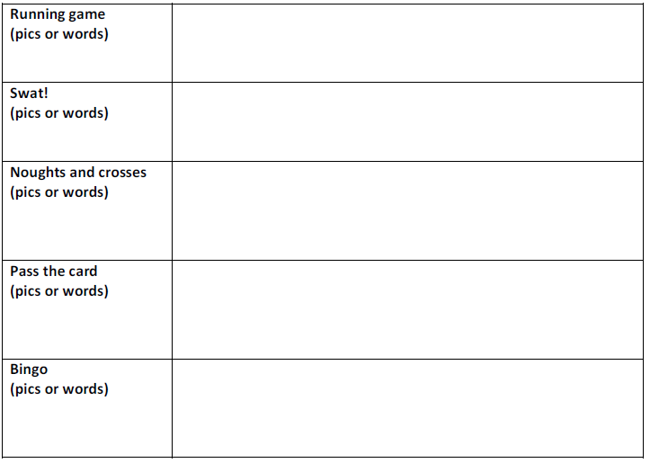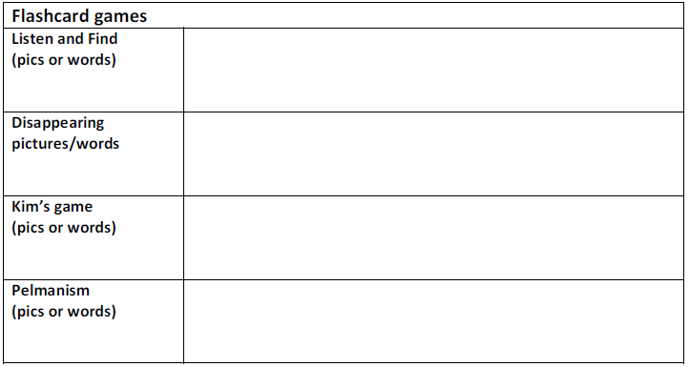**Write down a description of each game after we played it:**

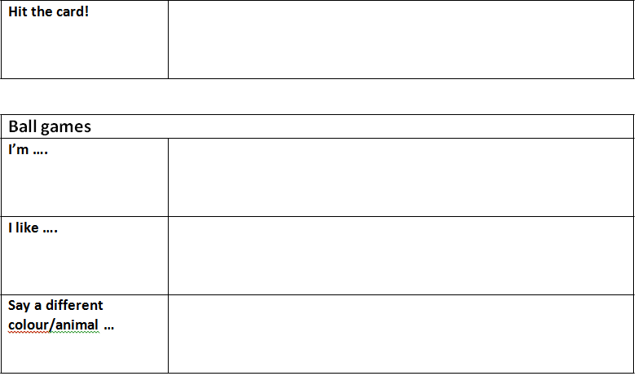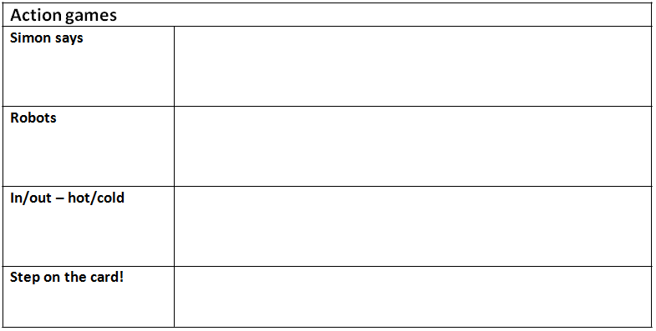

The example of table above is to fill out and make a game so that it is not monotonous and bored in teaching English for elementary students.

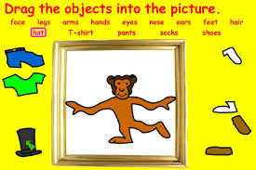

Picture 9. Example game

**Tips on games to teach English learners**

  We know it may be discouraging to read about having to do more preparation – especially when the phrase “time-consuming” is used. Never fear. Games to teach English learners are supposed to be fun, remember? “The ELT Grammar Book” suggests having students help you in preparing materials for the games. “Not only will that cut down on your work, but it will also give your students practice on the language points your game is focusing on.” You will find that many students enjoy being part of the creative process and will be more than willing to help – this is especially true with younger students. Another suggestion is to limit groups to four or five students so that the students won’t “get restless waiting for their turn to come up again.” Depending on the size of the class, this may mean that you will have to walk around the room to monitor various groups and assist them during the game as needed.

Genevieve Roth makes the following suggestion for presenting the game: “Play the game with one or two pupils in front of the class as a demonstration.” This will allow the others to see a model of what is to be done and how the game is to be played. She also suggests that the students sit in a circle around you as you explain. You may decide to act out the game by playing first one part and then the other for them to see. And finally, she suggests that you give the game a chance and not be discouraged, as it sometimes takes time for students to understand the game enough to really enjoy playing it. (Roth) Roth’s work is geared mostly toward teaching English to children; however her advice may still be helpful when working with adults.

**Examples on games to teach English learners:** If you are still uncertain of what kind of game to teach English learners you may want to use or how to go about making them work for your classroom, perhaps the following examples may help.

* **Tic-Tac-Toe** (British Naughts and Crosses) is altered slightly to accommodate for team play, but the traditional objective of three-in-a-row remains the same. Students must work together to correctly answer questions in order to gain a chance to place an X or O (based on their team) and each person on the team gets a chance to answer for their group. Questions can be in the form of pictures which match vocabulary, to creating a sentence using grammar points, or whatever you choose to review with the students.
* **Concentration** is a game to teach English learners that uses cards to match vocabulary or grammar points and is best played in circle-groups so that everyone can see the cards. The students can help you by making pairs of cards so that they get extra practice. Once you’ve shuffled each set of cards, they should be laid face-down in the middle of the circle. Each student takes a turn by flipping two cards face-up. If they match, the student wins those cards. If they do not match, the student must flip them face-down again and continue to pay attention so that they can make a match on their next turn. Students will help each other decide when a match is made, but you will want to monitor as well and perhaps have each student share their pairs at the end of the game for extra review.
* **The Clothesline** is a game to teach English learners of building sentences using different words each time. Have many different options for each part of speech, including punctuation, in piles. Students take turns (in teams or individually) changing the words in order to create sentences. Students read the sentence they’ve created upon completion, and points are awarded for correct use of vocabulary, grammar and punctuation. The student or team with the most points at the end of the round wins.
* **Oral Matching** can be a fun way for English learners to mingle and practice conversation. Each student is given a slip of paper with either a question or an answer on it (for more variety, they can have one of each, so long as they don’t match!) and they are to read their questions and answers to their fellow students in order to decide which ones go together. For more fun, use a dialogue or story to create your question and answer slips. Once each student has found his or her matching pair(s), you can have the students put it back together in the original order and read it together.
* **Scrambler** is more of a puzzle type of activity that can be fun for English learners as a break from traditional worksheets. Create a target word that you wish the students to discover (this can be an answer to a key question as well, if you wish). Use various vocabulary words that contain letters to be used in the target word. Then, scramble the vocabulary words so that the students must discover from each scrambled word the vocabulary to go letter-by-letter in the boxes behind it. The target word can then be placed in a vertical fashion using those letters from the vocabulary. If you are using a key question, be sure to leave a blank so that the students can re-write the target word from the boxes once they’ve discovered the answers to all the scrambled words.
* We hope these ideas and suggestions on**games to teach English learners** have been helpful for you and that you can find a way to use them in your next class.

**References**

Cameron, Lynne. 2001. Teaching Language to Young Learners. New York. Cambridge University Press

Scott, W.A. and L.H. Ytreberg. 1990. Teaching English to Children. London: Longman

Suyanto, Kasihani K.E., 2007. English for Young Learners. Jakarta: Bumi Aksara Willis, Judi., 2008. How Your Child Learn Best. Illinois: Sourcebooks, Inc.

Kay, Penny Mc and Jenni Guse. 2007. Five-minute activities for young learner. UK: Cambridge handbook for language.

Scott, Wendy and Lisbeth Ytreberg. 2010. Teaching English to children. USA: Longman.

Teaching Young Language Learners (Oxford Handbooks for Language Teachers) by Annamaria Pinter, Oxford University Press, 2006

<https://www.google.co.id/search?safe=strict&biw=1094&bih=462&tbm=isch&sa=1&ei=PtOKW8vwFYf3vgT-jaSoAg&q=using+games+teaching+english+to+young+learners+pic&oq=using+games+teaching+english+to+young+learners+pic>

<http://www.toolsforeducators.com/>