

MODUL PERKULIAHAN ELEARNING

MATA KULIAH - MCM 205 – ECOMMERCE (3 SKS)

PERTEMUAN 10 – *ELEARNING*

**Solusi *Supply Chain Management* dalam eCommerce**

Dosen

H. Andri Budiwidodo, S.Si., M.I.Kom.

(ID 7715)

Sumber penulisan modul:

Chaffey, Dave. 2009. *E-Business and E-Commerce Management, Strategy, Implementation and Practice*. 4th Edition. Essex England: Pearson Education Limited. Halaman 363-412.

“In the end business all comes down to supply chain vs supply chain”.

(Robert Rodin, then CEO of Marshall Industries, one of the largest global distributors of electronic components, 1999)

**Introduction**

Supply chain management is essentially the optimization of material flows and associated information flows involved with an organization’s operations. To manage these material and information flows e-business applications are today essential to bring the benefits illustrated in **Figure 1 and 2**.

|  |
| --- |
| The benefits of supply chain management according to a PMP (2008) survey are shown in **Figure** **1 & 2**. You can see that although benefits of reducing costs and increasing profitability are mentioned frequently, many respondents mentioned that supply chain management also assists with delivering better service to customers.  The figure also shows the challenges of implementing supply chain management technology since a large proportion had not fully realised the intended benefits, although the majority believed they would in the long term.  **Sample frame**  PMP surveyed a broad range of companies, including those from the manufacturing (32%) and retail sectors (17%) where supply chain issues are particularly important.  In addition companies responded from distribution & logistics (13%), energy & utilities (10%) and IT & telecoms (6%). The respondents represent a spread of different-sized companies, with 16% having in excess of £5 billion turnover, 7% in the £1 billion to £5 billion bracket and 13% in the £500 million to £1 billion range. |

|  |  |
| --- | --- |
| **Figure 1** | **The benefits of supply chain management** |
|  | |

*Source: PMP (2008)*

|  |  |
| --- | --- |
| **Figure 2** | **Realization of benefits** |
|  | |

*Source: PMP (2008)*

**Problems of supply chain management**

We have reviewed some of the benefits of using technology to support supply chain management in **Figure 1**. We can also review the benefits of SCM from the perspective of problems that can occur in a supply chain and consider how e-business technology can assist (**Table 1**). This introduces many of the key concepts of technology enabled supply chain management which we will review in this chapter.

|  |  |  |
| --- | --- | --- |
| **Table 1** | **A summary of the problems of supply chain management and how e-business technology can assist** | |
| **Problem of supply chain management** | | **How e-business technology can reduce problems in SCM** |
| Pressure to reduce costs of manufacturing and distributing products in order to remain competitive | | Reduction in paperwork through electronic transmission of orders, invoices and delivery notes. Reduced inventory holdings needed through better understanding of demand. Reduced time for information and component supply across the supply chain. Lower SCM system purchase and management costs through use of online services (SaaS). |
| Demand forecasting | | Sharing of demand by customers with suppliers as part of efficient consumer response (ECR) |

|  |  |
| --- | --- |
| Failure to deliver products on time  consistently or lack of items on shelf in retailer | Supplier becomes responsible for item availability through vendor-managed inventory |
| Failure to deliver or ship correct product | Human error reduced. ‘Checks and balances can be built into system’ |
| High inventory costs | Inventory reduced throughout the supply chain through better demand forecasting and more rapid replenishment of inventory |
| Time for new product development | Improved availability of information about potential suppliers and components, for example through online marketplaces |

**What is supply chain management?**

**Supply chain management** (SCM) involves the coordination of all supply activities of an organization from its suppliers and delivery of products to its customers (**Figure 3**). **Figure 3** introduces the main players in the supply chain. In **Figure 3**(a) the main members of the supply chain are the organizations that manufacture a product and/or deliver a service.

|  |
| --- |
| **Supply chain management (SCM)**. The coordination of all supply activities of an organization from its suppliers and partners to its customers. |

For most commercial and not-for-profit organizations we can distinguish between **upstream supply chain** activities which are equivalent to buy-side e-commerce and **downstream supply chain** activities which correspond to sell-side e-commerce. In this chapter and the next we focus mainly on improving the efficiency of upstream supply chain activities.

|  |
| --- |
| **Upstream supply chain**. Transactions between an organization and its suppliers and intermediaries, equivalent to buy-side e-commerce |

|  |
| --- |
| **Downstream supply chain**. Transactions between an organization and its customers and intermediaries, equivalent to sell-side e-commerce |

The supply chain management includes not only supplier and buyer, but also the intermediaries such as the supplier’s suppliers and the customer’s customers (**Figure 3**(b)). Indeed, **Figure 3**(b) is a simplification of some companies which may have first-tier suppliers, second-tier and even third-tier suppliers or first-, second- and higher-tier customers. Because each company effectively has many individual supply chains for different products, the use of the term ‘chain’ is limiting and **supply chain network** is a more accurate reflection of the links between an organization and its partners. The existence of this network increases the need for electronic communications technology to manage and optimize this network.

|  |
| --- |
| **Supply chain network**. The links between an organization and all partners involved in multiple supply chains. |

Technology is vital to supply chain management since managing relationships with customers, suppliers and intermediaries is based on the flow of information and the transactions between these parties. The main strategic thrust of enhancing the supply chain is to provide a superior value proposition to the customer, of which **efficient consumer response** (ECR, see **Figure 4**) is important within the retail and packaged consumer goods market. As explained that improving customer value involves improving product quality, customer service quality and/or reducing price and fulfilment times. An alternative emphasis is on increasing efficiency in obtaining resources from a supplier organization or distributing products to customers. This emphasis is about reducing operational costs and so increasing profitability.

|  |
| --- |
| **Efficient consumer response (ECR)**. ECR is focused on demand management aimed at creating and satisfying customer demand by optimizing product assortment strategies, promotions, and new product introductions. It creates operational efficiencies and costs savings in the supply chain through reducing inventories and deliveries. |

|  |  |
| --- | --- |
| **Figure 3** | **Members of the supply chain: (a) simplified view, (b) including intermediaries** |
|  | |

**Figure 4. Inter-organizational process flow for introduction of a new product (part of Efficient Consumer Response)**

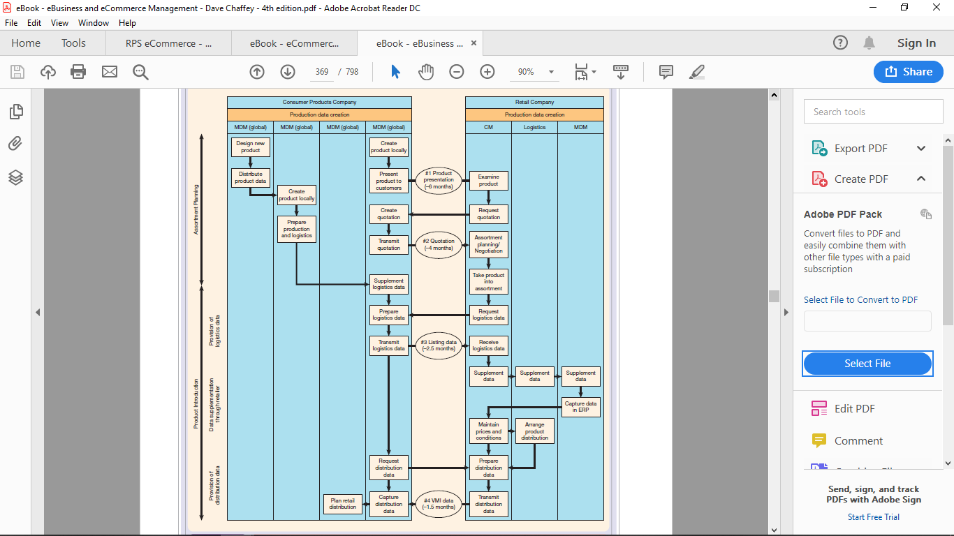

**Inter-organizational process flow for introduction of a new product.**

Source: excerpted from Toward the interorganisational product information supply chain – evidence from theretail and consumer goods industry by C. Legner and J. Schemm © 2008. Used with permission fromAssociation for Information Systems, Atlanta, GA, 404-713-7444, www.aisnet.org. All rights reserved.

The ECR concept was developed for the food retailing business in the USA but since then it has been applied to other products and in other countries. It was originally developed by David Jenkins, then chairman of Shaw’s supermarkets, to compete with other players such as Wal-Mart. Supply chain management had traditionally focused on efficient product replenishment whereas the focus of ECR is on demand management aimed at creating and satisfying customer demand by optimizing product assortment strategies, promotions and new product introductions (Legner and Schemm, 2008). Figure 6.3 shows the complexity and lead times of a process where a new consumer product is introduced and then stocked. ECR focuses on improving this process.

**Table 2** shows that some of the aims and strategic approaches generated by ECR can also apply to business customers.

**Table 2.**

**Objectives and strategies for effective consumer response (ECR)**

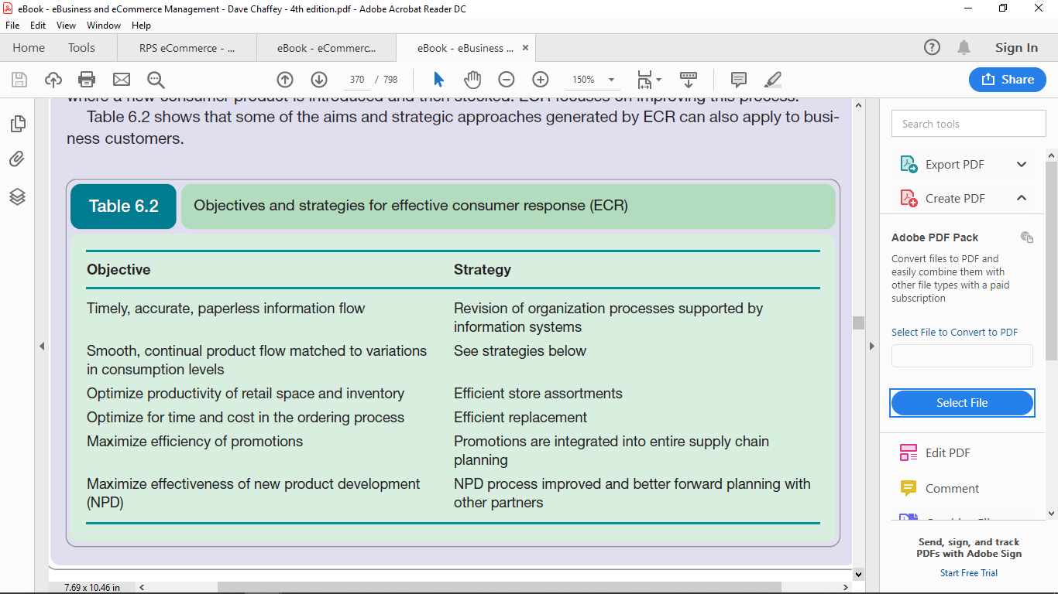

**Using technology to support supply chain management – an example**

A good example of how the introduction of information systems can be used to improve supply chain management is provided by BHP Steel (now BlueScope Steel, www.bluescopesteel.com.au), an Australian firm. Its use of PC-based technology for supply chain management dates back to the 1980s and e-business represents a change of emphasis rather than a radically new approach. Chan and Swatman (2000) assess the stages in **implementation of e-commerce for this company**. It highlights that electronic supply chain management and indeed ‘e-business’ are well established in large companies. The authors identify three phases:

1. ***Early implementation***: 1989–93. This was a PC-based EDI purchasing system. At this stage, objectives were to (1) reduce data errors to 0, (2) reduce administration costs, (3) improve management control, (4) reduce order lead time. Benefits of this phase included rationalization of suppliers to 12 major partnerships (accounting for 60% of invoices); 80% of invoices placed electronically by 1990; 7,000 items were eliminated from the warehouse, to be sourced directly from suppliers, on demand. Shorter lead times in the day-to-day process – from 10 days to 26 hours for items supplied through a standard contract and from 42 days to 10 days for direct-purchase items. At this stage the main barriers to the implementation were technological.
2. ***Electronic trading gateway***: 1990–4. This was again EDI-based, but involved a wider range of parties both externally (from suppliers through to customers) and internally (from marketing, sales, finance, purchasing and legal). The aim was to provide a combined upstream and downstream supply chain solution to bring benefits to all parties. The main learning from this process was the difficulty of getting customers involved – only four were involved after 4 years, although an industry-standard method for data exchange was used. This was surprising since suppliers had been enthusiastic adopters. From 1994, there was no further uptake of this system.
3. ***The move towards Internet commerce***: 1996 onwards. The Internet was thought to provide a lower-cost alternative to traditional EDI for smaller suppliers and customers, through using a lower-cost value-added network. So, one objective of the project was to extend the reach of electronic communications with supply chain partners. The second was to broaden the type of communications to include catalogue ordering, freight forwarding and customer ordering. The strategy divided transactions into three types: (1) strategic (high volume, high value, high risk) – a dedicated EDI line was considered most appropriate; (2) tactical (medium volume, value and risk) EDI or Internet EDI was used; (3) consumer transactions (low volume, value and risk) – a range of lower-cost Internet-based technologies could be used. One example of the benefits has been reducing test certificates for products from AU$3 to 30 cents. The main barriers to implementation at this stage have been business issues, i.e. convincing third parties of the benefits of integration and managing the integration process.

More recently, BlueScope Steel has introduced bluescope-steelconnect.com (**Figure 5**) which is a secure Internet-based steel procurement solution which allows customers to order and confirm the status of products. It also offers users the ability to check statements and download invoices in real time, simplifying reconciliations.

The implementation of SCM at BHP Steel reflects changing developments in the wider industry which are summarized in **Box 1**.

|  |  |
| --- | --- |
| **Figure 5** | **BluescopeSteelConnect transactional site**  **(www.bluescopesteelconnect.com)** |
|  | |

|  |
| --- |
| **Box 1. The past, present and future of SCM** |
| Professor Alan Braithwaite of LCP Consulting, writing in PMP (2008), identifies these developments in SCM technology:  *The 70s were characterised by monster batch-processing mainframes, manual data entry and primarily custom programming. These systems were driven by finance and generated huge piles of printout with little useful management information.*  *The 80s were the time when the minicomputer and the PC emerged, computing power became more accessible and the debate was between packaged software or customised solutions. Custom code was still the preferred route for many, but information rather than data was emerging.*  *The 90s saw a huge ‘Windows-based’ expansion of computing power – with packages overtaking custom software as their functionality matured – and the emergence of ERP. The debate was about best of breed versus all-in-one integrated software.*  *The end of the 90s was focused on the Y2K question as companies replaced their solutions wherever the risk of corruption in old legacy systems was too high – ERP was again a big winner from this.*  *In the first decade of the new century, the internet has come of age as a transaction medium, with exponential growth in computing power and storage encouraging the introduction of more and more sophisticated supply chain solutions and management information.*  Braithwaite goes on to make these predictions about the future of SCM:  *A fundamental principle of supply chain management is to secure end-to-end visibility and a single version of the truth – one number for forecasts, inventory, orders, billings and commitments; ERP in principle seeks to achieve that goal.*  *A second fundamental principle is that end-to-end visibility includes inventory and processes that extend beyond the focal firm and its ERP. The internet provides this capability in a way that was barely conceivable 10 years ago.*  *There are three key points from the growth of ERP and the internet that form the basis for my prediction of the future of supply chain systems …*  *The first is that managing the extended supply chain with a requirement to continually optimise means integrated ERP versus best of breed is an irrelevant argument. Systems in the future will be more open and include core and extended supply chain integration and optimisation. ERP is less good at the smart stuff and the data structures are not organised to deal with the extended chain.*  *The second point is that most systems are not delivering business benefits to their full potential because supply chain business processes are not good enough and the systems are not set up right to handle good practice.*  *The third factor is that a surprising number of companies are still stranded with legacy systems that are so customised it is difficult to migrate to new more open architectures based on ‘bestpractice’ processes. These companies have to determine how they will reengineer their businesses and migrate their systems. At present they will not be able to access the smart optimisation and extended chain capabilities easily.*  *The implication of these trends is that the long-term direction for companies will be extended open system architectures with an ERP core. Application and data interchange maturity exist, and the industry now talks widely about service oriented architecture (SOA). The real challenge now is process design and simplification and being able to represent that in supply chain systems.*  *So the future of supply chain systems will be about simply more of the same on the latest platforms, only this time better and more flexible. It will be up to management to provide better process clarity and execution, and work with the systems community to exploit the capabilities that exist. Anything new technically may be a bonus, but not if it distracts from the core concepts.*  Source: PMP (2008) |

**A simple model of a supply chain**

An organization’s supply chain can be viewed from a systems perspective as the acquisition of resources (inputs) and their transformation (process) into products and services (outputs) which are then delivered to customers. Such a perspective indicates that as part of moving to e-business, organizations can review the transformation process and optimize it in order to deliver products to customers with greater efficiency and lower cost. Note that the position of the systems boundary for SCM extends beyond the organization – it involves improving not only internal processes, but also processes performed in conjunction with suppliers, distributors and customers. However, this process perspective misses the strategic importance of supply chain management – it also provides great opportunities to improve product performance and deliver superior value to the customer as suggested by **Figure 1 and 2**. As a result, supply chain management can dramatically have an impact on the profitability of a company through reducing operating costs and increasing customer satisfaction and so loyalty and revenue. Since **Figure 3** is a grossly simplified version of most supply chains, a more representative supply chain is illustrated in **Figure 6** which shows the supply chain for a sample business-to-business company. Note that although this example is based on a business-to-business scenario, supply chain management is also vital to the management of business-to-consumer and service companies. With service companies such as financial services, the resources managed tend not to be physical but human, financial and information resources. However, the same principles of using e-commerce technology to enhance supply chain activities can be applied.

Shell Chemicals has developed a **vendor-managed inventory** (VMI) supply chain management system to enable delivery of supplies to be more responsive to customers’ demands. VMI is a key concept in electronic supply chain and procurement management which shifts the day-to-day tasks of stock management, purchasing and order tracking from the customer to the supplier.

|  |
| --- |
| **Vendor-managed inventory (VMI)**. Supply chain partners manage the replenishment of parts or items for sale through sharing of information on variations in demand and stocking level for goods used for manufacture or sale. |

|  |  |
| --- | --- |
| **Figure 6** | **A typical supply chain for a B2B company** |
|  | |