Modul 14

Mata kuliah : Manajemen Pengetahuan

Knowledge Elicitation – Converting Tacit Knowledge to Explicit

Objectives :

* Introduce the student to capturing tacit knowledge from human sources and convert it into explicit knowledge.
* Introduce the student to the various stages of the traditional one-on-one interview and how they can be managed for effectiveness.
* Other elicitation techniques such as observation, role-reversal, etc.
* The variations of the one-on-one interview when more than one person participates.

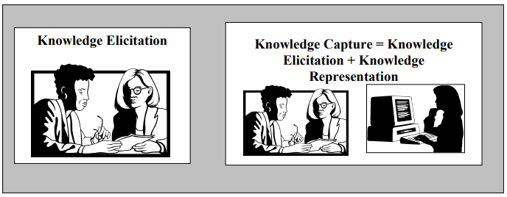

Objectives :

* Introduce the basic approach to face-to-face knowledge elicitation from an expert: the oneon-one interview.
* Introduce the Output-Input-Middle method for organizing captured knowledge
* Introduce alternate knowledge elicitation techniques
* Introduce variations to the one-on-one interview when more than two participants are present.

Basic One-On-One Interviews: Kickoff Interview

• Objective: establish good rapport with the expert

• Demonstrate to the expert that the KE has made an honest attempt to gain familiarization with the domain before the meeting

• Typical agenda (max 1 hour):

1.  Introduction and light conversation
2.  Explanation of the objectives of the elicitation process
3.  Discussion of the importance of the project
4.  Discussion of what is expected of the expert, and what the expert can expect from the KE
5.  Identification of reading materials the expert recommends for the KE to review
6.  Scheduling of subsequent meetings

Basic One-On-One Interviews:

General Knowledge-Gathering Sessions

• One kind of knowledge elicitation session

• Objective: learn general principles about the domain from the expert

 Better understand the subject matter

 Better understand the expert’s opinions and viewpoints on the domains

• Wide-ranging, emphasizing breadth

• Knowledge gathered probably will not be explicitly expressed

• Relieves some of the burden from the expert, by not requiring a continual definition of every term used

• Facilitates open-ended questions which require discussion cannot be answered simply with a yes, no, simple term, or number

• 1-2 hours per session

Basic One-On-One Interviews:

Specific Problem-Solving, KnowledgeGathering Sessions

• One kind of knowledge elicitation session

• Objective: learn how the expert solves specific problems or answers questions in the domain

• Highly directed, emphasizing depth instead of breadth of coverage

• Knowledge gathered probably will be explicitly expressed using the system’s knowledge representation language

• Ask many close-ended questions which

 are quite specific

 can be answered simply with a yes, no, simple term, or number

Basic One-On-One Interviews:

Knowledge Elicitation Sequence

• Output-Input-Middle method

• Output

 Identify the answers or solutions to the problem under discussion (goals)

 KE should focus on understanding subtle differences between goals

• Input

 Identify the sources of information that the expert uses to deduce the solution/answer

 KE should make sure how these inputs are identified, determined, or generated is known and understood

• Middle

 Determine the links between the inputs and outputs

 These connections represent the core of the expert’s knowledge

 Some inputs may not be required initially, but may be requested later after the

initial inputs are interpreted

 Intermediate goals/hypotheses may be required to complete the connections

Basic One-On-One Interviews:

Weaknesses

• The Q&A interview is not always the most efficient means of eliciting knowledge from an expert

• In some domains, considerable expertise is documented in instruction manuals or books

 eg, maintenance manuals for automobile diagnosis

• Sometimes even cooperative experts have difficulty articulating their expertise

• Other elicitation techniques can be used when appropriate

 Observational elicitation

 Role reversal

Observational Elicitation

• KE observes the expert at work, trying to understand and duplicate the expert’s problemsolving methods

• Types:

 Quiet on-site observation

 On-site observation with discussion

 Exercising the expert

 Problem description and analysis

Observational Elicitation:

Quiet on-site observation

• KE cannot question experts while they work

• Pros:

 Experts’ train of thought is not continually interrupted by questions, so they can proceed at their most effective and realistic form

• Cons:

 Lack of interaction leaves KE wondering about the solution approaches taken by the expert

 If expert is asked to talk out loud as they work, can make experts selfconscious causing them to alter it or to create a verbalization that is

much more or less complex than what they are actually doing

• Should be used:

 to get a feel for the total magnitude of the problem-solving process

 to verify (or reject) that a hypothesized approach is in use

• Should not be used:

 to obtain details about the process

• Q&A session should follow

Observational Elicitation:

On-site observation with discussion

• KE may interact with the experts while they work

• Pros:

 Permits KE to better probe the process observed

• Cons:

 Expert may become distracted by the questions and not follow the normal procedure

• Should be used:

 when the observed task does not significantly challenge the expert’s problem-solving abilities (eg, is fairly routine)

• Should not be used:

 when the expert needs to struggle to reach a solution

 Symptoms: uneasiness, hesitation in decision-making, refusing to

create a solution in front of the KE

• Q&A session should follow

Observational Elicitation:

Exercising the expert

• In some domains, problems arise only seldom and unpredictably

 Even when problems arise frequently, the difficulty level of the usual problems may not be sufficiently high

• Impedes knowledge elicitation by observation

• In such cases, KE may prepare cases of varying difficulty from historical data

• Presented to expert in an “off-line” environment to observe the expert’s methodology

• May also be used to supplement a case library for CBR

• Improvements to elicit experts’ abilities to provide additional

information about their problem-solving expertise: [Hoffman 1987]

 Limited information tasks: A routine task is performed, but the expert

is not provided certain information that is typically available

 Constrained processing tasks: A routine task is performed, but the expert must execute it under some constraint (eg, within a limited amount of time)

Observational Elicitation:

Problem description and analysis

• Sometimes it is useful to observe cases that are classical problems, rather than real or historical cases eg, cases typically discussed and analyzed by instructors in classroom situations designed/chosen because they illustrate important or significant relationships within the domain that every problem solver should possess

• Normally such cases are selected by the expert

 But occasionally the KE may find them useful to select when questioning the expert

• KE should make sure the expert explains the rationale behind distinguishing these problems as classics: what are the key relationships/features that make these cases significant?

• May also be used to supplement a case library for CBR

Role Reversal Techniques

• KE acts as the expert (pseudoexpert)

• The pseudoexpert attempts to solve a problem in the presence of the true expert (role-playing)

• The true expert questions the pseudoexperts about what they are doing and why

 Like the observation process, but the with roles reversed

• May be used when:

 KE already has a significant understanding of the provlemsolving process

 KE wishes to verify correctness of understanding

• Can clarify, modifiy, and provide significant new knowledge not previously uncovered by the KE

Team Interviewing

• Under some circumstances, interviewing may involve more than one KE and one expert

• Types:

 One-on-many

 Many-on-one

 Many-on-many

Team Interviewing:

One-on-many

• Common when several experts work closely together

• Each expert may be specialized in slightly different areas, in complementary fashion

• If differences of opinion arise during a discussion, good chance of resolving them immediately and amicably

 Typically in such an environment, this immediately uncovers a deeper level of knowledge (benefiting both KE and experts)

• Cons:

 Sometimes the experts do not get along; can undermine team’s productivity

 Can be redundant especially in general knowledge-gathering sessions, which is wasteful of experts’ time

 Inexperienced KEs may be overwhelmed by multiple experts

 Even experienced KEs may be exhausted quickly, since the KE must maintain concentration while each expert can drift in and out of “high gear”

Team Interviewing:

Many-on-many

• Pros:

 Few-on-few interviews may realize the benefits of both one-on-many and many-on-one interviews –synergism between experts as well as multiple

observer perspectives

 Only holds for few-on-few interviews, eg, two-on-two or twoon-three

 Sometimes unavoidable to external pressures (eg, time constraints dictated by management)

• Cons:

 Difficult to accomplish anything with larger groups

 High redundancy is wasteful of experts’ and KEs’ time

Team Interviewing:

Many-on-one

• Pros:

 Multiple sets of eyes and ears are better than one

 Each KE can subsequently provide an alternative perspective about what happened during the interview, leading to a clearer picture

• Cons:

 The single expert often feels overwhelmed by the multiple KEs – may become more defensive

 Little chance for synergism, since no one else present has the expert’s level of domain understanding

 Even a cooperative expert easily gets exhausted quickly

Section 10.3 - Objectives

• Introduce the concept of repertory grids as a tool to facilitate the elicitation of knowledge from ahuman expert

• Provide a detailed example of how an automated knowledge elicitation system that uses repertory grids would operate

Repertory Grids

• A repertory grid is a list of specific characteristics of a domain that are to be evaluated by an expert

 Mathematically: an attribute-value vector

 Attributes are also sometimes called elements or labels

 Values can be binary or a range of values

 A construct is an attribute-value pair (along with the specification of the range, ie, set of allowed values)

• Based on Kelly’s [1955] theory of personal constructs in clinical

psychology

 Designed to improve the effectiveness of clinical sessions with a patient

 Individuals perceive the world from a different and changing perspective

 A model is built for particular persons that represents their views of the world, which is updated to represent the person’s beliefs as they are revised

• Adopted in a number of knowledge elicitation tools during the 1980s and 1990s

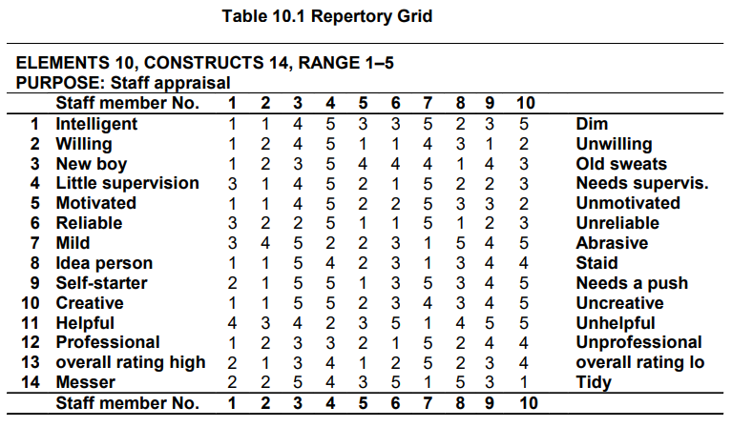

Repertory Grids

• Automated tools exploit the idea of repertory

grids by trying to help elicit:

 what attributes are important for the domain

 what range of values the attributes should have

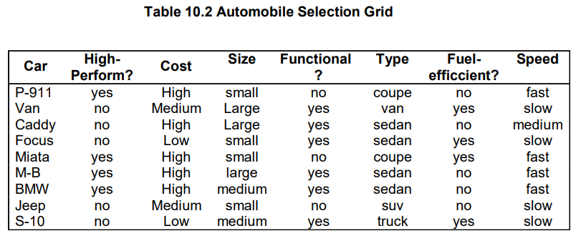

Repertory Grids

• Knowledge captured in repertory grids is rarely sufficient to build a complete knowledge-based system but provides an excellent starting point to simplify the KEs’ job to be one of refinement, instead of bulk knowledge capture

• Excellent means of acquiring knowledge that has the following characteristics:

 It is easily characterized as attribute-value pairs

 The values can vary over a range covering two extremes

 Certain characteristics of the object of knowledge can be easily defined

 The knowledge centers about knowing how an object fits within this template