**INTERMEDIATE WRITING**

**FOR AND AGAINST**

**ESSAY**

**MEIYANTI NURCHAERANI S.S., M.HUM**

**UNIVERSITAS ESA UNGGUL**

**JAKARTA**

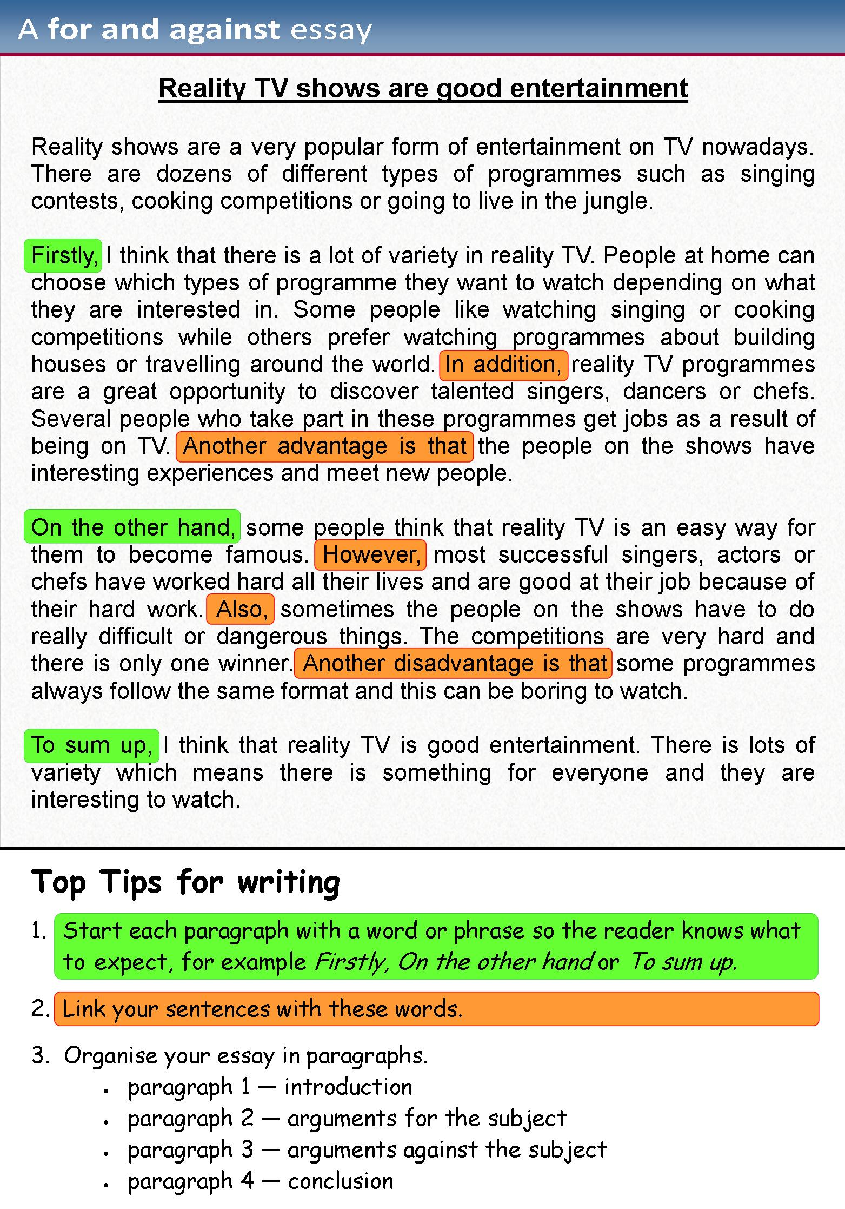

**FOR AND AGAINST ESSAY**

WRITING TIPS

WHAT IS A FOR AND AGAINST ESSAY?

•An essay on the advantages and disadvantages of some current issue.

•A formal piece of writing in which a topic is considered from opposing points of view.

•You should present both sides in a fair way by discussing them objectively and in equal detail.

POINTS TO CONSIDER

•Make a list of the points for and against.

•Start each paragraph with a topic sentence which summarizes the topic of the paragraph.

•Do not use informal style (e.g. contractions, colloquial language etc.) or strong language to express your opinion (e.g. I know…, etc.).

•Use quotations, rhetorical questions or direct address to the readers in the introduction to grab the their attention and make your composition more interesting.

STRUCTURE

•an introductory paragraph in which you clearly state the topic to be discussed, without giving your opinion

•a main body in which the points for and against along with your justifications, examples or reasons are presented in separate paragraphs

•a closing paragraph in which you give a balanced consideration of the topic and state your opinion

STRUCTURE OVERVIEW

•Introduction

•Paragraph one – topic sentence (advantages)

➢Supporting statement 1/arguments/examples

➢Supporting statement 2/arguments/examples

•Paragraph two – topic sentence (disadvantages)

➢Supporting statement 1/arguments/examples

➢Supporting statement 2/arguments/examples

•Conclusion

USEFUL LINKING WORDS AND EXPRESSIONS

•**To list points:**

Firstly, First of all, In the first place, To begin/start with, Secondly, Thirdly, Finally

•**To list advantages:**

One/Another/A further/An additional (major) advantage of… is … The main/greatest/first advantage of… is …

•**To list disadvantages:**

One/Another/ A further/An additional (major) disadvantage/drawback of. The main/greatest/most serious/first disadvantage /drawback of… Another negative aspect of…

**To introduce points/arguments for or against:**

One (very convincing) point/argument in favour of/ against …

A further common criticism of…

It could be argued/often claimed/suggested that …

It is widely argued/maintained/generally felt/believed/held that …

Some/many/most people/experts/scientist/skeptics/critics claim/suggest/argue/

feel/maintain/believe/point out/agree/hold/support the view that…

oppose the view that…

are in favour of/against…

are of the opinion that/convinced that…

are opposed to…

•**To add more points to the same topic:**

in addition (to this), furthermore, moreover, besides, apart from, what is more, as well as, not to mention (the fact) that, also, not only … but also/as well, both … and, There is another side to the issue/question/argument of…

•**To make contrasting points:**

on the other hand, however, still, yet, but, nonetheless, nevertheless, even so, it may be said/argued/claimed that,… others/many people oppose this viewpoint/strongly disagree…, claim/feel/believe this argument is incorrect/misguided although, though, even though, while, whilst, whereas, despite/in spite of (the fact that), regardless of the fact that Opponents of … argue/believe/claim that… The fact that… contradicts the belief/idea that… While it is true to say that…, in fact…

•**To introduce examples:**

for example, for instance, such as, like, in particular, particularly, especially, This is (clearly) illustrated/shown by the fact that… One/A clear/striking/ typical example of (this)… The fact that…. shows/illustrates that…

•**To emphasise a point:**

clearly, obviously, it is obvious, naturally, of course, needless to say, indeed

•**To express reality:**

In fact, the fact (of the matter) is, actually, in practice, it is a fact that, in effect

•**To make general statements:**

as a (general) rule, generally, in general, on the whole, by and large, in most cases

•**To make partially correct statements:**

to a certain extent/degree, to some extent/degree, in a way/sense, this is partly true (but), to a limited extent, there is some truth in (this), in some cases, up to a point

•**To explain/clarify a point:**

in other words, that is to say, this/which means that

•**To express cause:**

owing to, due to (the fact that), on account of, on the grounds that, given that, because, as, since

•**To express effect:**

therefore, thus, as a result/consequence, consequently, so, for this reason, if… were to happen, … the effect/result would be…

•**To express intention:**

to, so as to, in order to, so that, with the intention of (+ing)

Useful expressions and linking words/phrases: Conclusion expressing balanced considerations and your opinion

•In conclusion, On balance, All things considered, Taking everything into account/consideration, To conclude, To sum up, All in all, Finally/Lastly,

…it can be said/claimed that … … it seems/appears that…

... it would seem that… …it is likely/unlikely/possible that

… it is clear/obvious that… …there is no/little doubt that

…it is true to say that … … although it must be said that … … it may be concluded/said that …

… it is my belief/opinion that

… I (firmly) believe/feel/think that … … I am convinced that … … I am inclined to believe that … … I (do not) agree that/with …

Write an essay of 200-250 words.

Your essay must have an introduction, body and conclusion

*Some people say that international sports events bring countries closer, while others say that they cause problems between countries.*

Discuss both these views and give your own opinion.

INTRODUCTION

•An **adequate introduction contains**

•1 *general statements about the subject that provide the background for:*

•2 the *thesis statement, which names the specific topic and the main ideas or major subdivisions of the topic.*

•Example of an adequate introduction:

• **Sports events like the Olympics and the FIFA World Cup arouse global interest. But sport is all about competition. So do these events unite countries because of a shared interest in sport or divide them because of opposing interests in the result?**

CONCLUSION

•An **adequate conclusion contains:**

•1 a summary of the main points

•2 a final opinion.

•Example of an adequate conclusion:

• **In conclusion, international sports events can help people learn more about other countries. However, nationalist supporters may see opposing teams and their countries as enemies. Personally, I think that there will always be an element of war in international sports events.**

**REFERENCES**

[**http://www.gimnazija-vnazora-zd.skole.hr/upload/gimnazija-vnazora-zd/images/static3/975/File/matura/WRITING%20A%20FOR%20AND%20AGAINST%20ESSAY.pdf**](http://www.gimnazija-vnazora-zd.skole.hr/upload/gimnazija-vnazora-zd/images/static3/975/File/matura/WRITING%20A%20FOR%20AND%20AGAINST%20ESSAY.pdf)