

MODUL BAHASA INGGRIS UNTUK GURU SD

(PSD 316)

Materi12

TEACHING PRONOUNCIATION FOR YOUNG LEARNERS

Disusun Oleh

Dr. Febriyantina Istiara, M.Pd

UNIVERSITAS ESA UNGGUL

2018

TEACHING PRONOUNCIATION FOR YOUNG LEARNERS

1. **Introduction**

This module Pronunciation is In the teaching of foreign languages, such as English, pronunciation(pronunciation)need to be taught to the learners. Dalton and Seidlhofer (2004: 3) explain that teaching foreign language pronunciation will help learners understand the separate sounds of a foreign language and help the learner to interpret the sound context. Foreign language learners on the one hand can have the ability to understand the content of the text well, understand grammar, but it is possible to experience difficulties in understanding the pronunciation of foreign languages (for example English). Therefore, pronunciation needs to be taught so that learners can better express the production of foreign language sounds better and more clearly.

Learners of a foreign language, such as English as an example, may mistakenly say soup as soap in a restaurant situation so that the resulting sound context is incorrect. Therefore, in an effort to avoid or minimize the possibility of a wrong sound context, this pronunciation teaching becomes very useful. Teaching pronunciation can not only make the learner pay more attention to differences in sound, but also make the learner can improve the way of talking (Harmer, 2001: 183). Learners through teaching pronunciation can concentrate more on existing sounds.

It is widely thought that pronunciation is one of the most neglected aspects of English language teaching. In fact, Harmer explains: “almost all English language teachers get students to study grammar and vocabulary, practice functional dialogues, take part in productive skill activities and become competent in listening and reading. Yet some of these same teachers make little attempt to teach pronunciation in any overt way and only give attention to it in passing” (Harmer, 2001: 183). Regarding this aspect of the language, it is important to remark that, as Morley states, “intelligible pronunciation is an essential component of communicative competence” (Morley, 1991: 513). This consideration suggests that teaching pronunciation is crucial to help the students develop the skills that are necessary to communicate in the target language. Harmer claims: “pronunciation teaching not only makes students aware of different sounds and sound features (and what these mean), but can also improve their speaking immeasurably” and consequently “help them achieve the goal of improved comprehension and intelligibility” (Harmer, 2001: 183). Therefore, Kelly believes that “pronunciation work can, and should, be planned” (Kelly, 2000: 13).

1. **Basic Competencies**

Understanding kinds of Pronounciation for children

1. **Kemampuan Akhir yang Diharapkan**
   1. The students will be able to know about Pronounciation.
   2. The students will be able identify the principles of teaching Pronounciation for children.
2. **Learning Activities 1**

**Teaching Pronounciation**

**To Young Learners**

* 1. **Uraian dan contoh**

**A. What is pronunciation?**

What is pronunciation? There are several definitions of pronunciation. First of all, it is important to point out that there is a difference between phonology and pronunciation. In fact, as John Burgess and Sheila Spencer claim, “the phonology of a target language (TL) consists of theory and knowledge about how the sound system of the target language works, including both segmental and supra-segmental features. Pronunciation in language learning, on the other hand, is the practice and meaningful use of the target language phonological features in speaking, supported by practice in interpreting those phonological features in a target language discourse that one hears” (Burgess and Spencer, 2000: 191-192). The diagram below illustrates the features of English pronunciation (Burns, 2003).

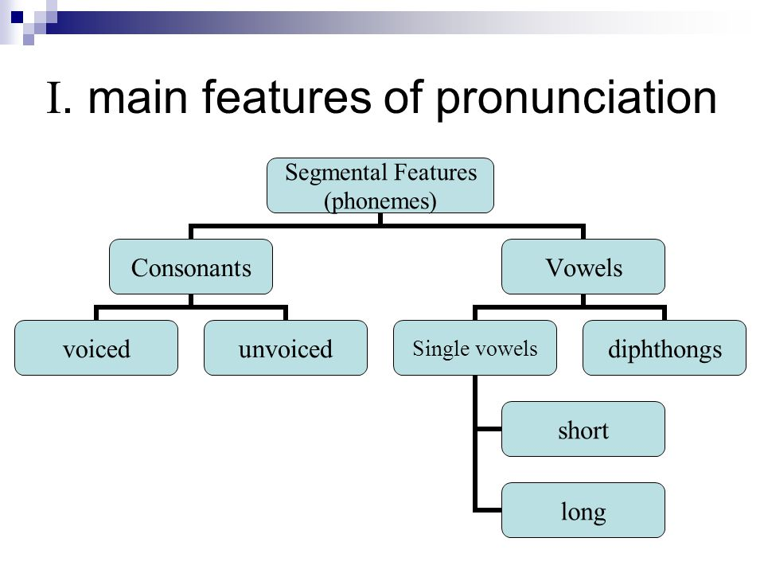

Figure 1: Features of English pronunciation.

According to Lynda Yates and Beth Zielinski, “pronunciation refers to how we produce the sounds that we use to make meaning when we speak. It includes the particular consonants and vowels of a language (segments), aspects of speech beyond the level of the individual segments, such as stress, timing, rhythm, intonation, phrasing, (suprasegmental aspects), and how the voice is projected (voice quality). Although we often talk about these as if they were separate, they all work together in combination when we speak, so that difficulties in one area may impact on another, and it is the 9 combined result that makes someone’s pronunciation easy or difficult to understand” (Yates and Zielinski, 2009: 11). Helen Fraser claimed that pronunciation “includes all those aspects of speech which make for an easily intelligible flow of speech, including segmental articulation, rhythm, intonation and phrasing, and more peripherally even gesture, body language and eye contact. Pronunciation is an essential ingredient of oral communication, which also includes grammar, vocabulary choice, cultural considerations and so on” (Fraser, 2001: 6). Furthermore, Christiane Datlon and Barbara Seidlhofer state that "we can define pronunciation in general terms as the production of significant sound in two senses. First, sound is significant because it is used as part of a code of a particular language; and so, we can talk about the distinctive sounds in English, French Thai and other languages. In this sense, we can talk about pronunciation as the production and perception of sounds of speech. Second, sound is significant because it is used to achieve meaning in contexts of use. Here, the code combines with other factors in ensuring that communication becomes possible. In this sense, we can talk about pronunciation with reference to acts of speaking" (Dalton and Seidlhofer, 1994: 4).

**Why pronunciation practice is so important for Young Learners**

The critical period hypothesis for language acquisition was first coined by Montreal neurologist Wilder Penfield. The basic idea of the theory is that children are biologically better equipped to learn a language when they are young and that, over time, this ability decreases. While Penfield’s initial research was about a child’s L1 (first language), many linguistic researchers extended the idea to second language acquisition. This is still an area of debate as to the extent of a critical language period for a second language, however, there are definitely certain advantages that young learners have when learning a language–this is especially true of pronunciation.

Firstly, children aren’t as scared of making mistakes. Last night I taught a beginner adult class. In this class was a strong attractive man in his late twenties who was simply too cool to choral any of the questions we were practicing or the word stress for countries/nationalities. Eventually, I coaxed him into trying, but his pronunciation practice during this class period had suffered.

Children aren’t as focused on being cool as adults are. With the correct leadership in the class, they will gladly step out of their comfort zone. Additionally, as their L1 is not as deeply entrenched, they are open to the differences that an additional language has. As any TEFL teacher knows, it is extremely difficult to train entrenched pronunciation errors out of an adult student. Younger learners come to you, not with a blank slate, but one with more open space to write upon.

**B. Factors Affecting Pronunciation Teaching**

At the beginner level, instructors of a foreign language (for example English) expect superior learners in pronunciation so that learners can demonstrate their ability to communicate. At the advanced level, instructors expect learners to focus on elements in communication, such as intonation (Brown, 2007: 340). These expectations should be accompanied by a teacher's understanding of the factors that influence the teaching of pronunciation. Brown (2007: 340-341) describes six factors that influence the pronunciation of learners of foreign languages ​​(such as English) regarding the teaching of pronunciation, as interpreted by the speakers as follows.

1) Everyday language used by the

language used by the learner influences the pronunciation of the learner. If the teacher can understand well the daily language used by the learner, the instructor will be able to detect learning difficulties in pronunciation learning.

2) Age

can affect the learner's pronunciation form, but it generally applies if a child has been taught to speak a foreign language from childhood. Age can also not affect the accuracy of pronunciation, for example a 50-year-old learner can have pronunciation skills that are as good as an 18-year-old learner. However, in general, age can be a reference for teachers to apply pronunciation teaching activities differently. More successful imitation activities are aimed at younger learners (children, adolescents), while older (adult) learners are better suited to learning analytical pronunciation (Brown, 1992; Jones in Richards and Renandya (ed.), 2002: 179) As for learners of different ages can also have different emotions when taught about pronunciation.

3) Caution

If the learners pay great attention to pronunciation, and the teacher also pays attention to the learners, the learners and instructors concerned will be able to achieve their goals.

4) Ability to speak from birth

Every human being generally has the ability to pronounce from birth, therefore the learner can also improve their own competence, in addition to the help of the teacher as the main assistance.

5) Attitude

In this case the teacher needs to be respectful of learners who have tried to understand pronunciation.

6) Motivation

Motivation affects the teaching of pronunciation. Teachers must be able to motivate learners in terms of pronunciation so that learners can develop their abilities.

In addition to the six factors that have been described, there are other factors that influence the teaching of pronunciation. Richards and Renandya (ed.) (2002: 184) describe two factors that influence the teaching of pronunciation. The factors are psychological factors and sociological factors.

1) Psychological

factors This psychological factor influences the teaching of pronunciation, ie the teacher must be able to help the learner to improve the learner's pronunciation ability. In this case, the learner does not want to be able to actually say the sound sequence like a native speaker, but they want to be able to understand the pronunciation in depth.

2) SociologicalThese sociological

factorsfactors can affect the final results of teaching pronunciation. Learners in this case want to be able to feel identical or even truly the same as native speakers in terms of pronunciation to support social life. Therefore, teachers must be able to target teaching pronunciation as an attempt to be able to communicate (in terms of pronunciation) like native speakers.

Different factors in the teaching of pronunciation refer to the needs and expectations of the learners themselves. Therefore, teaching foreign languages ​​(such as English) in terms of pronunciation should be careful in seeing what is needed by learners.

**C. Problems in Teaching Pronunciation and Solution**

In teaching foreign languages ​​(such as English), including teaching pronunciation, there may be problems. However, that does not mean that the existing problems cannot be solved. Harmer (2001: 184-185) explains the existence of two main problems in teaching pronunciations and their solutions. The following are the problems and problem solving.

1) Problems what learners hear

Some learners may find it difficult to understand the pronunciation they hear, for example English learners may find it difficult to distinguish sounds from the words '*two'* and '*too'*. If the learners find it difficult to distinguish the two words, then the learners find it difficult to produce the right pronunciation. To solve this problem, the teacher can try to demonstrate words that sound similar and explain them. In addition, the instructor can also train listening sensitivity more directed, namely learners are trained to listen to the sounds of foreign language words (such as English) intensively so that learners are able to distinguish sounds in words correctly, and are able to pronounce them correctly too. The training to hear this is also described by Jones in Richards and Renandya (ed.) (2002: 180), namely listening training can produce pronunciation, then repeating the word heard can improve hearing perception. From training to hearing this, pronunciation becomes more communicative.

2) Intonation problems (accuracy of tone of voice)

Teachers of foreign languages ​​(such as English) may have problems in teaching intonation, especially when learners find it difficult to distinguish the accuracy of the upward tone and down tone. These problems can be solved by the teacher by teaching the context of up and down tones, for example learners are taught how to determine the tone used to express surprise, tone when they want to ask something, tone when they want to say something, and so on.

Based on the possible problems that arise in the teaching of pronunciation, it can be seen that the key to success in teaching pronunciation is not teaching that immediately gets the learner's results always right in pronouncing sounds. However, instructors in teaching pronunciation should be able to give learners an understanding of how foreign languages ​​(such as English) are spoken so that learners will be motivated to improve their abilities in terms of pronunciation.

**D. The Right Conditions for Teaching Pronunciation**

Foreign language pronunciation (like English) can be taught by the teacher depending on the right conditions according to the teacher. In addition, needs analysis can also determine the right conditions to teach pronunciation. The following are the three right conditions (in one full teaching, in teaching speaking, in a teaching opportunity) to teach pronunciation according to Harmer (2001: 186), which is used by the speakers as follows.

1) In one full teaching

In this condition, pronunciation is taught thoroughly in a separate lesson, which is related to the teaching of pronunciation. Teachers in each meeting can discuss different issues related to pronunciation, such as pressure and intonation. However, in teaching this pronunciation at a meeting it does not always have to be emphasized on pronunciation. Learners can also be trained in listening skills or abilities that are more profound, namely listening. Learners are also trained to understand vocabulary that can be started by reading, before learning deeply about word pressure. These exercises will support the teacher in teaching pronunciation, and will also support the learner in improving his pronunciation skills.

2) In speaking teaching

In teaching speaking, the teacher can condition a certain allocation of time to teach pronunciation. This teaching can be done with the practice of dialogue that emphasizes aspects of pronunciation, such as intonation, vowels, consonants.

3) In a teaching opportunity

pronunciation*(pronunciation)*can be taught in a teaching opportunity, in addition to a full teaching and in the teaching of speaking. For example, in general English lessons, when learners are trained to read. In the condition that the learner mistakenly says the word, the teacher spontaneously corrects the pronunciation of the word. From these conditions, learners can try to improve their own pronunciation in the future.

**E.Teaching Teaching Technique**

In teaching pronunciation there are techniques that teachers can use to support success in the teaching of pronunciation process. Yates (2002: 1-3) describes six pronunciation teaching techniques as follows.

1) *Drills*

*Drills* refer to practice in the classroom, as instructors say one word which is then repeated by the learners. Through thistechnique, it *drills* is expected that learners can remember the sound of the words spoken by the teacher. Thistechnique *drills* is divided into *choral drills* (all learners in a class repeat the words spoken by the instructor and *individual drills* (the instructor chooses a learner to repeat the words spoken by the teacher)

2) Indicates pressure The

teacher with this technique can use the mark as needed, such as clapping to indicate a pressure in a word.

3) Correcting the words of the

teacher using techniques to correct the words of the learner. With this technique, the learner will feel getting reciprocity about how the learner pronunciation.

4) Demonstrating how sound is produced

Although teaching pronunciation can be dominated by the subject of saying words, sentences correctly, but learners also need to be taught to analyze how sounds are generated so that learners can distinguish sounds, for example learners can distinguish **/ l /** and **/ r /** in English . After the instructor is successful in helping the learner distinguish **/ l /** and **/ r /** , the learner can know that the sound **/ r /** does not touch the palate, otherwise the sound **/ l /** touches the palate.

5) Organize multilingual classes

Foreign language teachers (for example English) who teach multilingual classes, can use techniques to organize multilingual classes by actually analyzing the conditions of all learners. For example, at the first meeting, the teacher analyzed five learners who had difficulty pronouncing consonants. The teacher gives direction to the learners to practice consonants, and so that the learners report the results of the exercises at the next meeting.

6) Giving homework related to pronunciation lessons

This technique is considered effective because it can help learners to be more serious and calm in practicing pronunciation.

**F. Media-Media Supporting Teaching Pronunciation**

To support the teaching of pronunciation, a teacher of a foreign language (for example English) requires media. With the media, learners can be more motivated to learn pronunciation more seriously. The following are the media that can be used by teachers regarding the teaching of pronunciation according to Harmer (2001: 187-197), as interpreted by the speakers as follows.

1) Mirror, which can help teachers and learners demonstrate pronunciation.

2) Film or video, which presents illustrations related to teaching pronunciation.

3) Games, which can help learners to practice their abilities in terms of pronunciation. Examples of games:

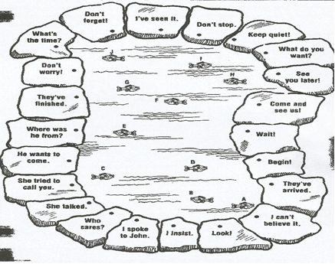

Source: Harmer (2001: 192)

Description: The learner must find sentences that have pressure and the same.

4) Recordings of words, poems, songs, which can help learners feel more relaxed and happy in learning pronunciation.

5) Pictures and tables related to pronunciation teaching.

Examples:

**a)** Image of the said tool

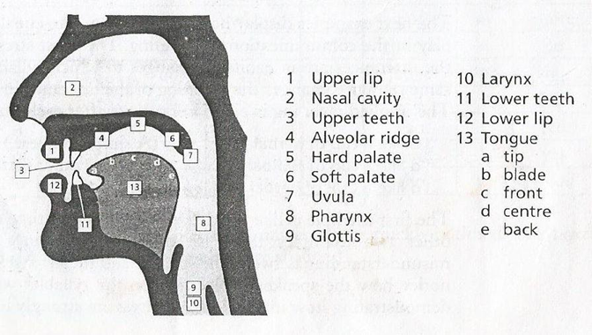

Source**:** Kelly (2000: 4)

Remarks (translation of the utterance parts)**:**

(1) Upper lip (labium) (11) Lower teeth (dent)

(2) Nasal cavity (nasal ) (12) Lower lip (bilabium)

(3) Upperdental) teeth (13) Tongue

(4) Gum, dental arch (alveolar)       a. Tongue tip (apical)

(5) Hard palate ()        bTongue leaves (lamiral)

(6) Soft palate (velar)        c. Front of the tongue

(7) Children of phlegm (uvular) d. Middle tongue (medial)

(8) Upper esophagus (pharyngeal) e. The base of the tongue (dorsal)

(9) The cleft of the sound

(10) The throat of the throat (laryngal)

**b)** Pronunciation Table

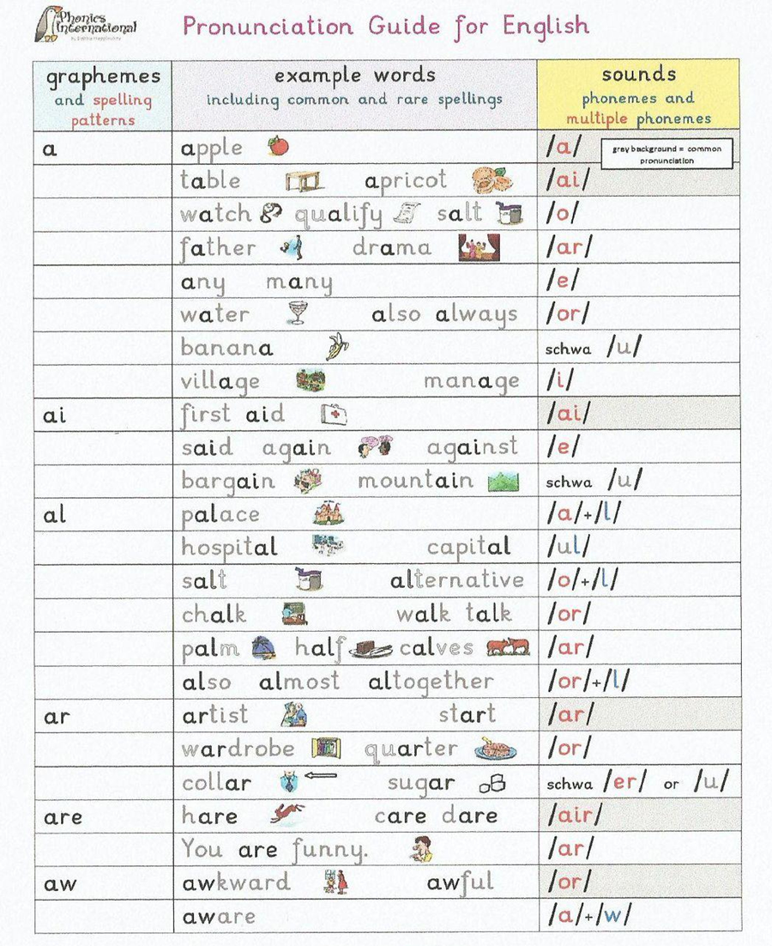

**Conclusions**

Students need to understand how sounds are produced and Students need to be able to communicate efficiently and effectively as soon as possible Pronunciation is an important aspect in teaching foreign languages, such as English. Through teaching pronunciations, learners produce sounds of foreign language well, clearly and precisely. This pronunciation teaching can be done through full teaching about pronunciation, teaching speaking, and through teaching on one occasion, depending on the needs and teaching objectives that the teacher wants to achieve. As for the teaching of pronunciation it is possible to have problems. However, the existing problems can still be solved along with the teacher's motivation to still help the learner to learn pronunciation, such as English pronunciation.

* 1. **Latihan**

a. **Answer these following questions correctly!**

By making sure you use variety in your pronunciation lessons, your students will be more successful with English pronunciation and gain the confidence that comes with it.

**How to Teach Vowel Pronunciation in English**

1. what is Listen and repeat?

2. What is Isolation?

3. What is Minimal Pairs?

4. What is Record and Replay?

5. What is Phonetics and Tongue Twister?

b**. Assignment Instructions**

Some questions to reflect on or discuss when one child is pronounciation practice, when we are going about our job of being teachers, we can use English naturally in all kinds of situations and the children are Pronounciation. When the children playing games , listen song etc, they can be creative Pronounciation practice.

**Summary**

Teaching and learning pronunciation need some methods and also techniques which can help both the teacher and students, means the method and the technique should appropriate or match with them. The method that considered in teaching and learning pronunciation is audio lingual method, which focus on repetition and drilling, here the students while teaching and learning process, they have to drill and repeat what the teacher says as the parts of improving their pronunciation. This method also argued that “Spoken is primarily and writen is secondarily”

(Brooks 1964). So, it is clear that speech has priority in Language teaching (in this case pronunciation).

* 1. Tes Formatif

Choose the right answer from questions below!

**1.** Which word of them is pronounced oʊ

A. Cousin

B. Loud

C. Country

D. Soul

E. Couple

**2.** Which is pronounced /ə/

A. Doughnut

B. Sound

C. House

D. Loud

E. Cousin

**3.** Which is pronounced /aʊ/

A. Shoulder

B. Bought

C. Found

D. Although

E. Soul

**4.** The missing pronounciation of /ə/

A. Tough

B. Country

C. House

D. Cousin

E. Couple

**5.**The missing sound of /oʊ/

A. Tough

B. Soul

C. Doughnut

D. Shoulder

E. Although

* 1. Umpan Balik dan Tindak Lanjut

Please match your answers above with answer key of formative test 1 which is located in the end of the module. Measure your topic mastery of learning activity 1 with formula given below:

Level of mastery= (total of right answers: 5) x 100%

Vey good = 90-100%

Good = 80 - 89%

Fair = 70 – 79%

Poor = 0 – 69 %

If level of mastery of the topic is more than 80%, you can continue to learning activity 2 . If level of mastery is less than 80% you need to re-do learning activity 1 especially from you have not understood part.

**F. Kegiatan Belajar 2**

* 1. Uraian dan contoh

text

* 1. Mendengarkan

video

* 1. Latihan

video

* 1. Tes Formatif

text

* 1. Umpan Balik dan Tindak Lanjut

text

1. **Kegiatan Belajar 3**
   1. Uraian dan contoh

text

* 1. Latihan

text

* 1. Latihan

Video/audio

* 1. Tes Formatif

text

* 1. Umpan Balik dan Tindak Lanjut

text

1. **Kunci Jawaban**
   1. Tes formatif 1

1. D

2. E

3. C

4. C

5. A

* 1. Tes formatif 2

text

* 1. Tes formatif 3

Text

**REFERENCES**

DAFTAR PUSTAKA

Brown, H. Douglas. Teaching by Principles: An Interactive Approach to Language

Pedagogy. New York: Pearson Education, 2007.

Cahyono, Bambang Yudi dan Utami Widiati. The Teaching of English as a Foreign

Language in Indonesia. Malang: State University of Malang Press, 2011.

Chaer, Abdul. Linguistik Umum. Jakarta: Rineka Cipta, 2007.

Dalton, Christiane dan Barbara Seidlhofer. Pronunciation. Oxford: Oxford University Press,

2004.

Harmer, Jeremy. The Practice of English Language Teaching: Third Edition Completely

Revised and Updated. Essex: Longman, 2001.

Kelly, Gerald. How to Teach Pronunciation. Essex: Longman, 2000.

Osowski, Lauren. Pronunciation Practice: Games, Activities, Curriculum Suggestions, and

Word Lists to Improve Pronunciation. New Hampshire: ESOL Adult Learning Center, 2012.

Phonics International. Debbie's Pronunciation Guide for English. Online. (http://www.

phonicsinternational.com), diunduh 25 Oktober 2014.

Richards, Jack C. dan Willy A. Renandya (ed.). Methodology in Language Teaching: An

Anthology of Current Practice. Cambridge: Cambridge University Press, 2002.

Yates, Lynda. Teaching Pronunciation: Approaches and Activities. Journal of Adult Migrant

English Program Research Centre. November 2012:1-10.

<https://www.teflexpress.co.uk/blog/pronunciation-practice-for-young-learners/>

<http://www.academia.edu/8701104/HOW_TO_TEACH_PRONUNCIATION_WELL>