

MODUL PERKULIAHAN ELEARNING

MATA KULIAH - MCJ 301 - PENULISAN ADVERTORIAL

PERTEMUAN 3 – *ELEARNING*

**STUDI KASUS ADVERTORIAL – MINUMAN DALAM KEMASAN**

Dosen

H. Andri Budiwidodo, S.Si., M.I.Kom.

(ID 7715)

Sumber penulisan modul:

Drewniany, Bonnie L., dan A. Jerome Jewler. *Creative Strategy in Advertising*. 9th edition. Boston: Thomson Watsworth. Halaman 164 –180.

Catatan: Setelah mempelajari HEADLINE pada pertemuan sebelumnya, kali ini mari belajar tentang body copy, sebelum melanjutkan pada studi kasus produk minuman dalam kemasan.

**Body Copy Tells the Rest of the Story**

Whereas the headline piques the readers’ attention, the body copy completes the story. Remember the headline “What not to do in bed”? As promised, here’s the answer:

You can read.

You can rest.

You can sleep.

You can make phone calls.

You can eat breakfast.

You can watch television.

You can listen to music.

You can exercise.

You can snore.

You can even eat crackers—provided you’re alone.

And, yes, you can snuggle.

But don’t ever light up a cigarette when you’re in bed.

Because if you doze off just once, all your dreams can go up in smoke.

Although R. J. Reynolds could have run a public service ad with the simple headline “Don’t smoke in bed,” the combination of an intriguing headline and interesting copy involves readers and makes it more likely that they’ll remember the message.

**Approaches to Writing Body Copy**

**The Standard Approach**. Most ads start with a lead-in paragraph that bridges the headline and the rest of the copy. Like the headline, this paragraph should pique readers’ curiosity and make them want to continue reading. The interior paragraphs stress benefits as they elaborate on the selling premise. The closing paragraph ties the ad together and often invites the reader to consider the product.

An ad for Columbia Sportswear (see **Figure 1**) follows a standard approach, although there’s nothing standard about the ad—or the company or its chairperson, for that matter. The headline grabs your attention: “She snaps necks and hacks off arms.” You read on and learn in the first paragraph that “My Mother, Columbia Sportswear’s chairman, will stop at nothing to get what she wants—superior outerwear.” In the next few sentences, you learn about the demands of Mother, the “vociferous chairman”; in the process, you learn about the construction of a Columbia Sportswear parka. The copy closes with “All in all, it’s easy to see why not just any parka can survive Mother’s rather pointed demands.”

**Figure 1.** Truly, there is nothing standard about this ad. The headline certainly might make you curious, but nothing about it will confuse you, mainly because the headline bears a direct relationship to the product. Remember the difference; it’s an important one.

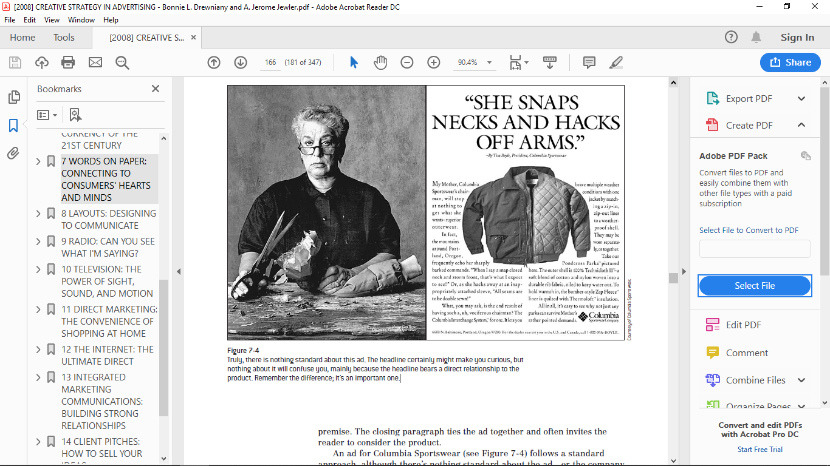

**Copy as Story**. Narrative copy reads like a piece of fiction because it sets a scene and presents characters who become involved in some action.

**Dialog Copy**. You know the routine “I said. She said.” Although you usually find this format in radio and television, it works in print, too. However, make certain that your dialog sounds realistic by reading your copy out loud.

**Bulleted Copy or Listings**. An ad for the Massachusetts Society for the

Prevention of Cruelty to Animals was headlined “Get the best of everything. Adopt a mutt.” The picture shows an adorable mutt looking straight into the reader’s eyes, and bulleted copy addresses the advantages of adopting a mutt: “The smarts of a Lassie. The spots of a Dalmatian. The bark of a Shepherd. The friendliness of a Beagle. The heart of a St. Bernard. The paws of a Great Dane.”

**Poetic Copy**. Norwegian Cruise Lines used poetic images to sell its fantasy adventures:

It’s different out here.

I will put first things last.

I will study a sunset.

I will be naked more.

I will discover a color.

I will memorize clouds.

I will be amphibious.

I will eat a mango.

I will get a really good tan.

**Mandatories: Writing the Small Print**

*Mandatories* are statements required to appear in your ads and are usually found in the small print along the bottom or side of an ad. Sometimes law requires these statements. For example, bank ads state “Equal Opportunity Lender.” Other times the statements are something the client insists on including. Motel 6 ads, for example, include the statement, “Motel 6. An Accor Hotel.” It’s your job as a writer to ensure that your copy contains these small but important words.

**Answers to Common Questions about Writing Copy**

**Is It OK to Break the Rules?**

Some people believe advertising has destroyed the dignity of our language.They are appalled when they read sentences such as, “Winston tastes goodlike a cigarette should.” Cringe when they read incomplete sentences (likethis one). And wince when a sentence starts with a conjunction. Others arguethat advertising must sound like people talking, so it’s OK to break the rules.However, most people agree that, before you break the rules, you’d betterknow them. See the box on the for some copy mistakes.

|  |
| --- |
| **COPY MISTAKES**  You must proofread your copy. Spell Check is a big help, but it can’t find every type of error. Here are some mistakes from the classifieds: “For sale: an antique desk suitable for lady with thick legs and large drawers.” “Four-poster bed, 101 years old. Perfect for antique lover.” “Now is your chance to have your ears pierced and get an extra pair to take home, too.” “Wanted: 50 girls for stripping machine operators in factory.” “Tired of cleaning yourself? Let me do it.”  “Used cars: Why go elsewhere to be cheated? Come here first!” Church bulletins have their share of gaffes. Here are a few of our favorites: “Thursday, at 5 p.m., there will be a meeting of the Little Mothers Club. All those wishing to become little mothers, please meet the pastor in his study.” “The ladies of the church have cast off clothing of every kind and they may be seen in the basement on Friday afternoon.” “This being Easter Sunday, we will ask Mrs. Johnson to come forward and lay an egg on the altar.”  But don’t think it’s just small-town classifieds and church bulletins that make mistakes. Consider the following: A Mercedes-Benz accessories ad begins, “Her trademark has always been making art out of the everyday. First, she was taken with fruits and vegetables. Next, she was inspired by popcorn, footballs and sharks. Then one day, Nicole Miller was struck by a Mercedes-Benz.” Bruce Hardwood Floors insulted a few grandmothers with the line “Solid oak, just like your grandmothers.” |

**What’s the Best Headline Length?**

Unless you’re writing to a specific layout with a predetermined character count, there is no “best” length. One of the most famous headlines for a car was one simple word, “Lemon.” This unexpected headline for Volkswagen motivated people to read the copy, which explained the auto manufacturer’s rigorous quality standards. In contrast, another famous headline for a car contained 18 words: “At 60 miles an hour, the loudest noise in the new Rolls Royce comes from the electric clock.” Sometimes you’ll find you don’t need a headline—the visual can stand alone. A Volkswagen ad spoke volumes about the car’s gas mileage without a single word of copy. A cartoon illustration of a man holding a gas nozzle to his head resonated with consumers fed up with the high prices at the pump.

**Which Is Better, Long or Short Copy?**

Certain product categories, such as perfume and fashion, are sold primarily on the basis of image, so brief copy, along with a striking visual, is probably the best answer. Other products, such as cars and computers, require quite a bit of thought before the buyer takes the plunge; therefore, they warrant longer copy with specific details about the various features.

However, even these rules are successfully broken occasionally. Volkswagen ads often contain only a few lines of copy. Lands’ End fills the page with details about its clothing.

The best advice is to write as much as you need to accomplish your advertising objectives. You may find you don’t need any copy. The right visual and logo may be all you need. The North Carolina tourism ads shown in **Figure 2** use long copy to capture the interest of people who want to go on an adventure, but there’s almost no copy in the North Carolina tourism ads that target those who need a vacation to escape from the pressures of work (see **Figure 3**).

**Figure 2**. Copy reads: “Why sugarcoat it? There is an undertone—the slightest whiff—of danger about the place. Of course, that’s what gives the Outer Banks its seductive, otherworldly appeal. These islands were, after all, the favorite hideaways of some of history’s most feared pirates: Blackbeard and Stede Bonnet. Today, the same qualities that drew those fugitives from justice attract a different breed of runaways: vacationers. Qualities like its remoteness. Its unapologetic plainness and simplicity. Its stark contrast to the bland tranquility of the cities. It’s an edge of the world type of place. A place where the sand dunes grow taller than four-story buildings. Where dignified old lighthouses shine beacons atop the restless waters. And over 2,000 shipwrecks lie below them. The Outer Banks. Spare. Romantic. Unhip. Stunning. Part beauty. Part beast. We’ll be expecting you.”

**Figure 2** (continued)

Copy reads: “In the beginning, they were both part of the prehistoric continent called Pangaea. Today, a living link still remains: the North Carolina Zoo in Asheboro, America’s first natural habitat zoo. Here, during the course of a day, you and your children can watch antelopes and birds gather as they do on the African veldt. Observe endangered white rhinos feeding in a natural grassland habitat. Laugh at the antics of a family of lowland gorillas. And the age-old bond between the two lands continues to flourish in other ways. For example, a rare female wattled crane born in captivity here was recently flown back to her native South Africa to breed and help replenish their dwindling population. Strolling the grounds, you get a sense of the fragile interrelatedness of things. But that’s as it should be. You see, long ago, we learned a valuable lesson: It’s not just animals who benefit from staying connected with the past. Human beings do, too.”

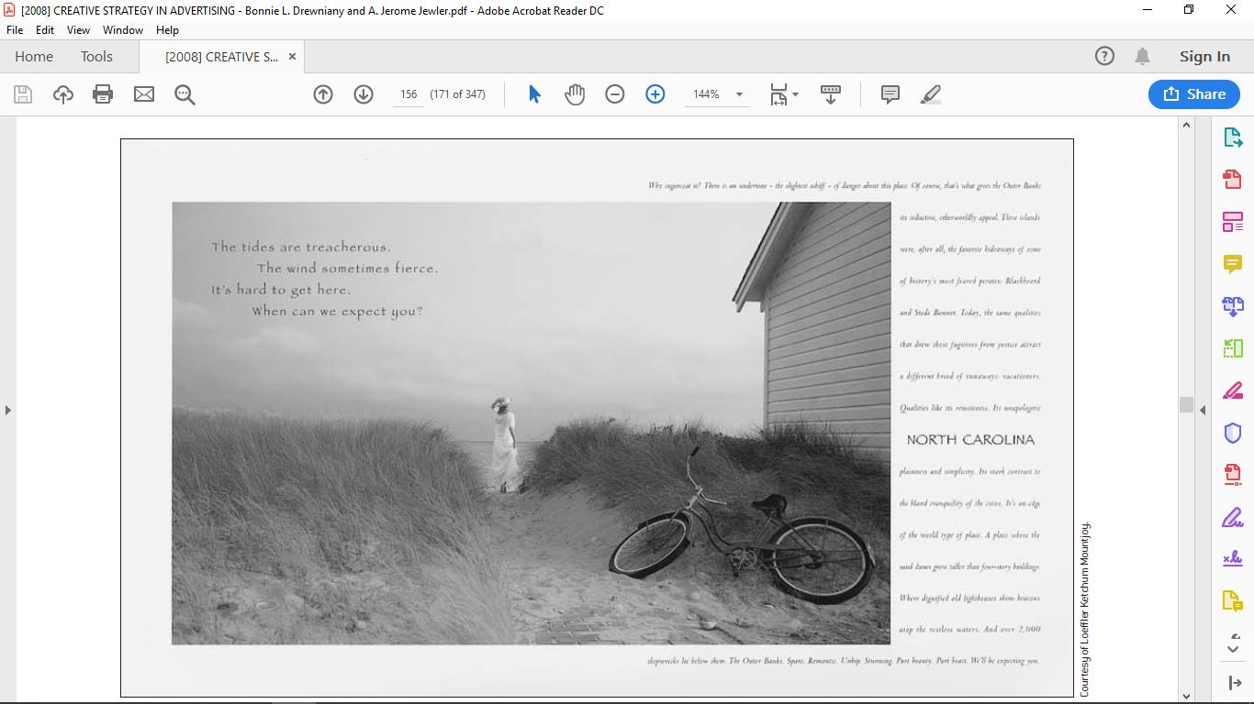

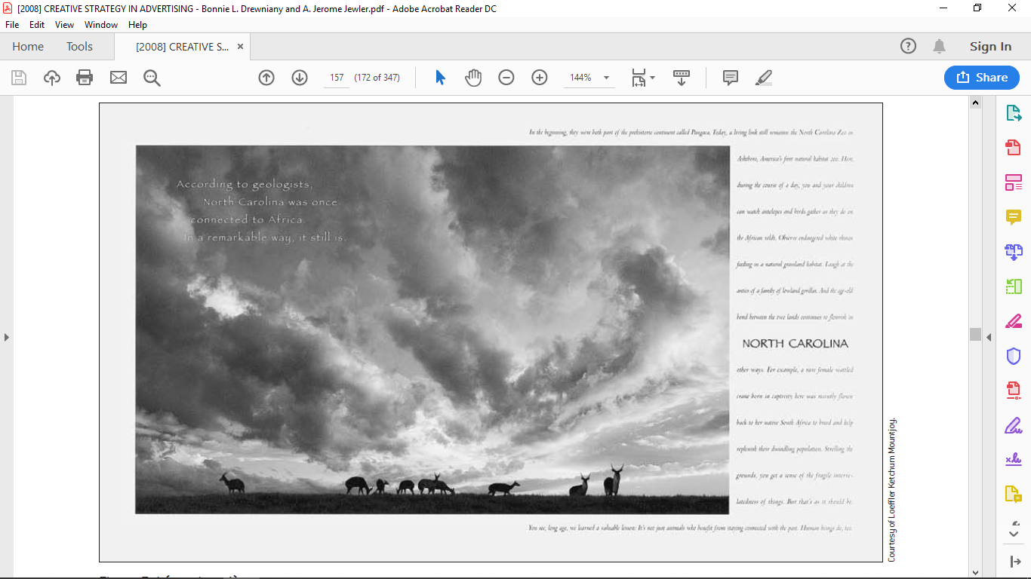

**Figure 3.** The lack of headline or body copy in these ads is perfect for vacationers who just want to “veg out.” Notice how differentthey are from the ad shown in **Figure 2**, which are targeting different groups of visitors.

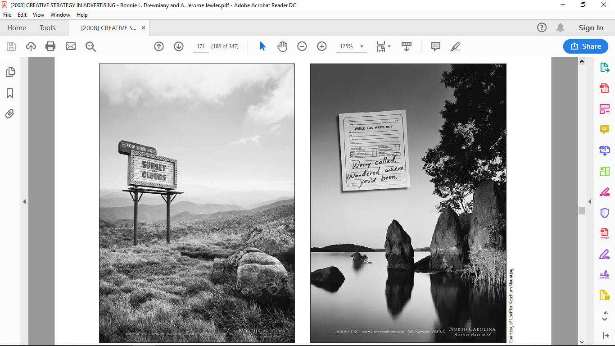

**Does a Brand Need a Slogan?**

A good slogan captures the essence of a brand in a few words. Here are a few that work:

“It’s not delivery. It’s DiGiorno.”

(For DiGiorno frozen pizza)

“Have You Met Life Today?”

(For MetLife Insurance)

“Hey. You Never Know.”

(For New York State Lottery)

“We Answer to a Higher Authority.”

(For Hebrew National Hotdogs)

“Don’t Mess with Texas.”

(Started as a slogan for the antilitter campaign; became a

rallying call for the state)

Unfortunately, many slogans say little and are indistinguishable from those used by other brands. For years Macy’s slogan said, “We’re a part of your life.” Meanwhile, Sears boasted, “There’s more for your life at Sears.”

And General Electric claimed, “We bring good things to life.” Each of these slogans could have worked for a hospital, a real estate agent, a bank, a health food store, a veterinarian, or any number of products and services. Like the previous examples, too many slogans do little more than add clutter to an ad. Still, many clients will insist on having a slogan, almost as if they’re not getting their money’s worth from their ad agency if they don’t have one. As a writer, you can do two things: talk the client out of one, or write one that means something to their customers.

**How Should Copy Be Formatted?**

**Figure 4** shows a suggested copy format for print ads. “Slug” the ad in the upper-left corner with the name of the company, size, and medium (full page, magazine) and a working title in quotes. Identify the visual idea, headline, copy, logo, and baseline, plus other elements when used. Double-space so that it’s easy to read, easy to revise, and easy to sell. **Figure 5** shows how the finished ad looks

**Figure 4**. In this sample copy draft, note the use of a working title, double spacing, and adequate margins on all sides. To see how this translates into an ad, see **Figure 5**.

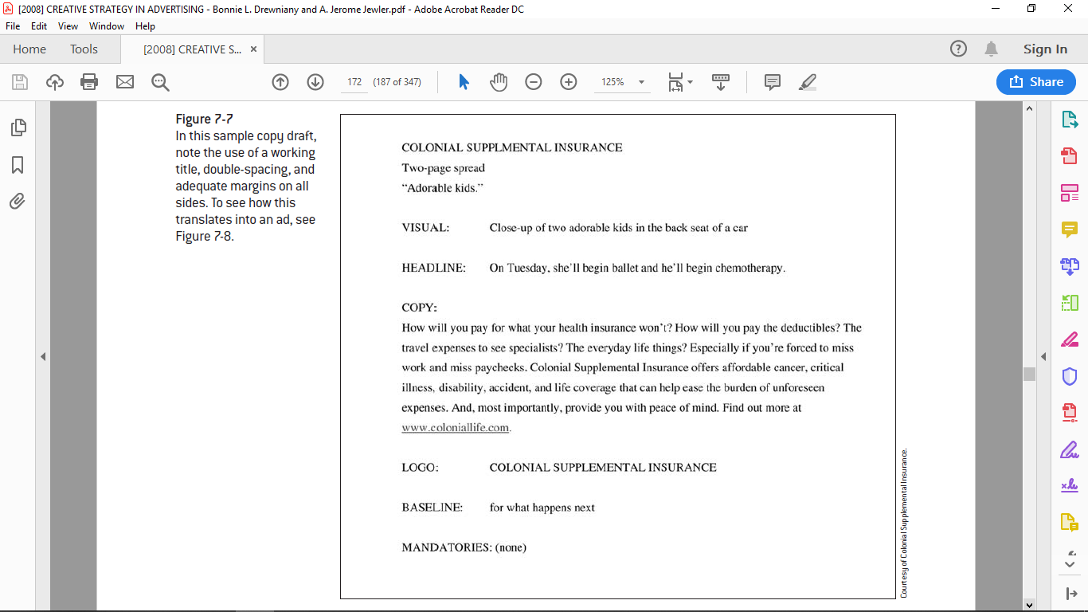

**Figure 5.** This moving ad makes itclear why you need supplementalinsurance.Sales of Colonial SupplementalInsuranceincreased 40 percent inadvertised markets. Toread the text of the ad,see **Figure 4**.

