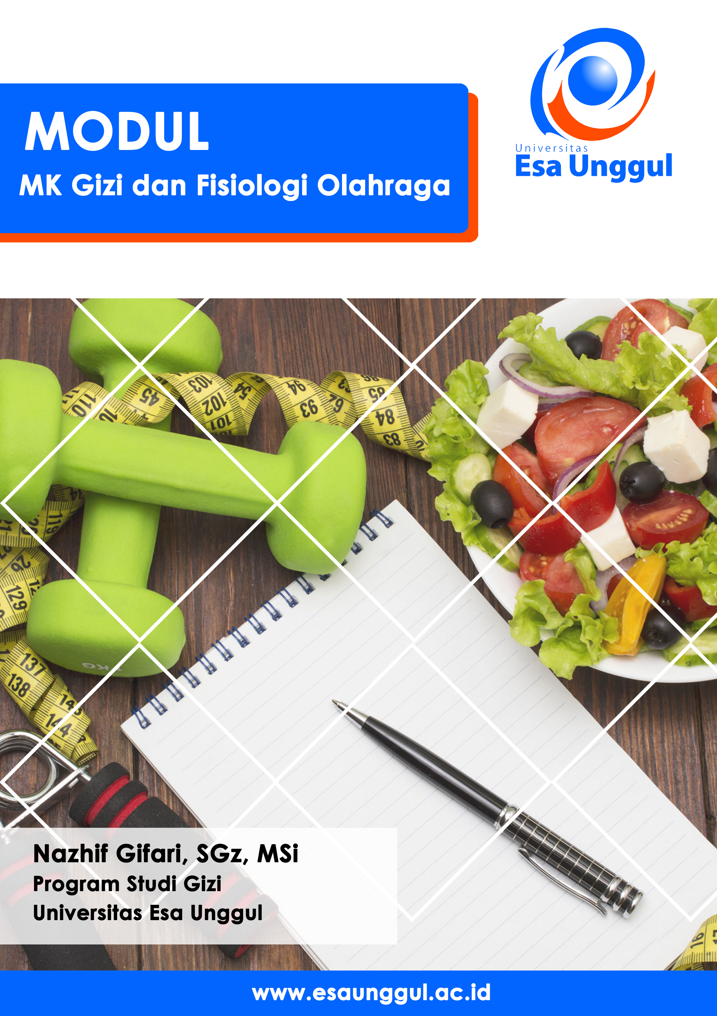

PERTEMUAN II
MK Gzi dan Fisioogi Olahraga (online)
Nazhif Gifari

Tujuan:
Memahami peranan ahli gizi olahraga

Pendahuluan
- Sports nutrition: defined as the “application of eating strategies to promote good health and adaptation to training, to recover quickly after each exercise session, and to perform optimally during competition” (Louise Burke, in Williams, p. 14)
- Are athletes getting adequate nutrition?
- Groups that may be “at risk” due to restrictive dieting: dancers, gymnasts, body builders, distance runners are most susceptible to inadequate diet

What does a “sports nutritionist” do?
- Sports nutrition is a specialty that requires traditional nutritional science studies (minimum - BS in Nutrition)
- Involves investigation of interactions between dietary manipulations and physical performance
- Assessments and recommendations given based on specific needs of athletes
- Ongoing research and review of professional publications as well as attendance at annual professional meetings is necessary
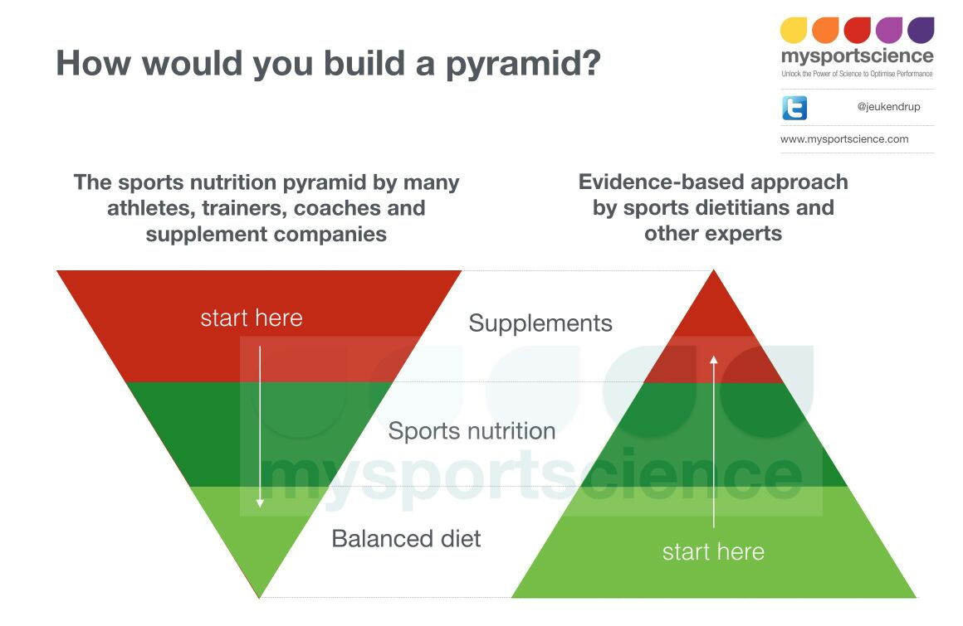

Purpose of Nutrition
- Good nutrition promotes a healthier mind and body.
  - Aids in resistance to illnesses.
  - Provides energy
  - The right foods help the athlete to:
    - Feel Better
    - Sleep Better
    - Speed The Healing Process
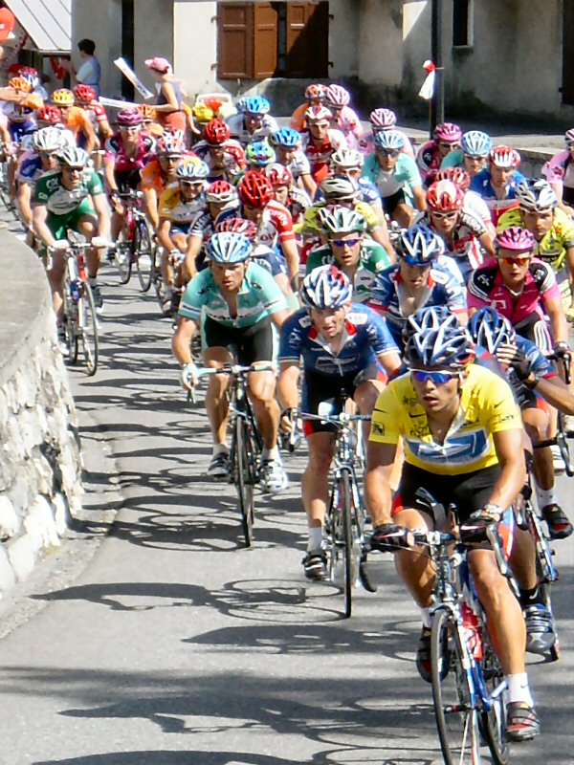

  - A proper diet will provide the proper nutrients and energy for athletic performance, training and healing.
  - Many factors affect nutrient needs and nutrient availability including the athletes’:
    - Nutritional Status
    - Hysical Condition
    - Age
    - Genetic Background
  - These factors make it essential that the diet be individualized

Sports Nutrition Goals

  - Adequate energy intake to meet the energy demands of training
  - Adequate replenishment of muscle and liver glycogen with dietary carbohydrates
  - Adequate protein intake for growth and repair of tissue, particularly muscle
  - Adequate overall diet to maintain a healthy immune system

Sports Nutrition Goals
  - Adequate hydration
  - Delay fatigue during training and competition
  - Minimization of dehydration during exercise
  - Utilization of dietary strategies known to be beneficial for performance including:
    - Pre-competition meals
    - Carbohydrate loading

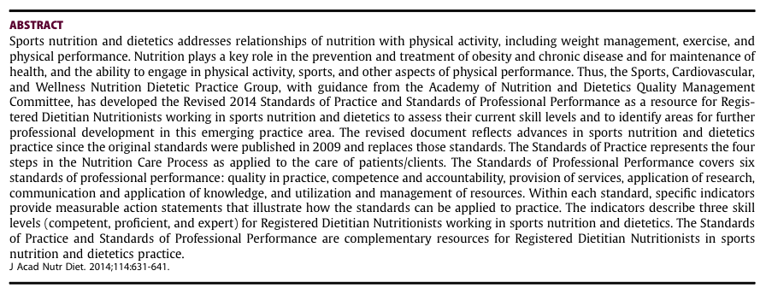
Sumber: J Acad Nutr Diet. 2014;114:631-641.

Menjadi seorang ahli gizi olahraga dengan jenjang karir yang baik

Sports nutritionists develop and implement nutritional plans for people, athletes and sports teams, for the purposes of maximizing the health and performance of the athletes

- Nutrition Assessment
- Nutrition Diagnosis
- Nutrition Intervention
- Nutrition Monitoring
- Nutrition Evaluation

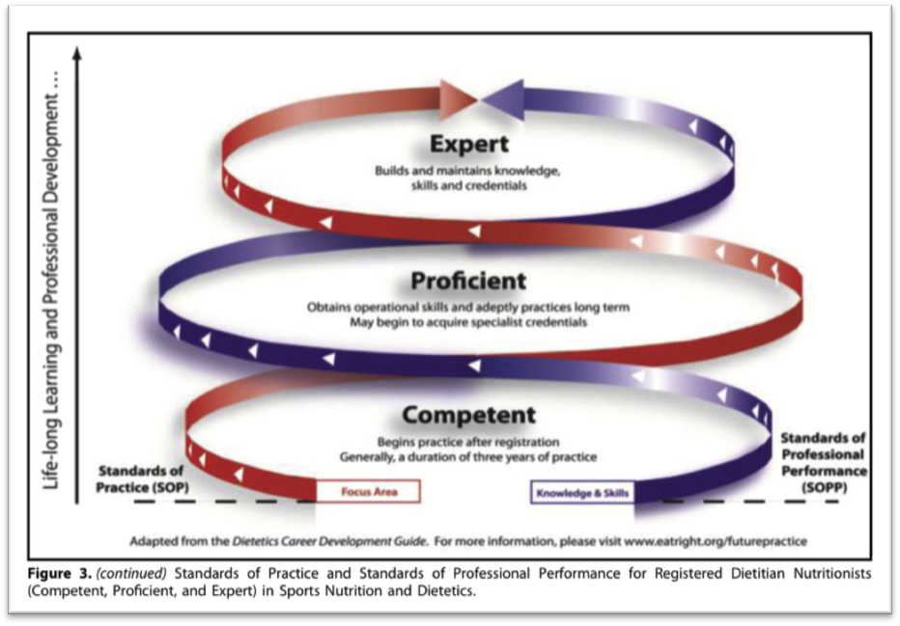

Pengukuran:
Antrophometric
Biochemical
Clinic
Dietary

Weight Standar
- Inappropriate use of weight standards
  - Seriously abused by coaches, players
  - Misconception that small weight loss good, large weight loss better
  - Can lead to ê performance, eating disorders
  - Making weight: severe weight loss
  - Wrestling, boxing, etc.
  - Weight classes can force extreme weight loss
  - Compete in class too low à injury, poor health
- Appropriate weight standards
  - Inappropriate standard risks athlete health
  - Body composition, not total body weight
  - Optimal range of percent body fat
  - Account for sex differences
  - Weight standards not always appropriate
  - Technical measurement errors
  - Not all athletes perform best at ideal composition

Risks With Severe Weight Loss

- Dehydration
  - Fasting, extreme caloric restriction à water loss
  - 2 to 4% weight loss as water à impaired performance
  - Risk of kidney, cardiovascular dysfunction, death
- Chronic fatigue
  - Underweight à fatigue à ê performance, injury
  - Mimics overtraining and chronic fatigue syndromes
  - Underweight à substrate depletion
- Eating disorders
  - Weight standards can à disordered eating
  - Anorexia nervosa, bulimia nervosa
  - More prevalent with women in lean sports
- Menstrual dysfunction
  - Delayed menarche, oligomenorrhea, or amenorrhea
  - Prevalent in low-body-weight sports
  - Due to caloric intake < caloric expenditure
- Bone Mineral Loss
  - Serious consequence of athletic amenorrhea
  - Anorexia à fracture rate 7 times higher
- Female Athlete Triad
  - Eating + menstrual + bone mineral disorders
  - Seen with women in lean-physique, low-body-weight, or endurance sports
  - Skating, dance, gymnastics, running, swimming

